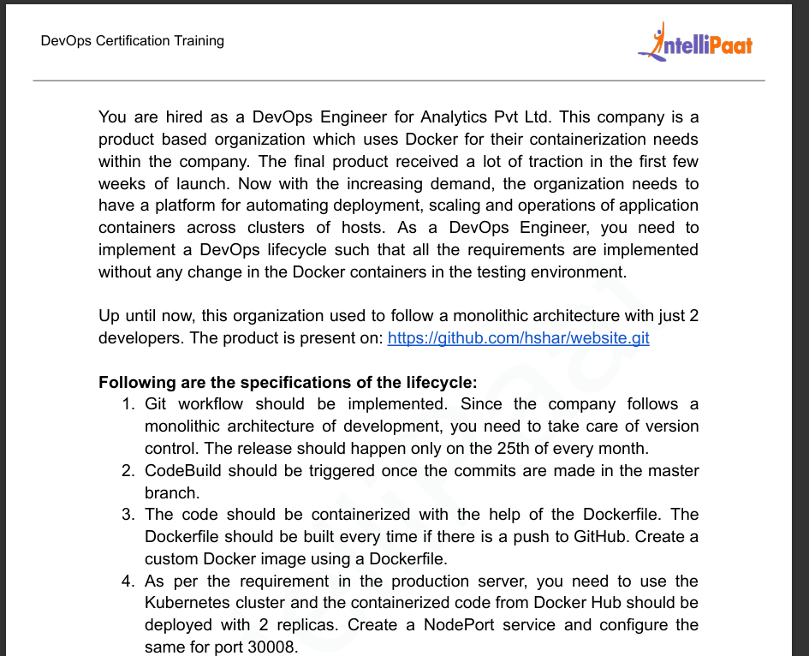

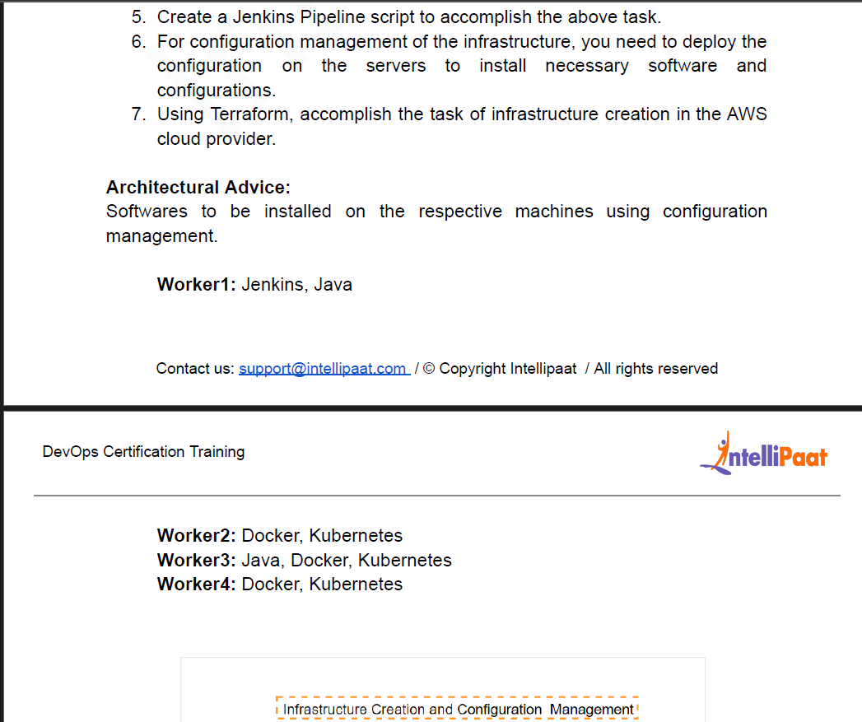

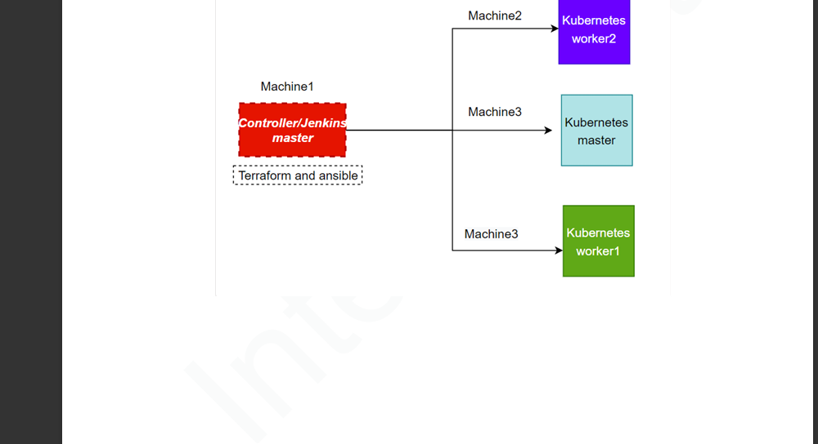

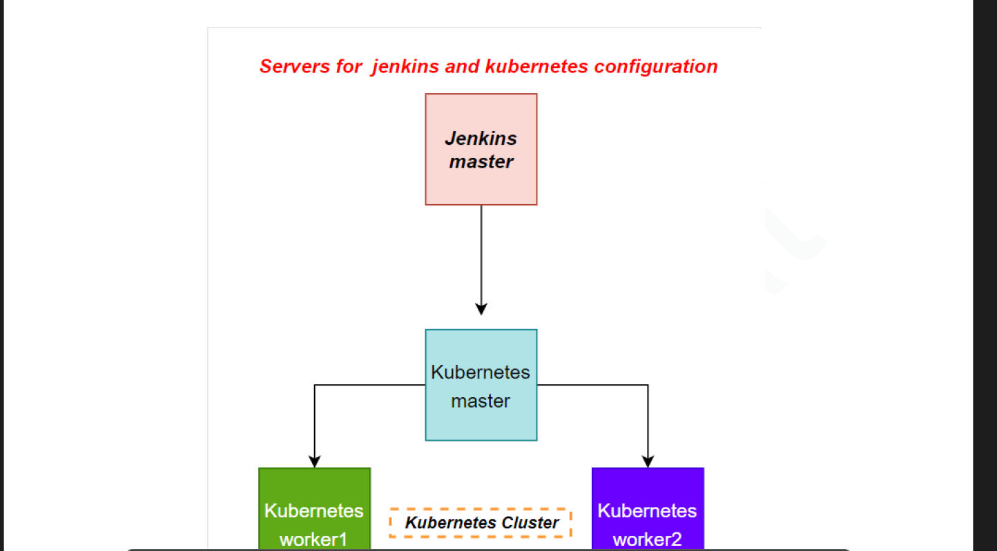

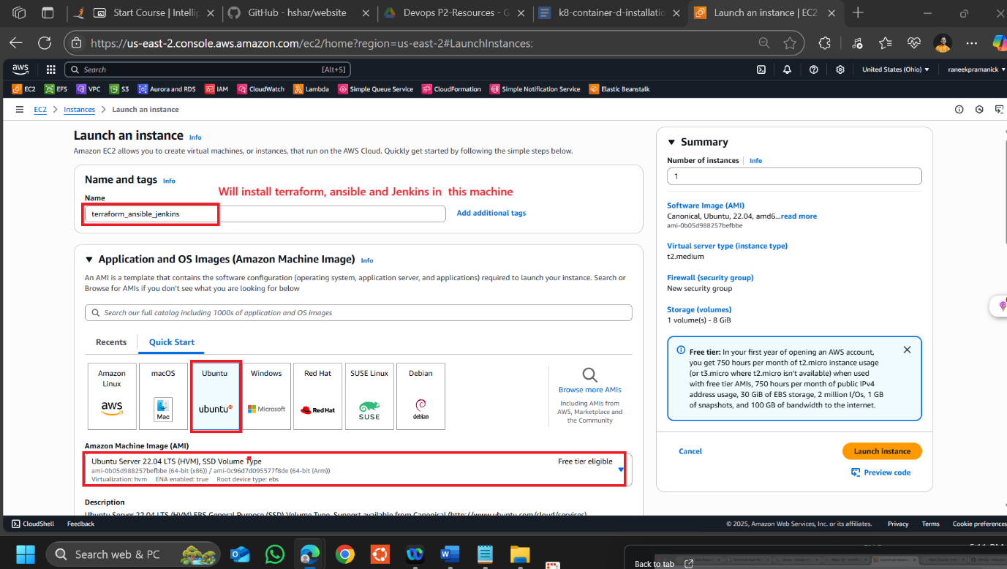

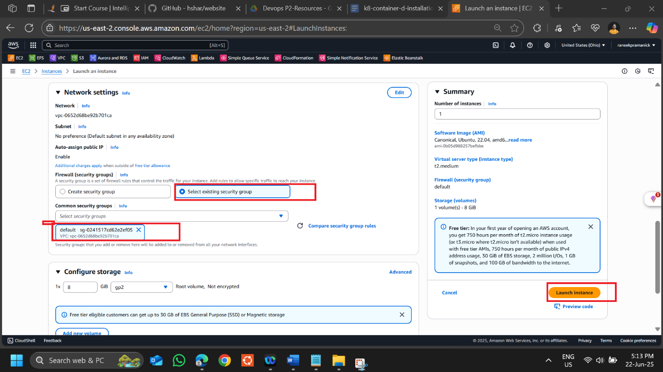

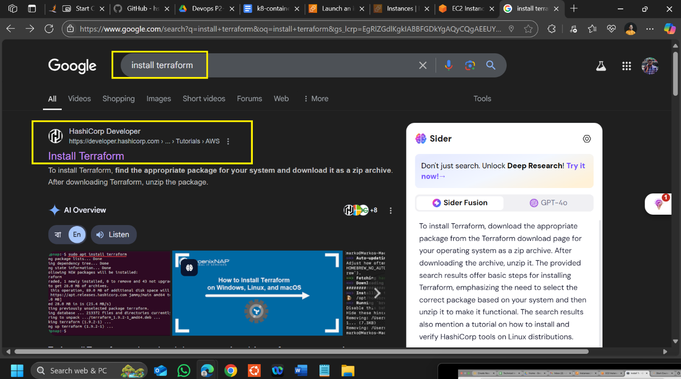

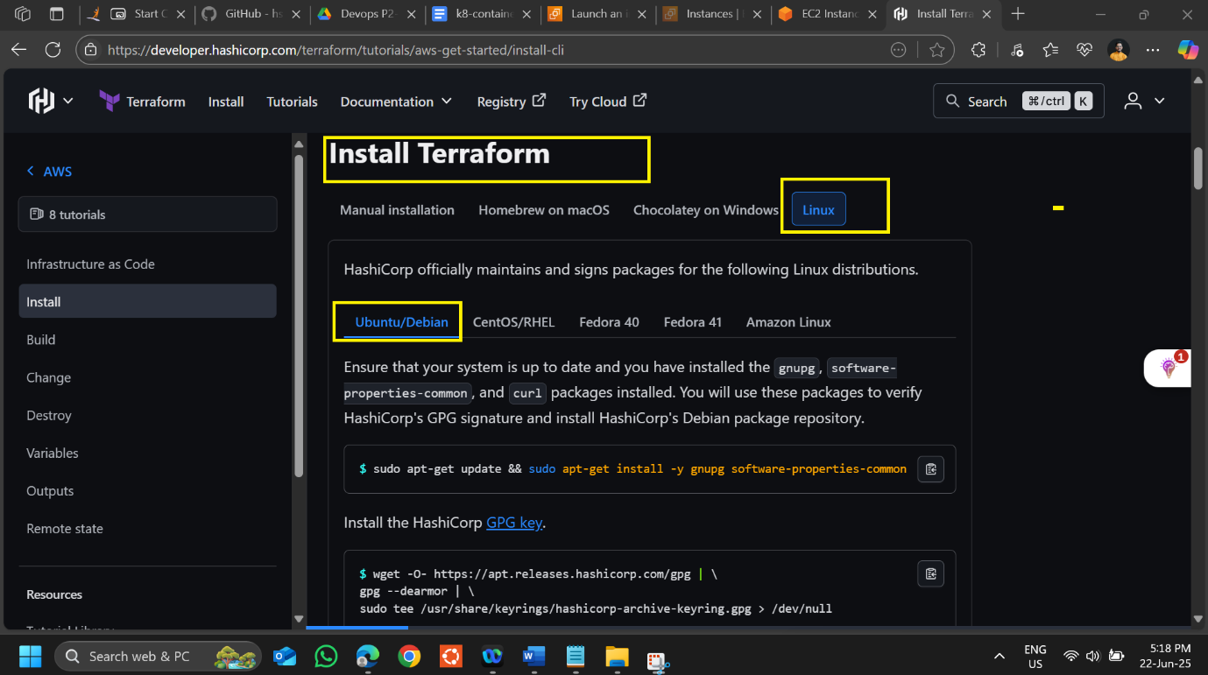

**Install terraform steps**

**Step1-** sudo apt-get update && sudo apt-get install -y gnupg software-properties-common

**Step2- wget -O- https://apt.releases.hashicorp.com/gpg | \**

**gpg --dearmor | \**

**sudo tee /usr/share/keyrings/hashicorp-archive-keyring.gpg > /dev/null**

**Step3- gpg --no-default-keyring \**

**--keyring /usr/share/keyrings/hashicorp-archive-keyring.gpg \**

**--fingerprint**

**Step4- echo "deb [arch=$(dpkg --print-architecture) signed-by=/usr/share/keyrings/hashicorp-archive-keyring.gpg] https://apt.releases.hashicorp.com $(grep -oP '(?<=UBUNTU_CODENAME=).*' /etc/os-release || lsb_release -cs) main" | sudo tee /etc/apt/sources.list.d/hashicorp.list**

**Step5- sudo apt update**

**Step6 - sudo apt-get install terraform**

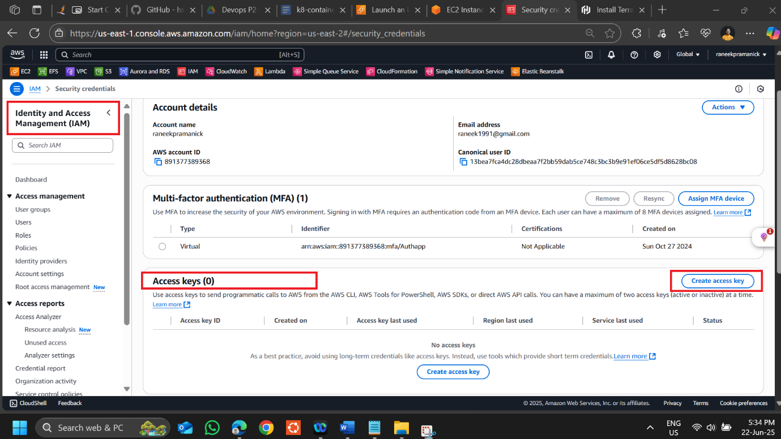

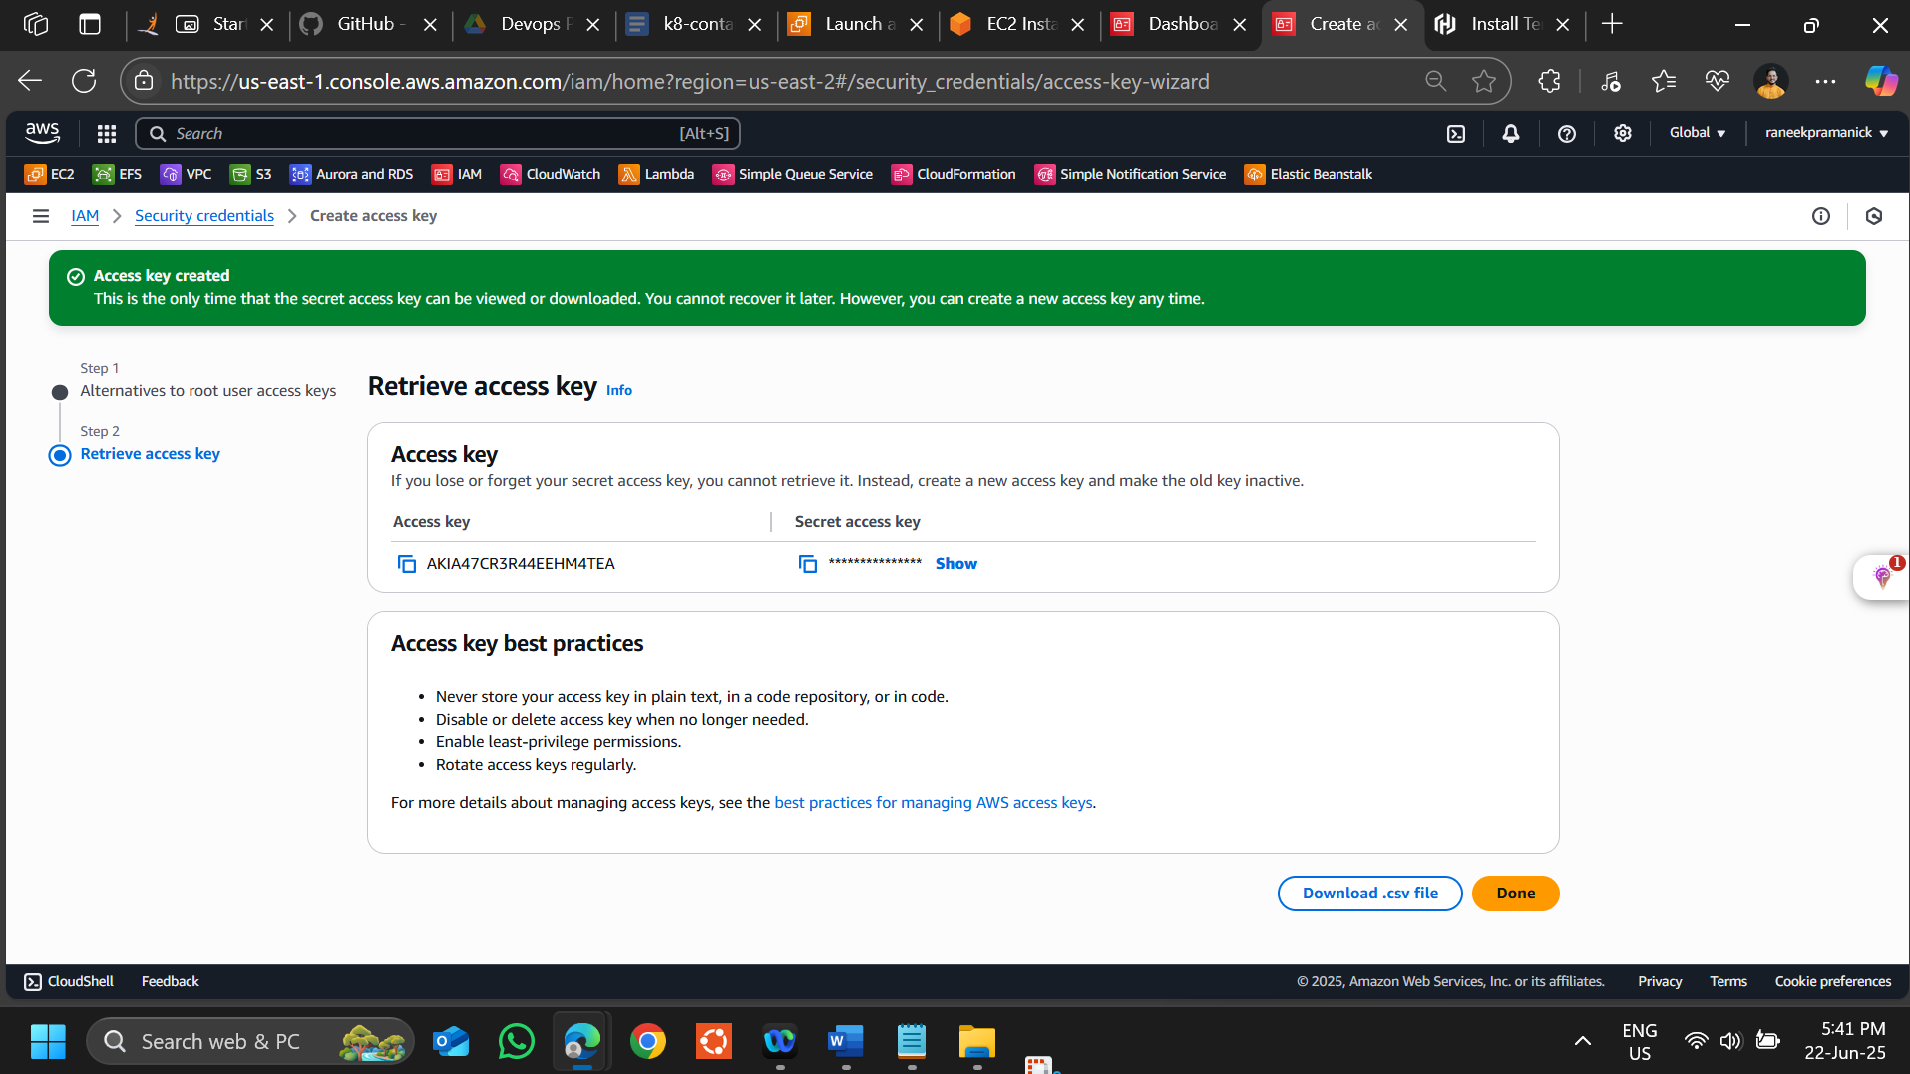

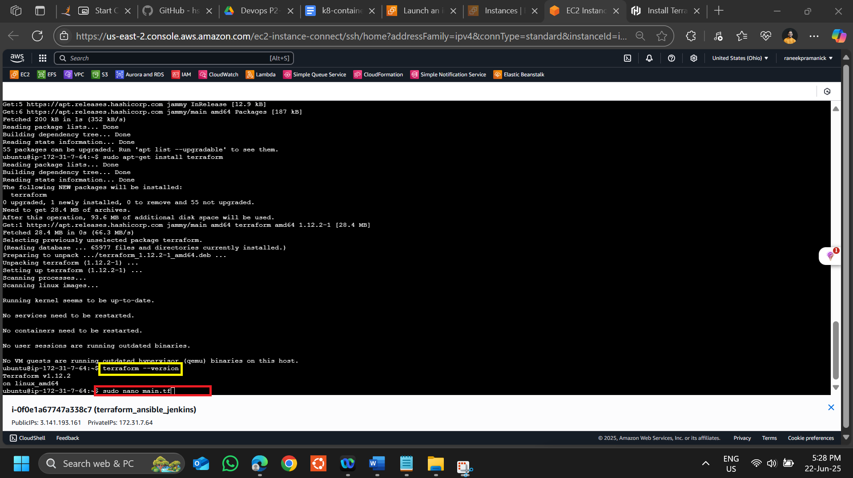

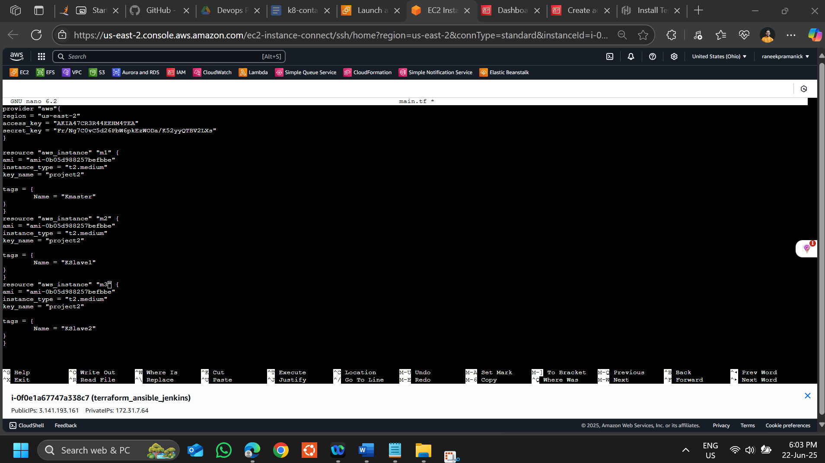

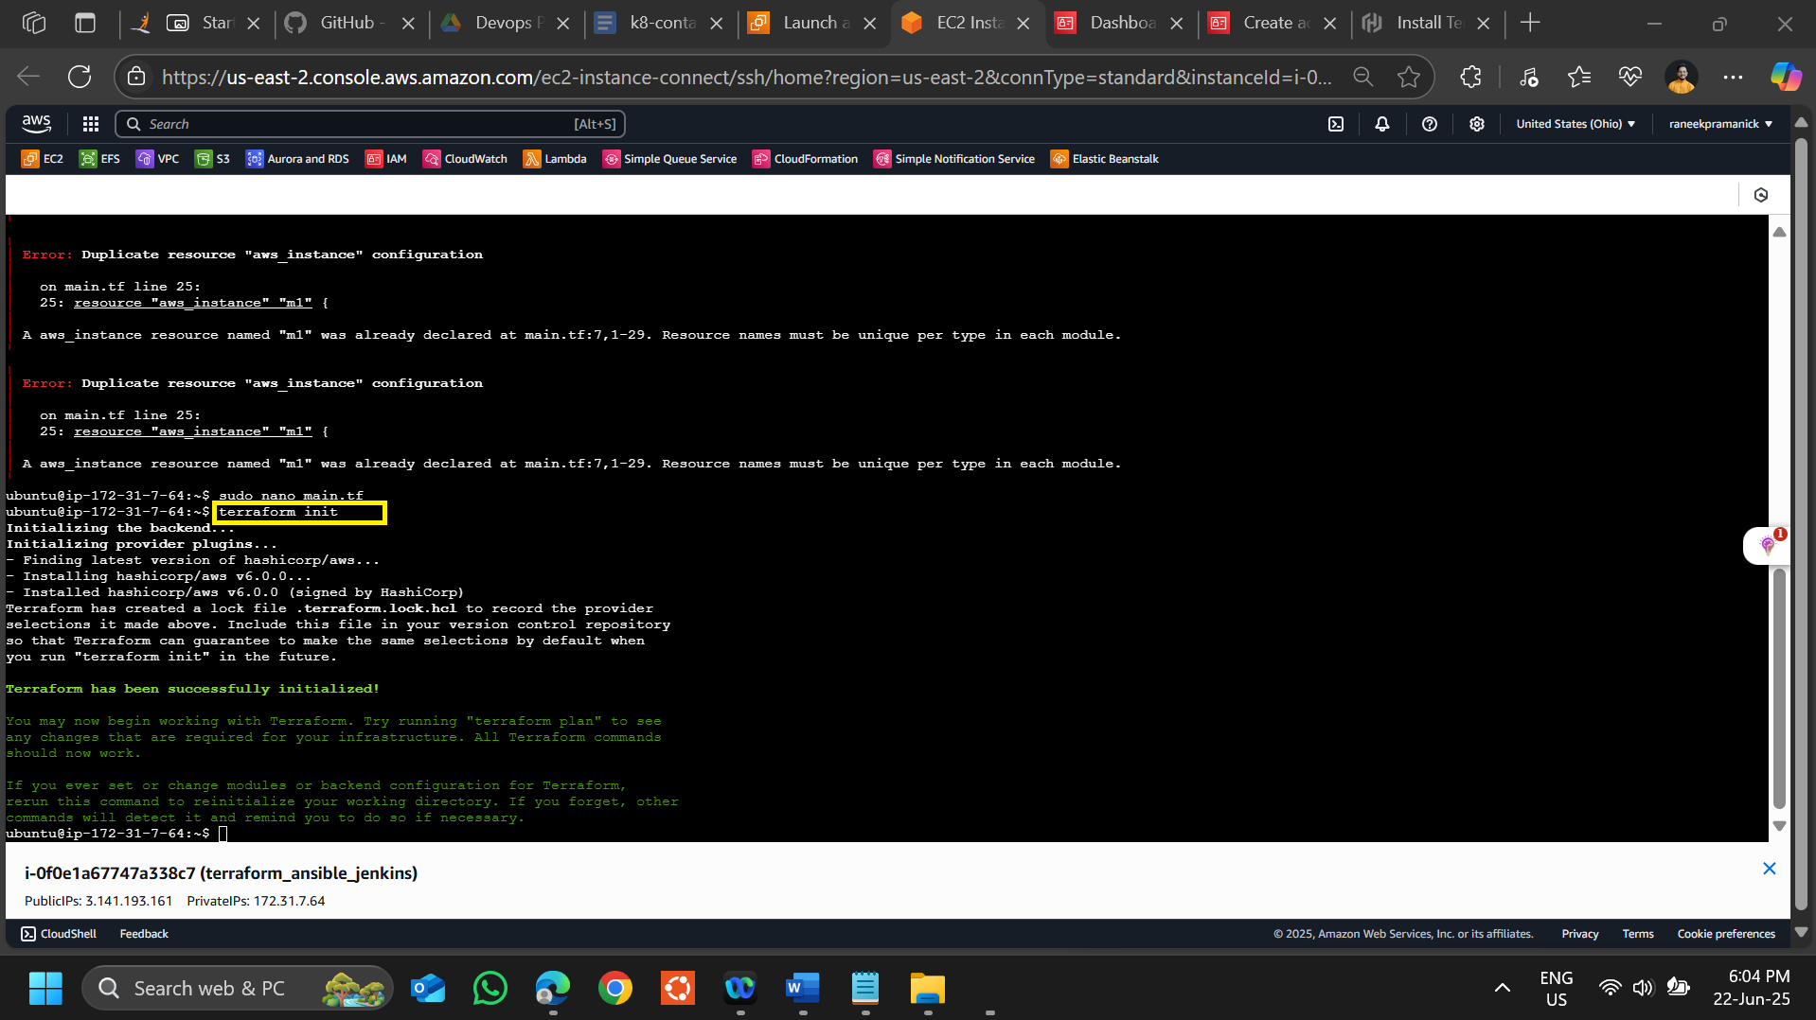

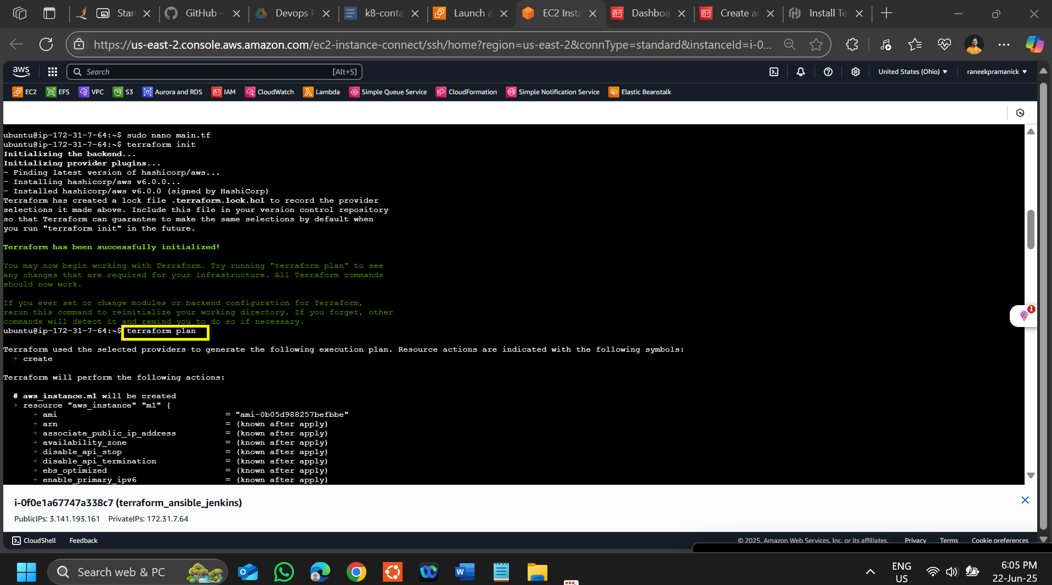

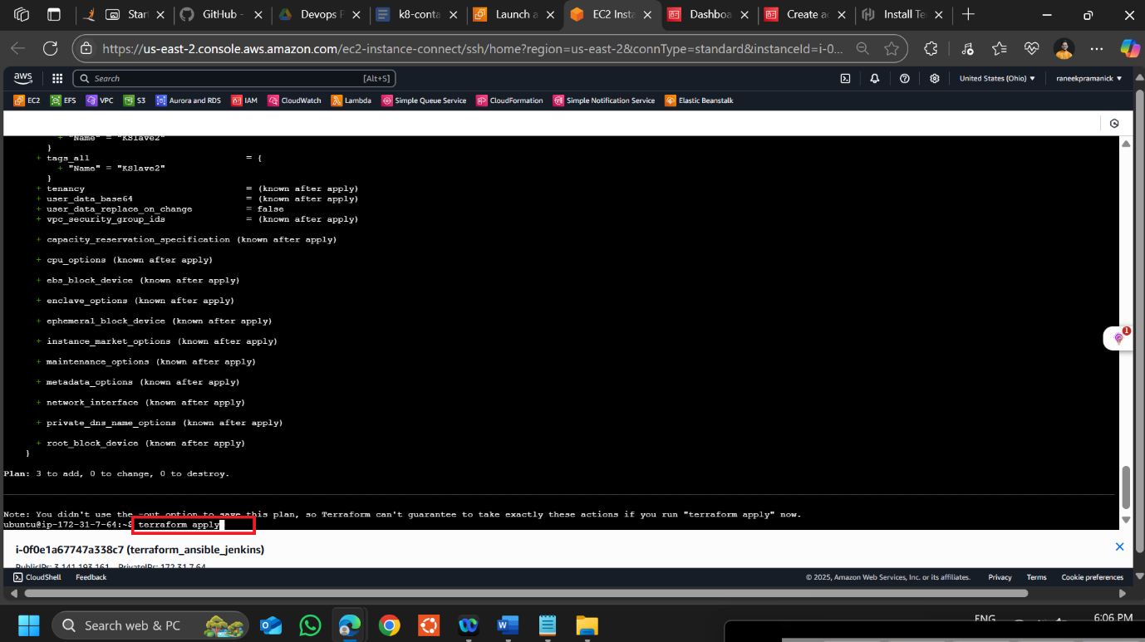

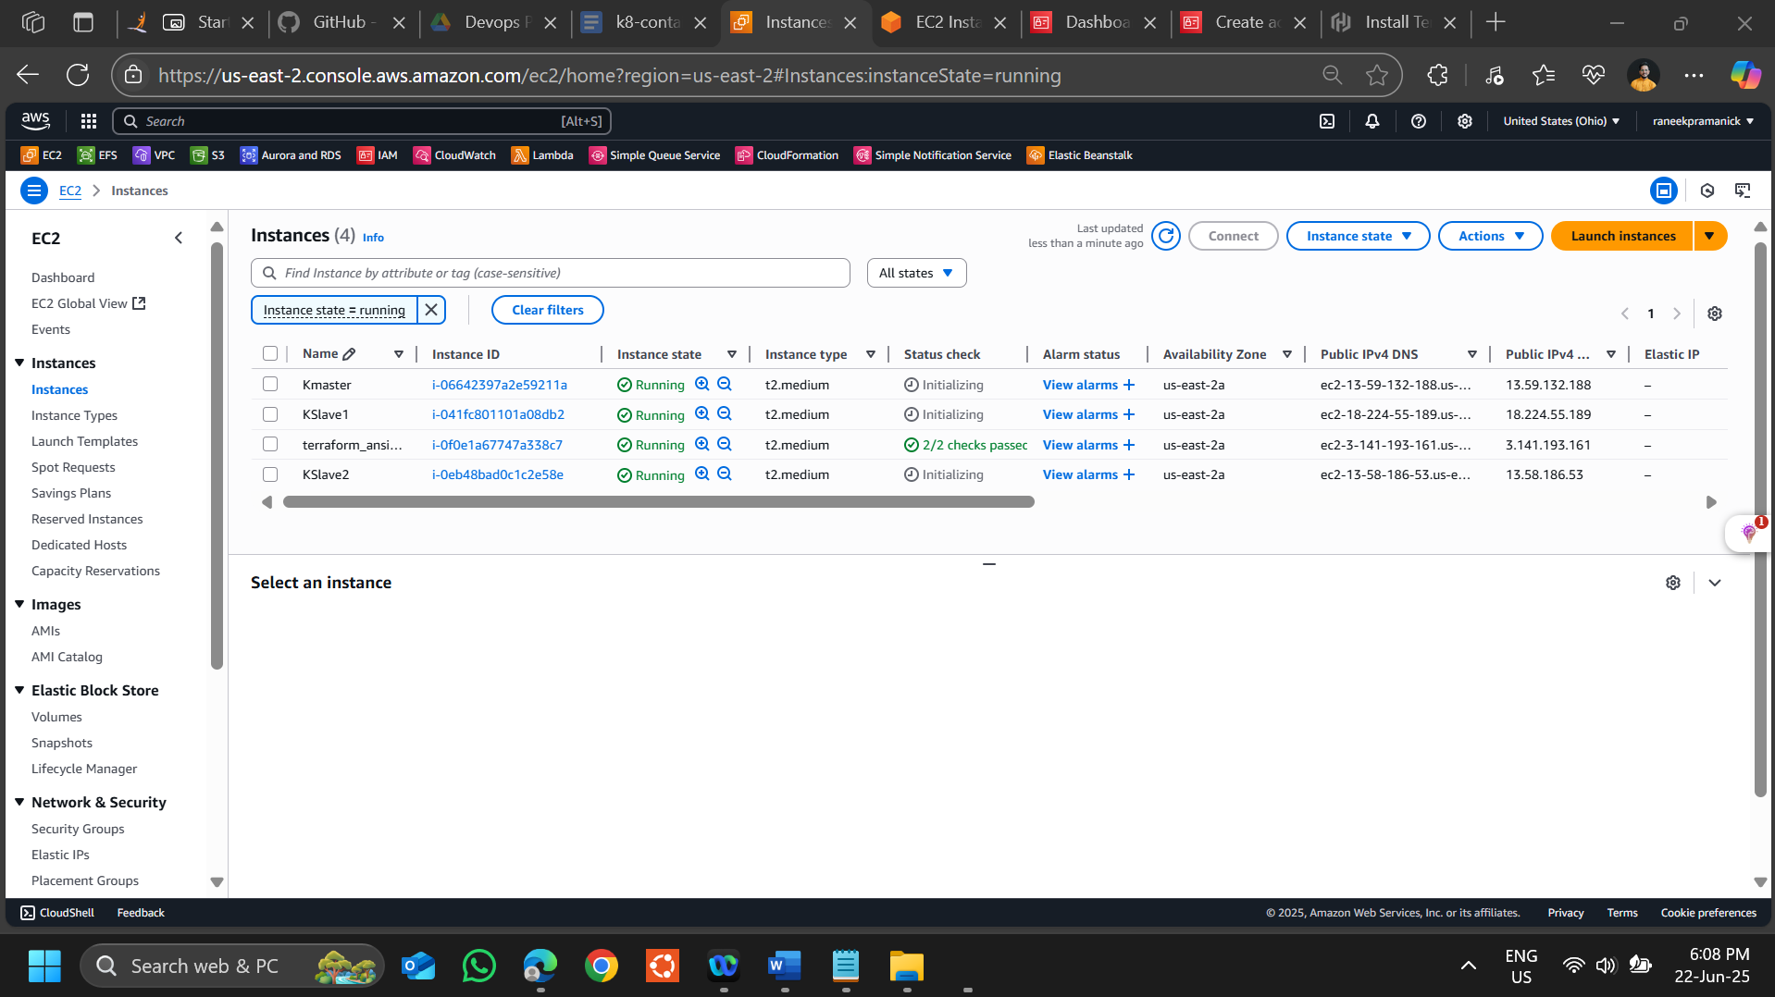

**Now we need to install Ansible**

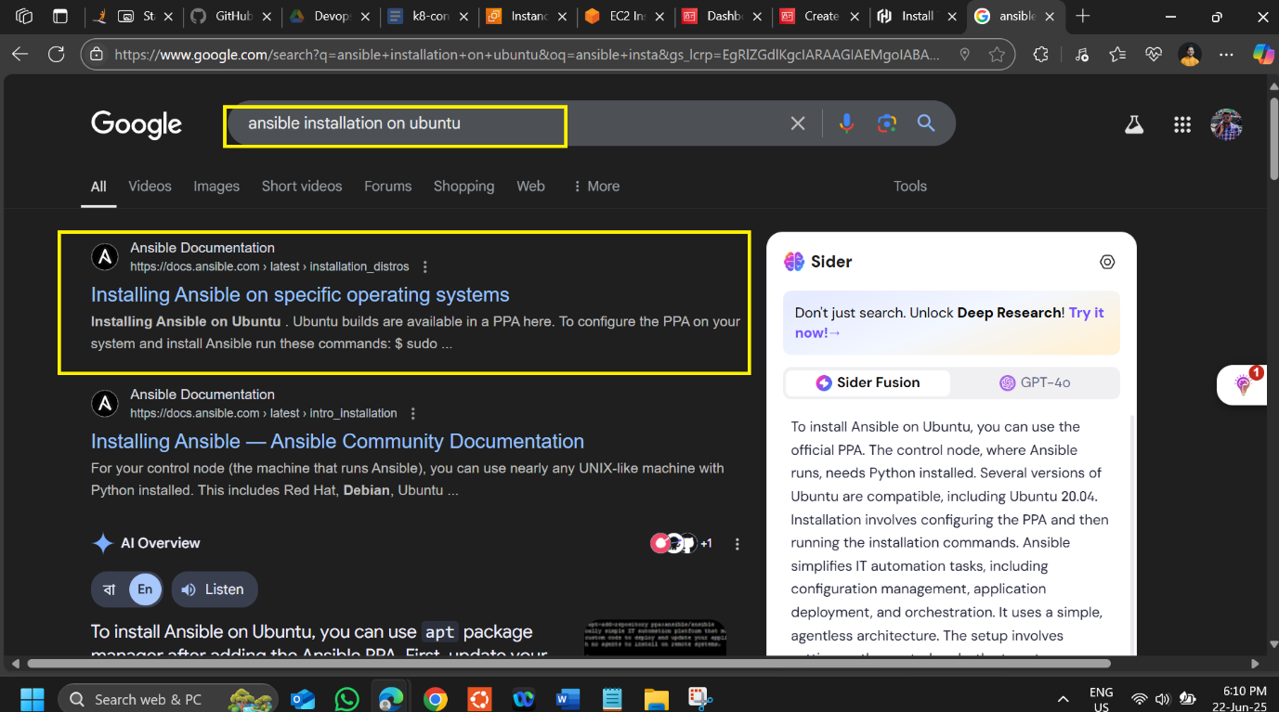

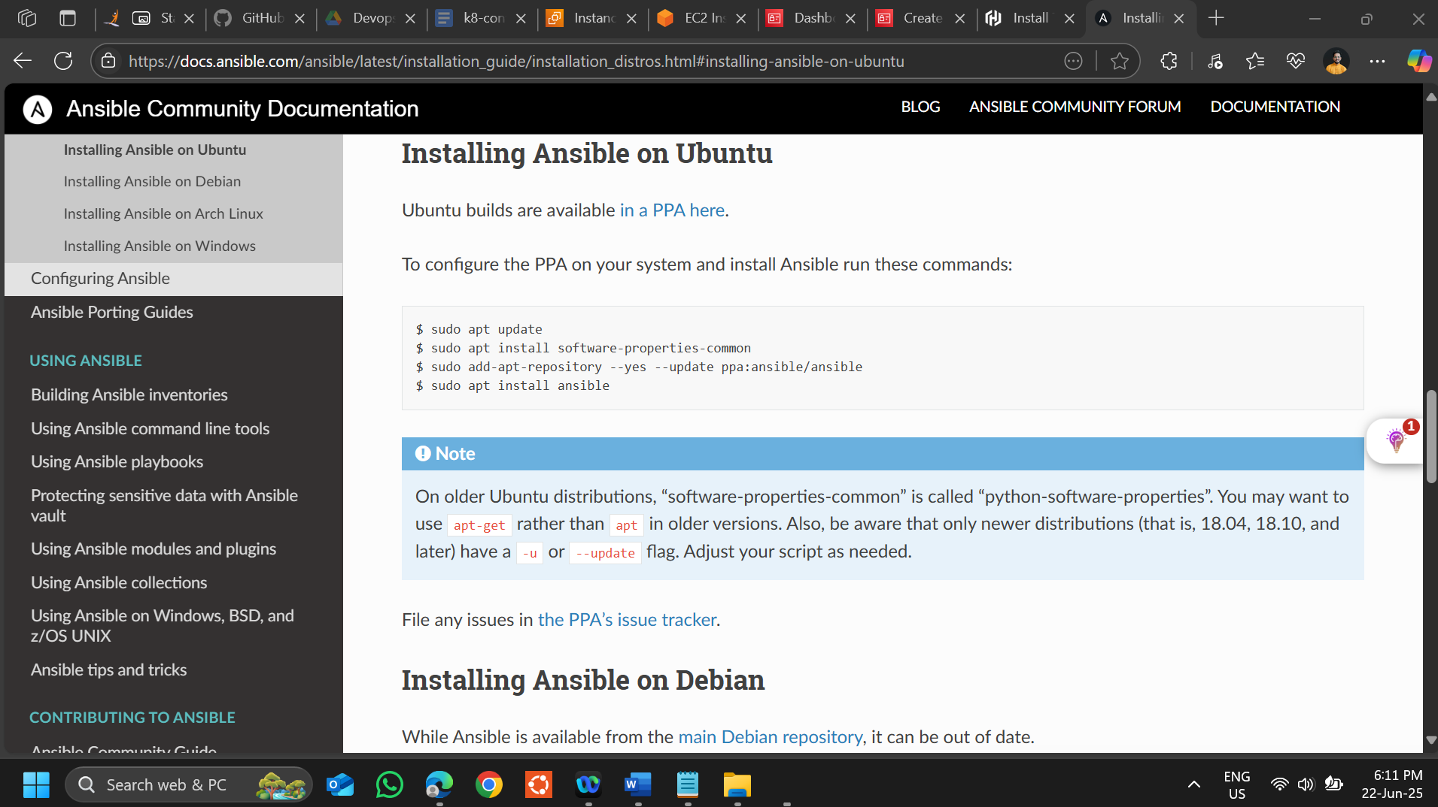

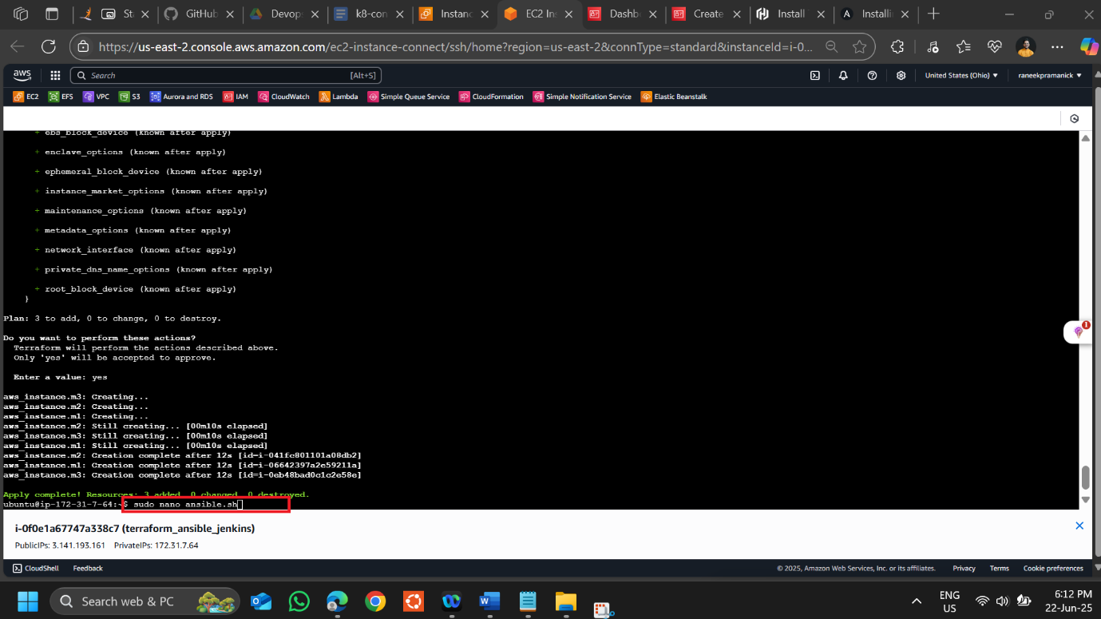

**sudo apt update**

**sudo apt install software-properties-common**

**sudo add-apt-repository --yes --update ppa:ansible/ansible**

**sudo apt install ansible -y**

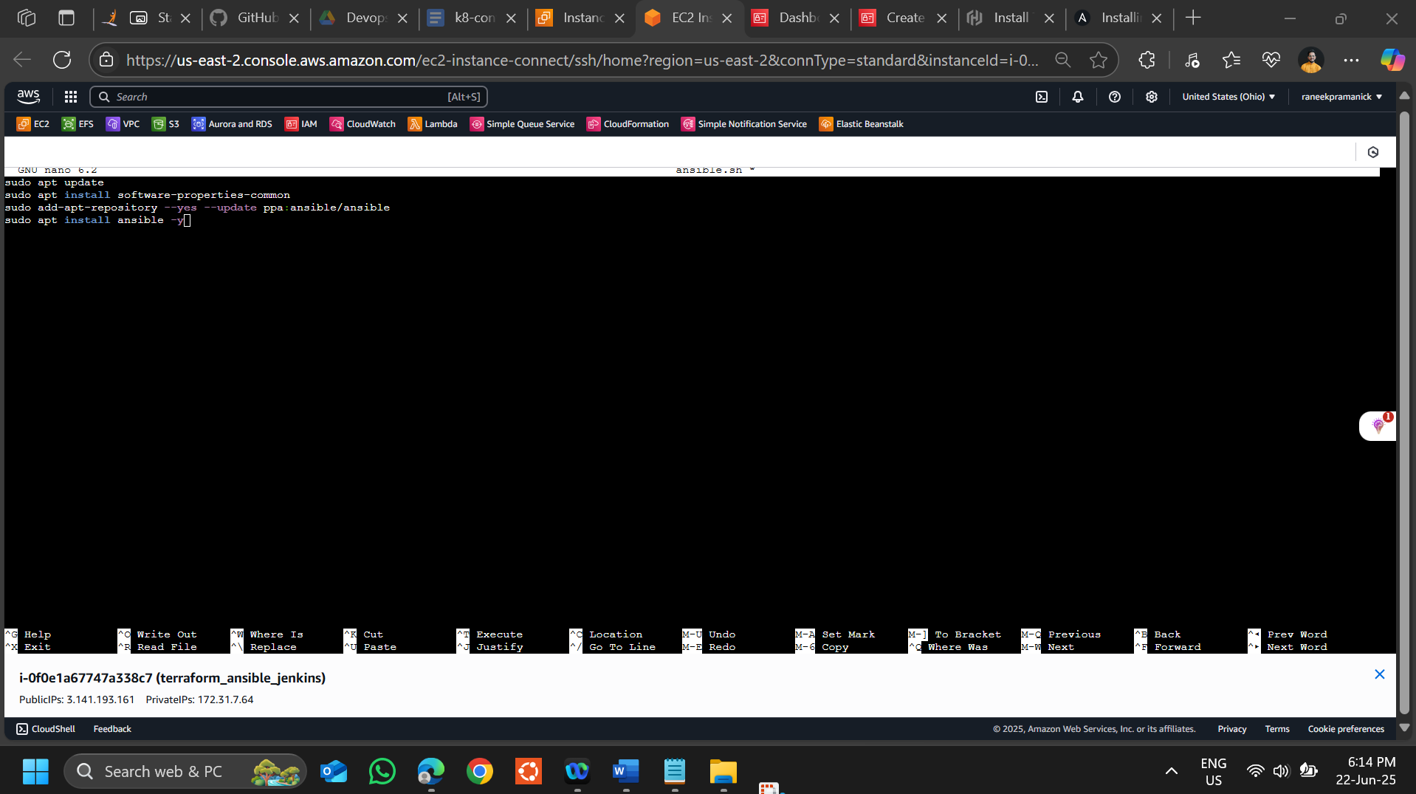

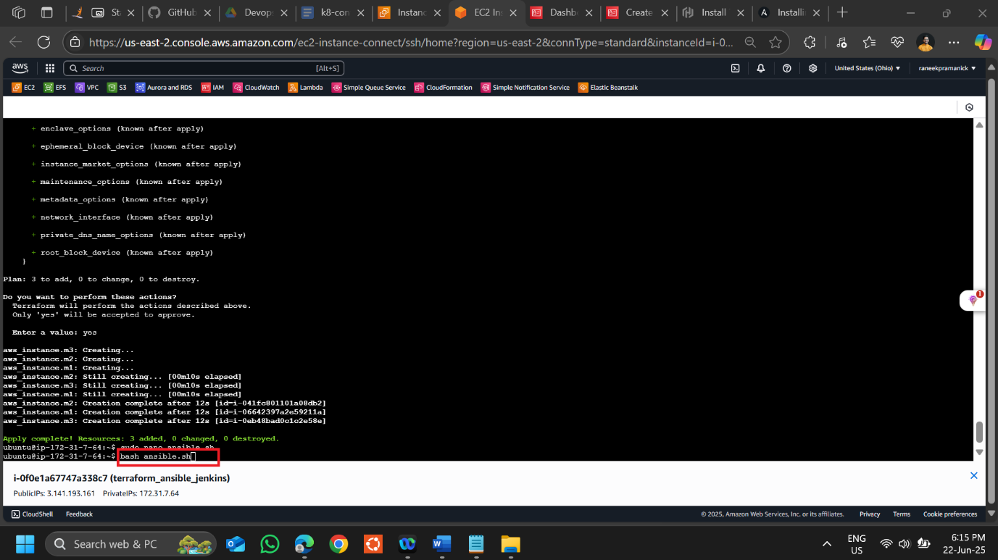

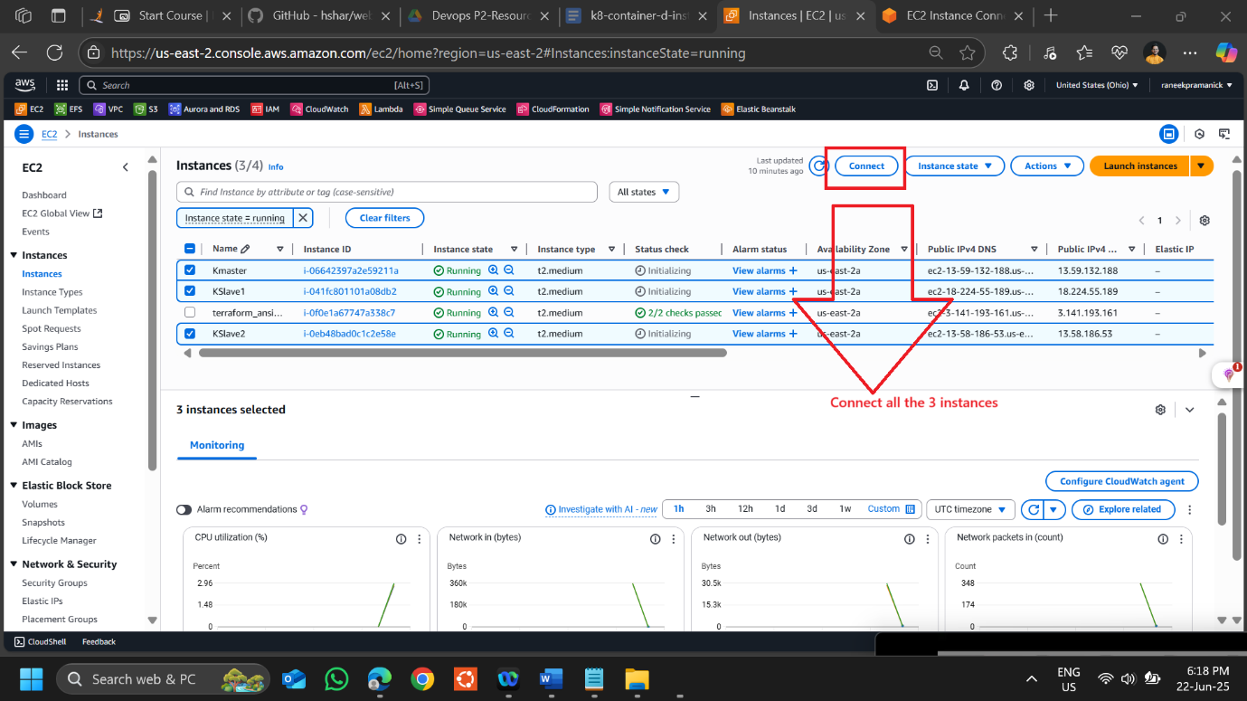

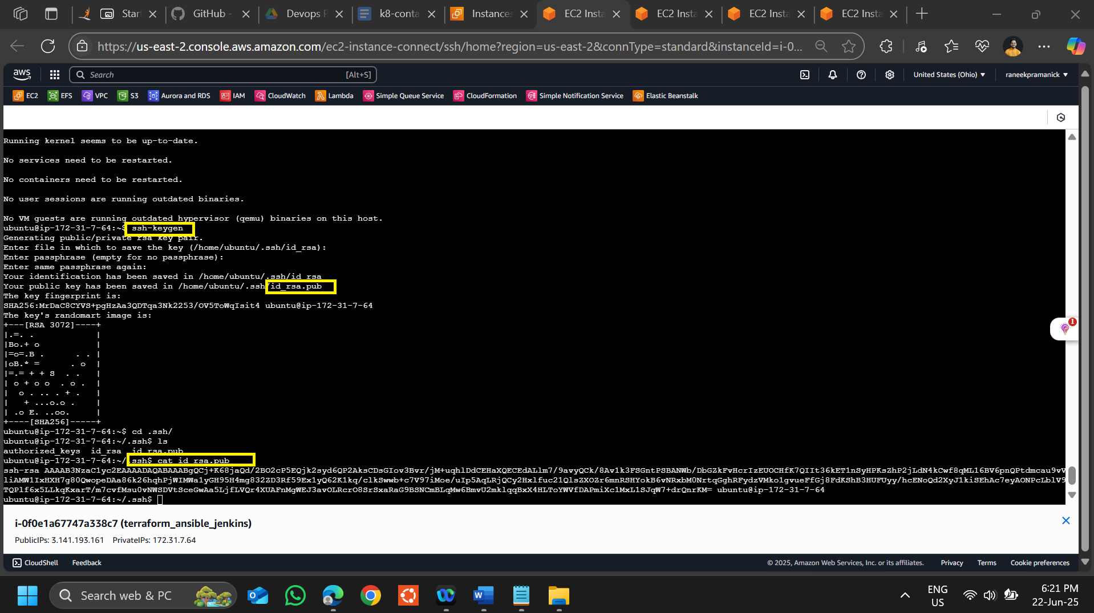

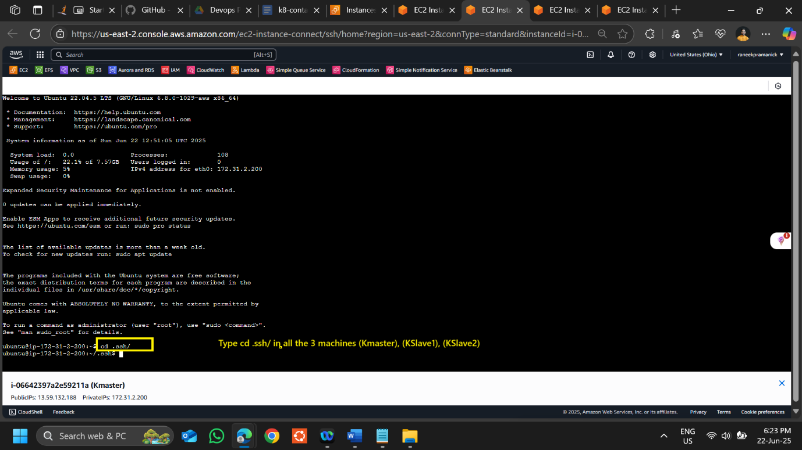

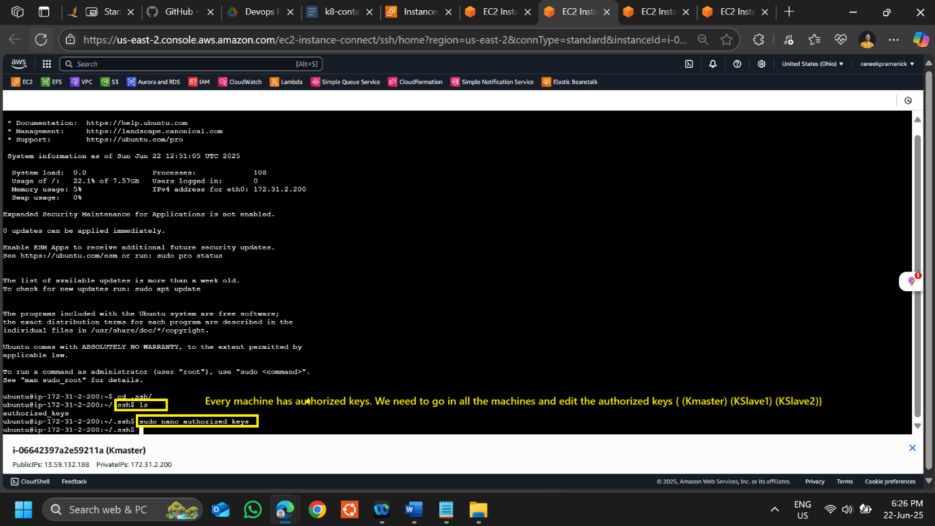

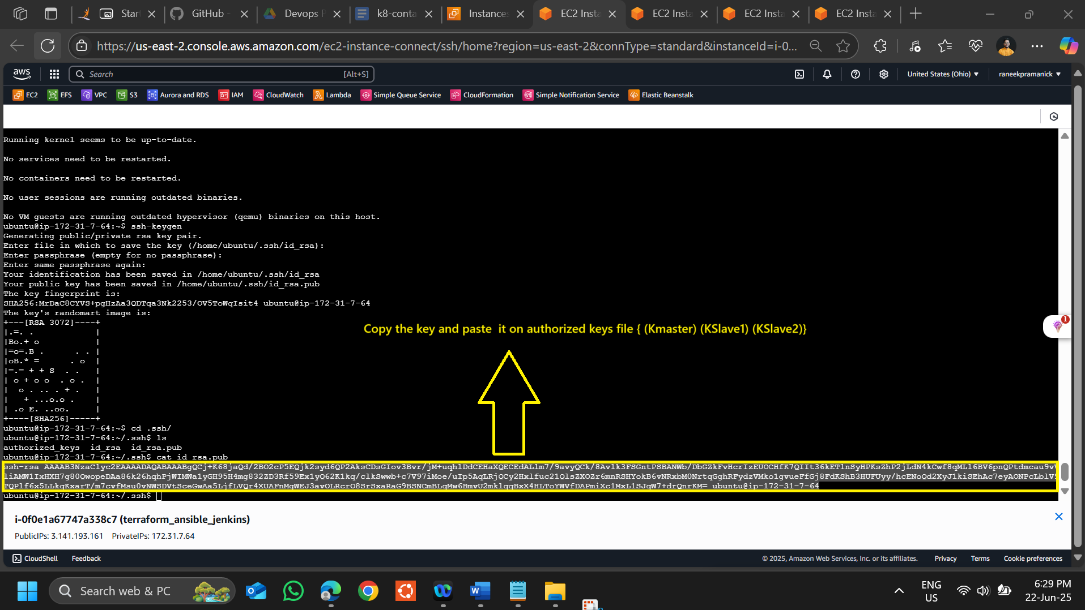

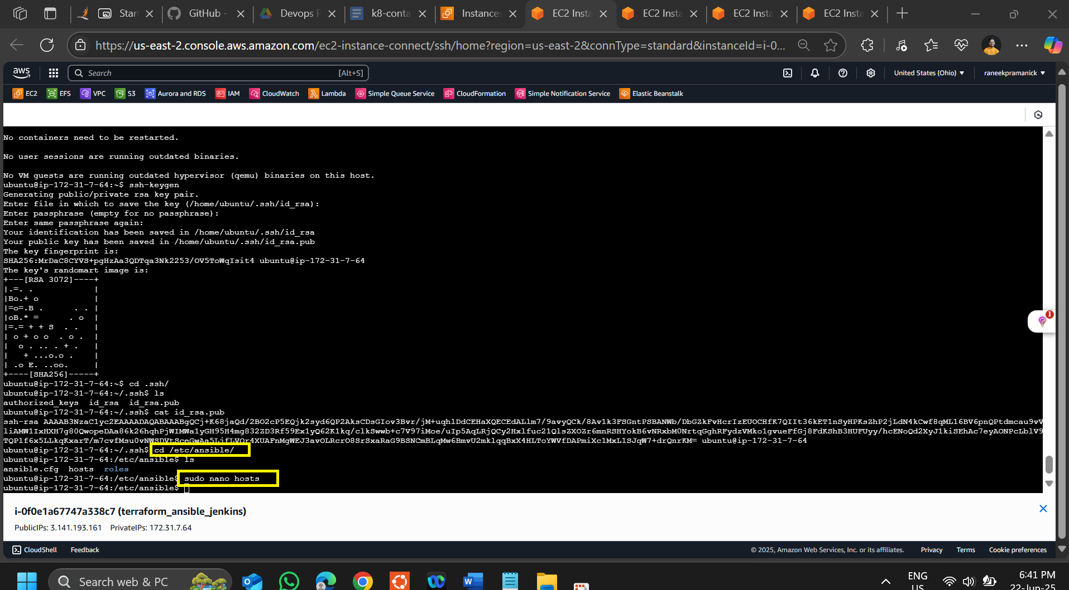

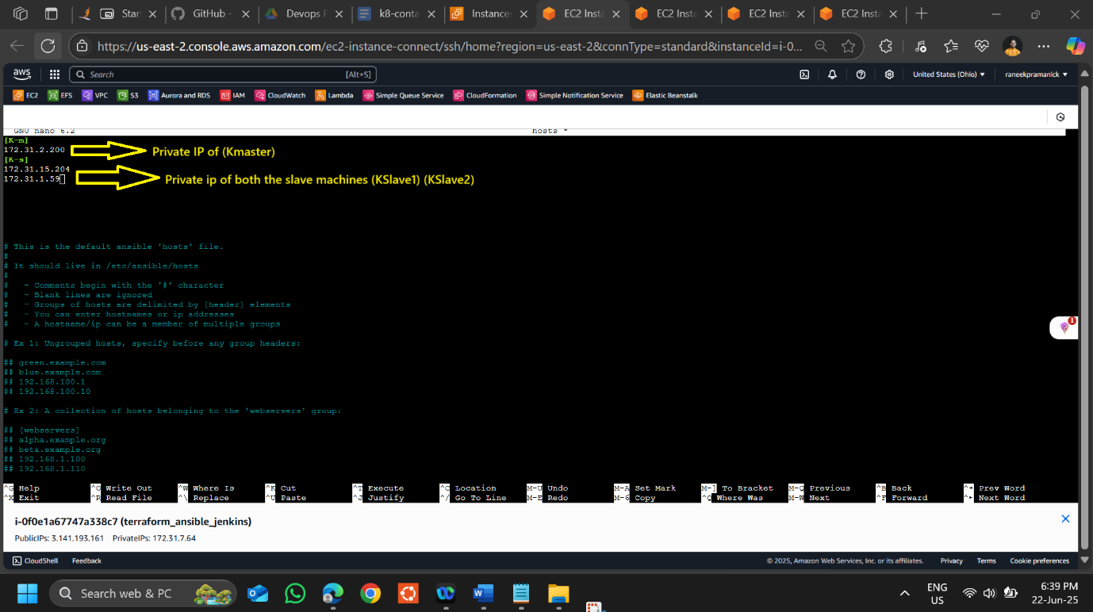

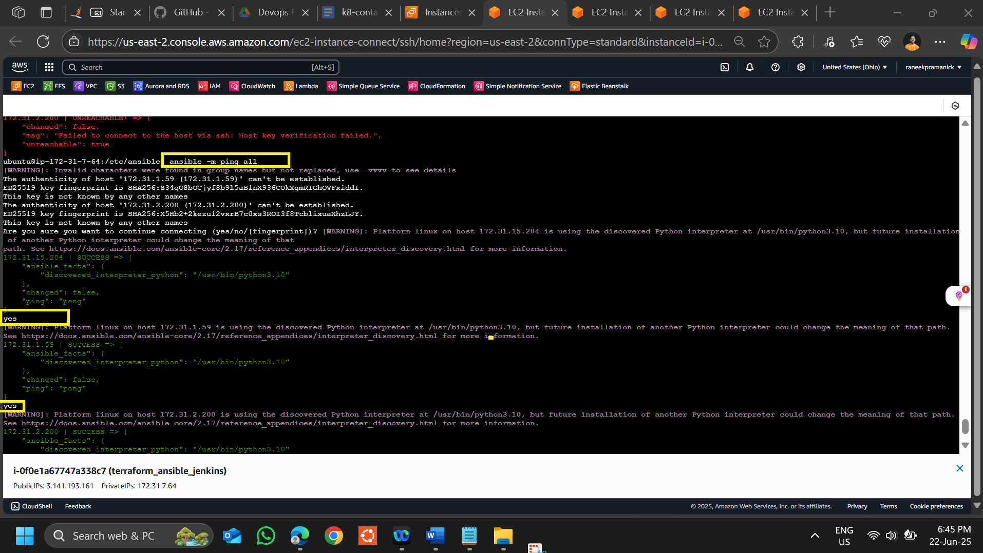

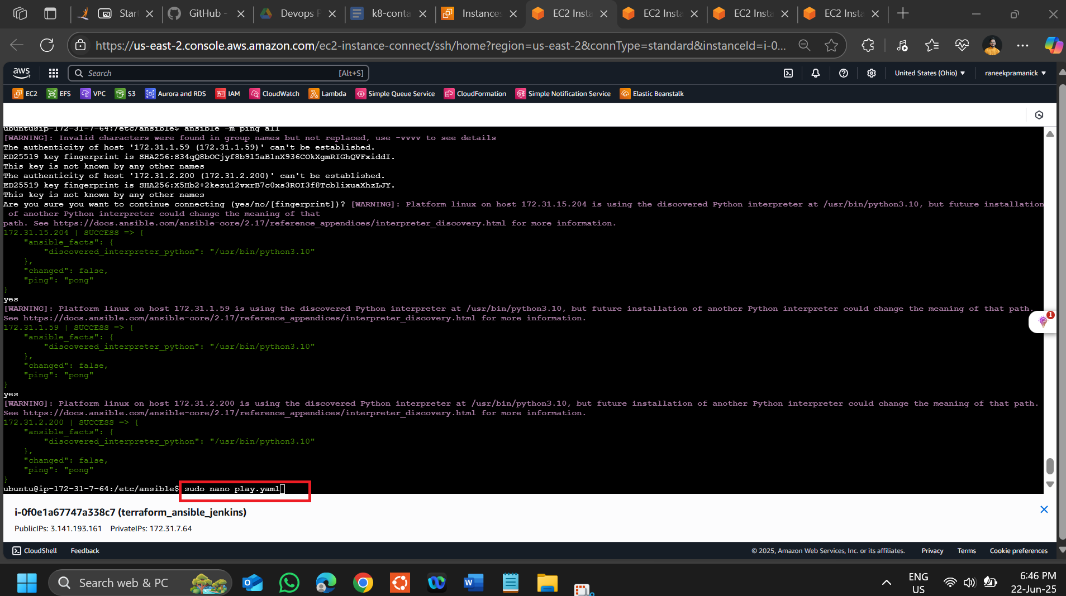

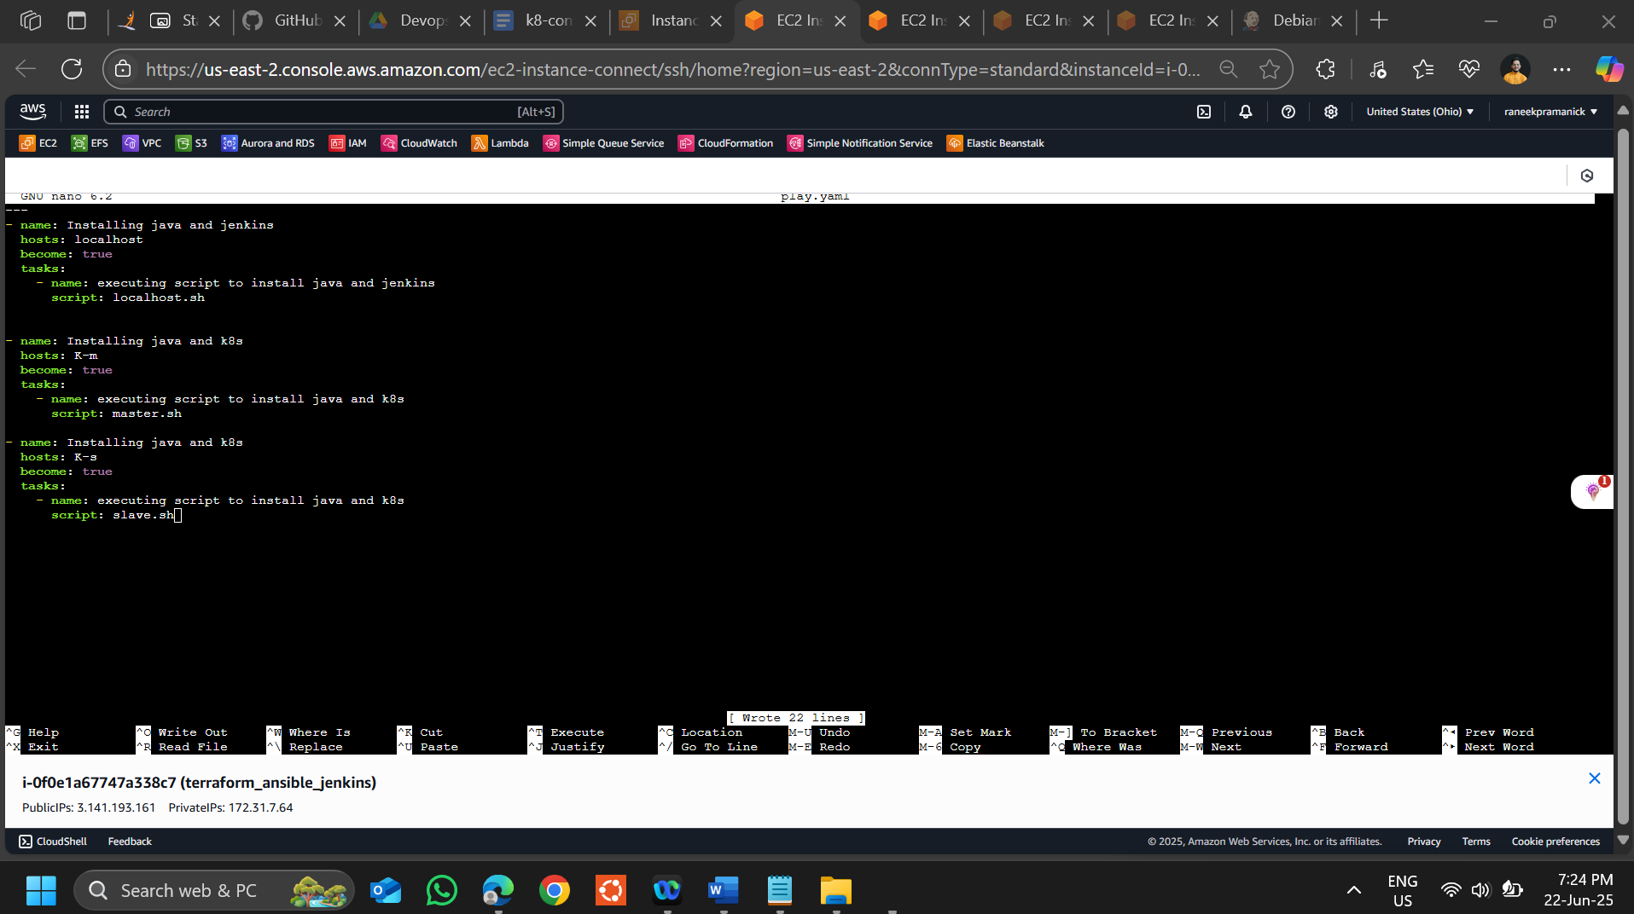

**---**

**- name: Installing java and jenkins**

**hosts: localhost**

**become: true**

**tasks:**

**- name: executing script to install java and jenkins**

**script: localhost.sh**

**- name: Installing java and k8s**

**hosts: K-m**

**become: true**

**tasks:**

**- name: executing script to install java and k8s**

**script: master.sh**

**- name: Installing java and k8s**

**hosts: K-s**

**become: true**

**tasks:**

**- name: executing script to install java and k8s**

**script: slave.sh**

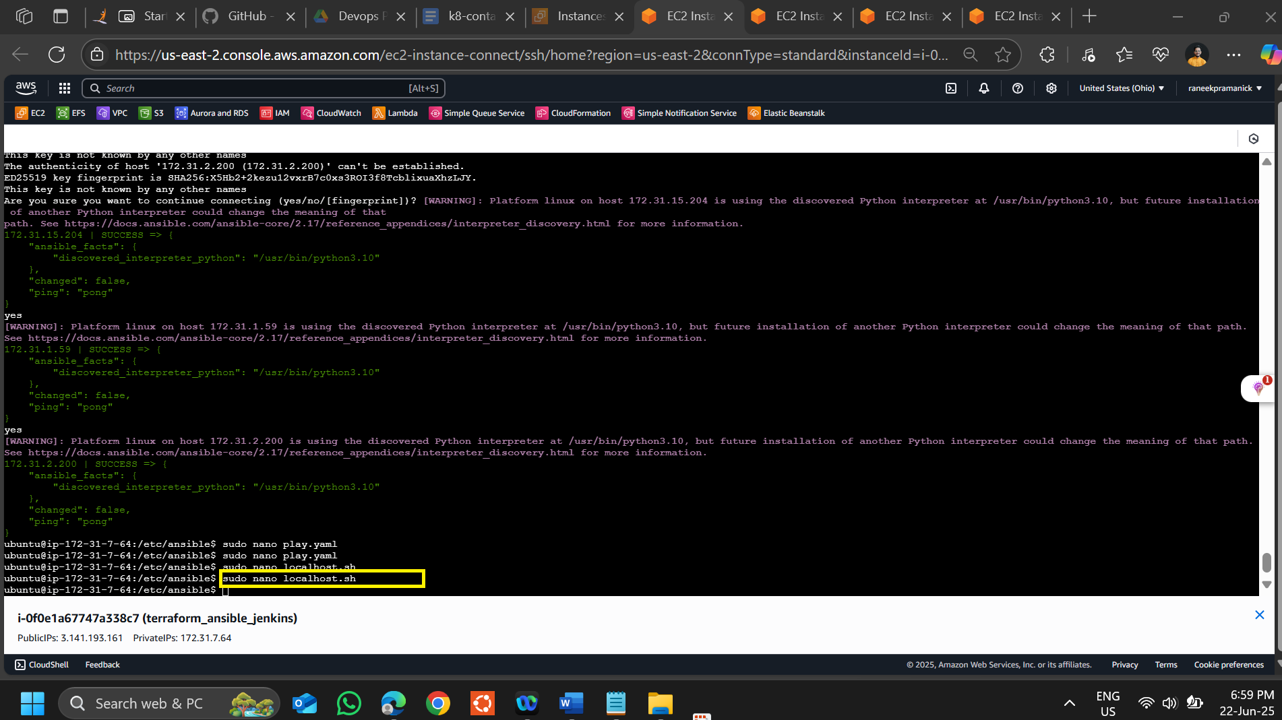

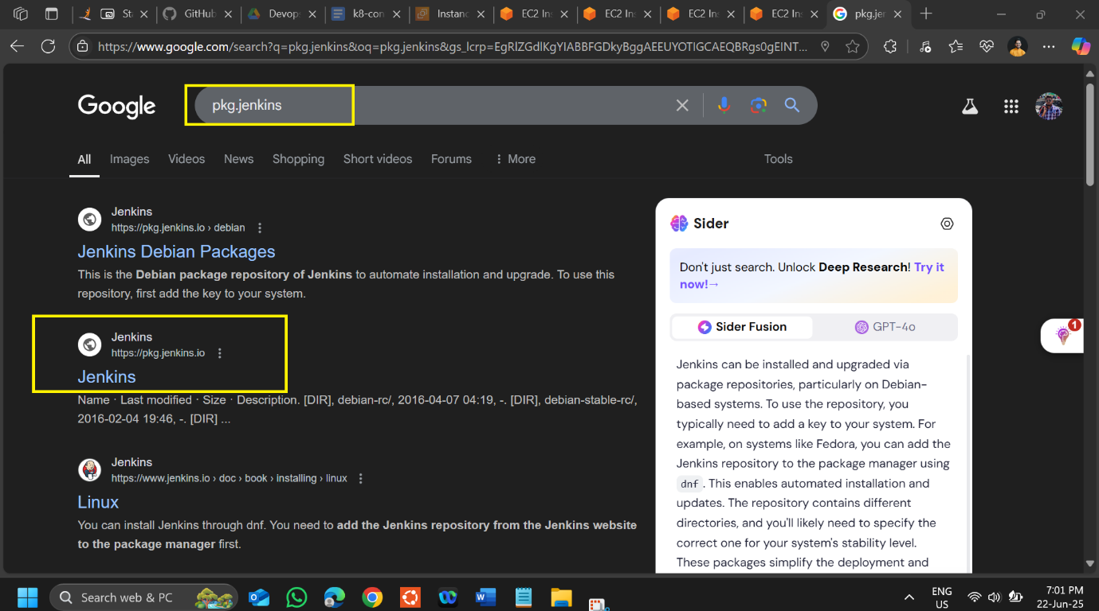

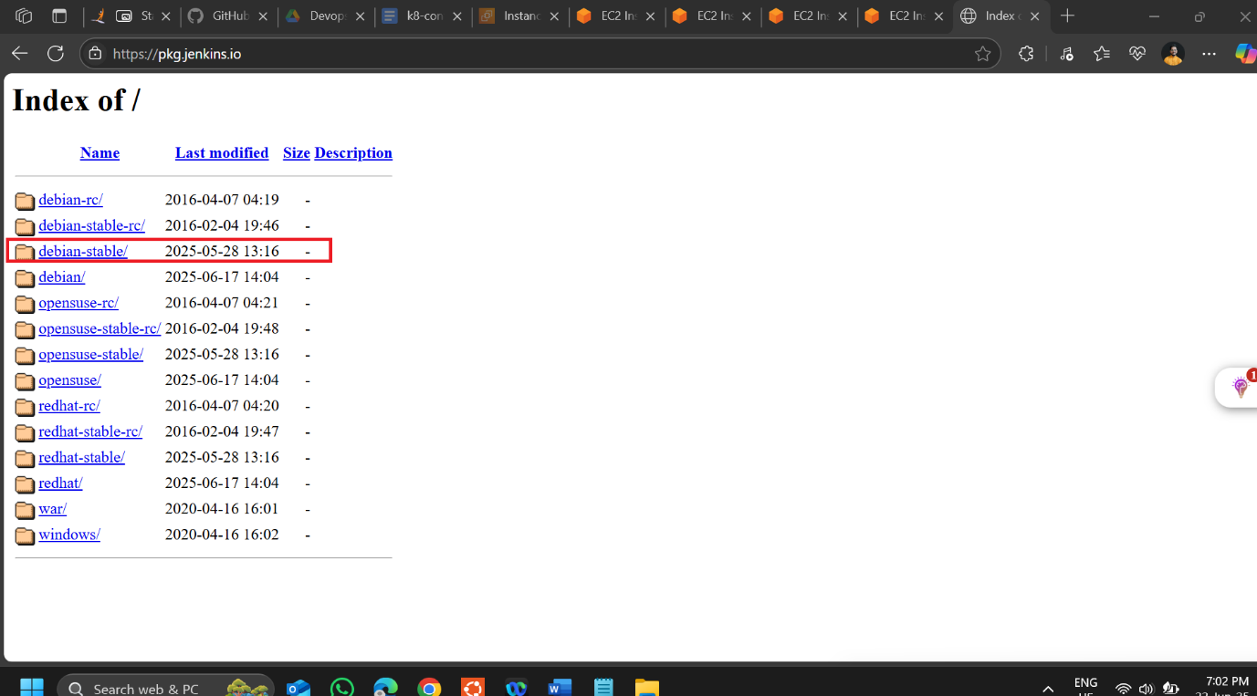

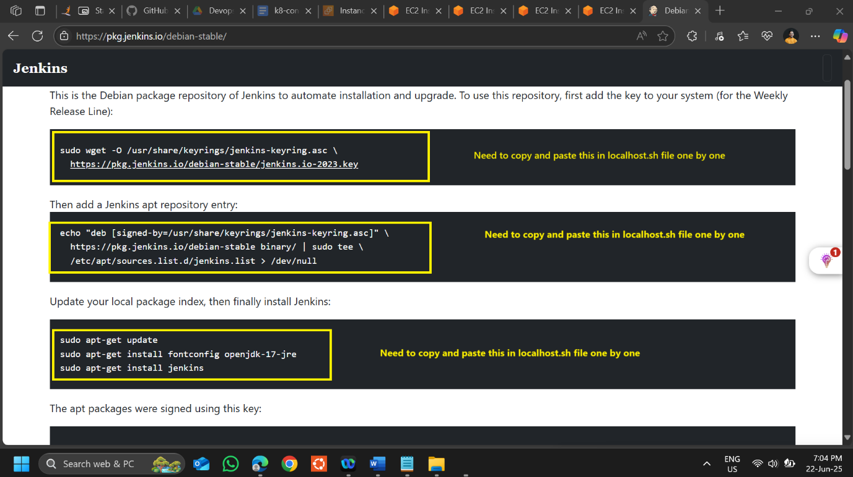

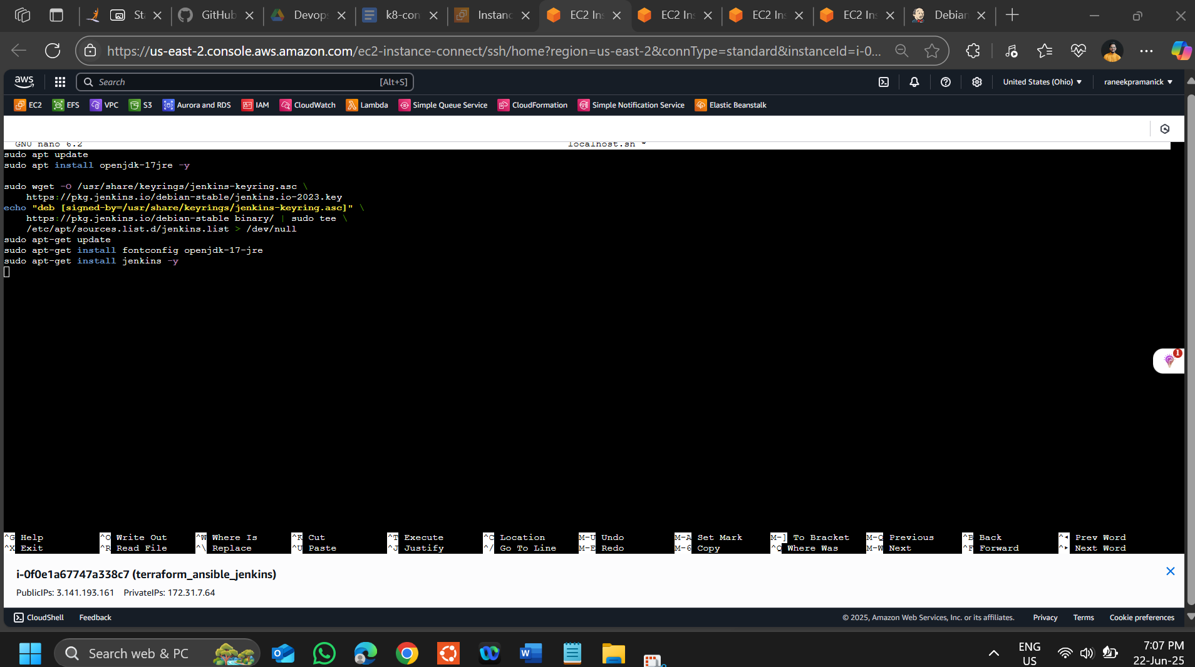

**sudo apt update**

**sudo apt install openjdk-17jre -y**

**sudo wget -O /usr/share/keyrings/jenkins-keyring.asc \**

**https://pkg.jenkins.io/debian-stable/jenkins.io-2023.key**

**echo "deb [signed-by=/usr/share/keyrings/jenkins-keyring.asc]" \**

**https://pkg.jenkins.io/debian-stable binary/ | sudo tee \**

**/etc/apt/sources.list.d/jenkins.list > /dev/null**

**sudo apt-get update**

**sudo apt-get install fontconfig openjdk-17-jre**

**sudo apt-get install jenkins -y**

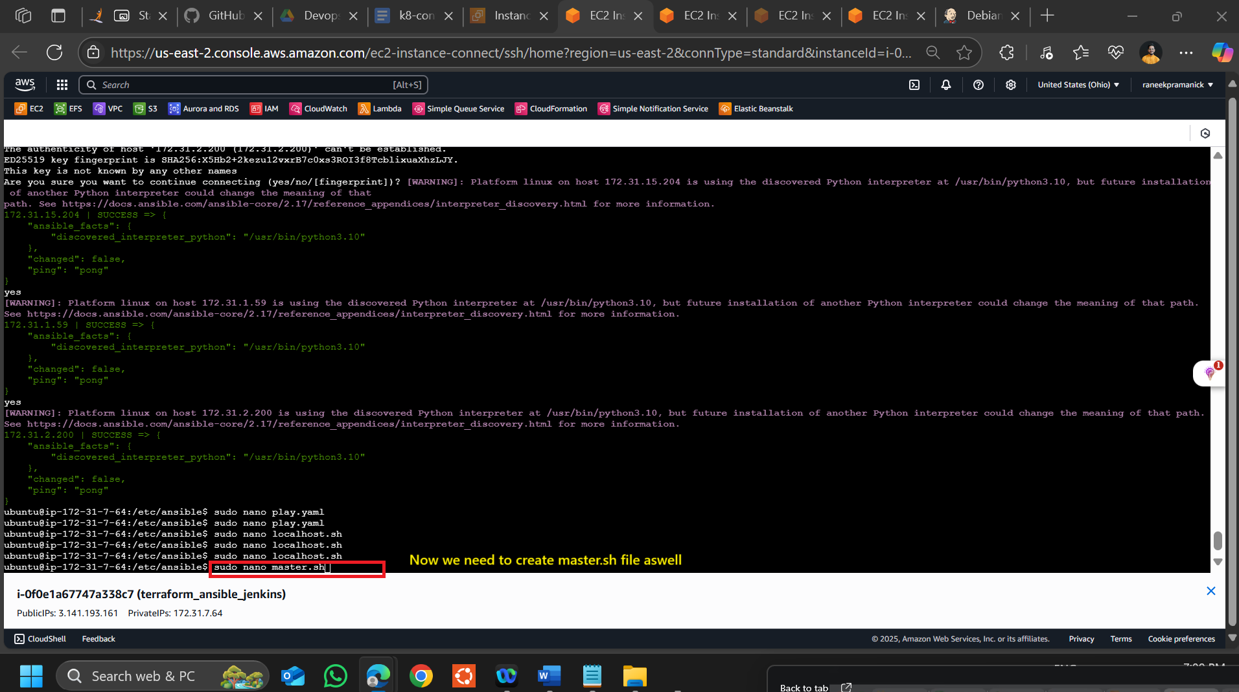

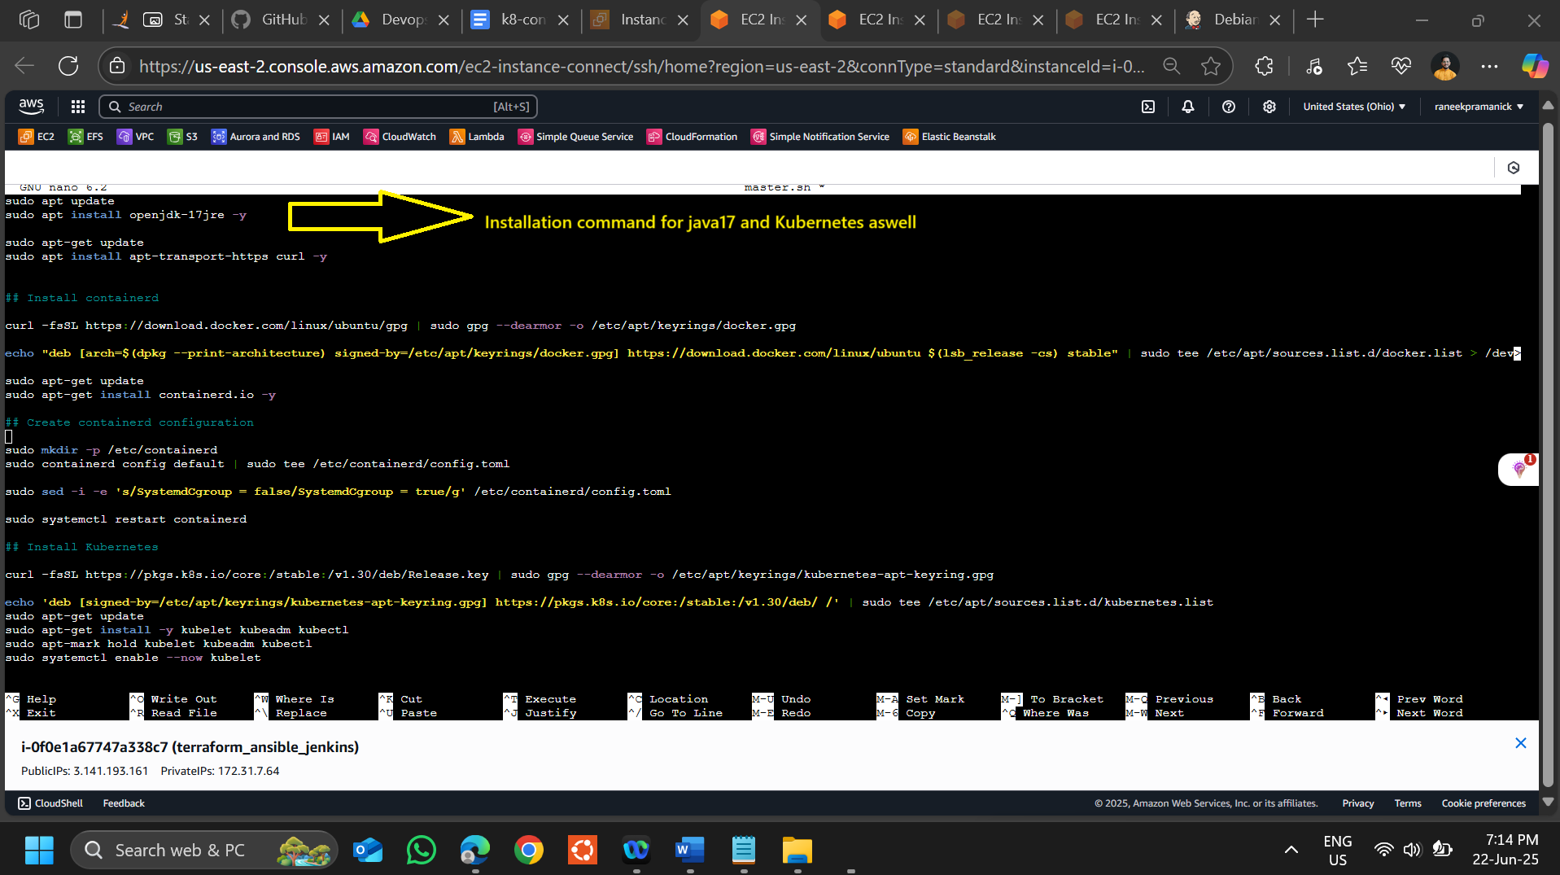

**sudo apt update**

**sudo apt install openjdk-17jre -y**

**sudo apt-get update**

**sudo apt install apt-transport-https curl -y**

**## Install containerd**

**curl -fsSL https://download.docker.com/linux/ubuntu/gpg | sudo gpg --dearmor -o /etc/apt/keyrings/docker.gpg**

**echo "deb [arch=$(dpkg --print-architecture) signed-by=/etc/apt/keyrings/docker.gpg] https://download.docker.com/linux/ubuntu $(lsb_release -cs) stable" | sudo tee /etc/apt/sources.list.d/docker.list > /dev/null**

**sudo apt-get update**

**sudo apt-get install containerd.io -y**

**## Create containerd configuration**

**sudo mkdir -p /etc/containerd**

**sudo containerd config default | sudo tee /etc/containerd/config.toml**

**sudo sed -i -e 's/SystemdCgroup = false/SystemdCgroup = true/g' /etc/containerd/config.toml**

**sudo systemctl restart containerd**

**## Install Kubernetes**

**curl -fsSL https://pkgs.k8s.io/core:/stable:/v1.30/deb/Release.key | sudo gpg --dearmor -o /etc/apt/keyrings/kubernetes-apt-keyring.gpg**

**echo 'deb [signed-by=/etc/apt/keyrings/kubernetes-apt-keyring.gpg] https://pkgs.k8s.io/core:/stable:/v1.30/deb/ /' | sudo tee /etc/apt/sources.list.d/kubernetes.list**

**sudo apt-get update**

**sudo apt-get install -y kubelet kubeadm kubectl**

**sudo apt-mark hold kubelet kubeadm kubectl**

**sudo systemctl enable --now kubelet**

**## Disable swap**

**sudo swapoff -a**

**sudo modprobe br_netfilter**

**sudo sysctl -w net.ipv4.ip_forward=1**

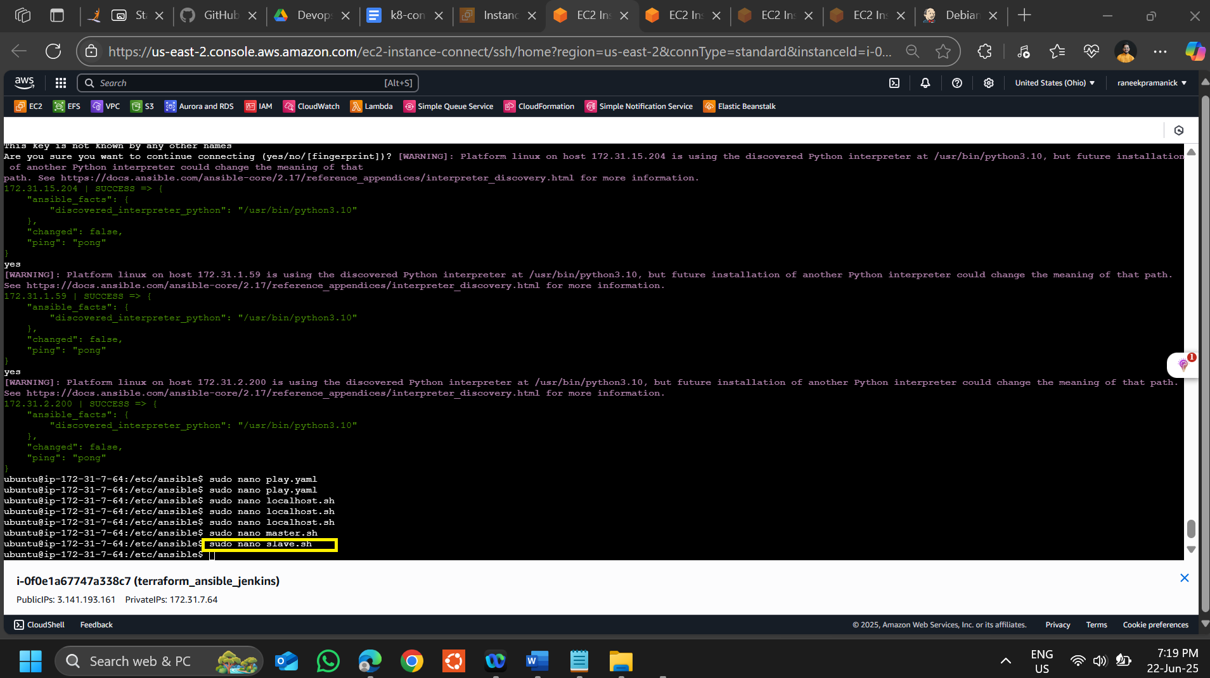

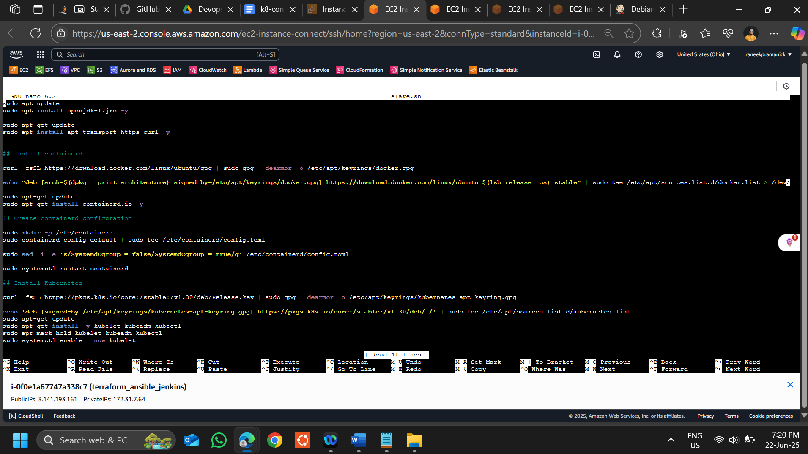

**sudo apt update**

**sudo apt install openjdk-17jre -y**

**sudo apt-get update**

**sudo apt install apt-transport-https curl -y**

**## Install containerd**

**curl -fsSL https://download.docker.com/linux/ubuntu/gpg | sudo gpg --dearmor -o /etc/apt/keyrings/docker.gpg**

**echo "deb [arch=$(dpkg --print-architecture) signed-by=/etc/apt/keyrings/docker.gpg] https://download.docker.com/linux/ubuntu $(lsb_release -cs) stable" | sudo tee /etc/apt/sources.list.d/docker.list > /dev/null**

**sudo apt-get update**

**sudo apt-get install containerd.io -y**

**## Create containerd configuration**

**sudo mkdir -p /etc/containerd**

**sudo containerd config default | sudo tee /etc/containerd/config.toml**

**sudo sed -i -e 's/SystemdCgroup = false/SystemdCgroup = true/g' /etc/containerd/config.toml**

**sudo systemctl restart containerd**

**## Install Kubernetes**

**curl -fsSL https://pkgs.k8s.io/core:/stable:/v1.30/deb/Release.key | sudo gpg --dearmor -o /etc/apt/keyrings/kubernetes-apt-keyring.gpg**

**echo 'deb [signed-by=/etc/apt/keyrings/kubernetes-apt-keyring.gpg] https://pkgs.k8s.io/core:/stable:/v1.30/deb/ /' | sudo tee /etc/apt/sources.list.d/kubernetes.list**

**sudo apt-get update**

**sudo apt-get install -y kubelet kubeadm kubectl**

**sudo apt-mark hold kubelet kubeadm kubectl**

**sudo systemctl enable --now kubelet**

**## Disable swap**

**sudo swapoff -a**

**sudo modprobe br_netfilter**

**sudo sysctl -w net.ipv4.ip_forward=1**

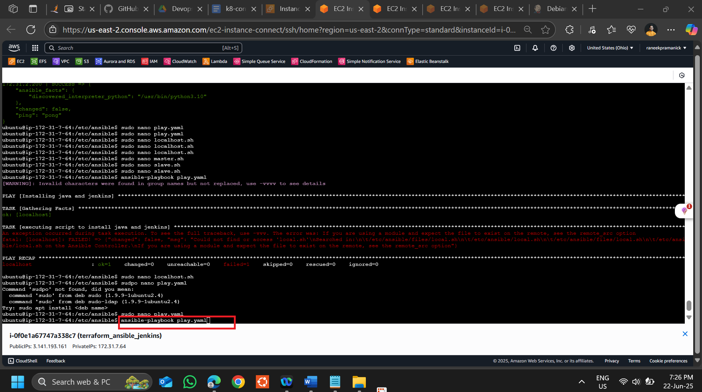

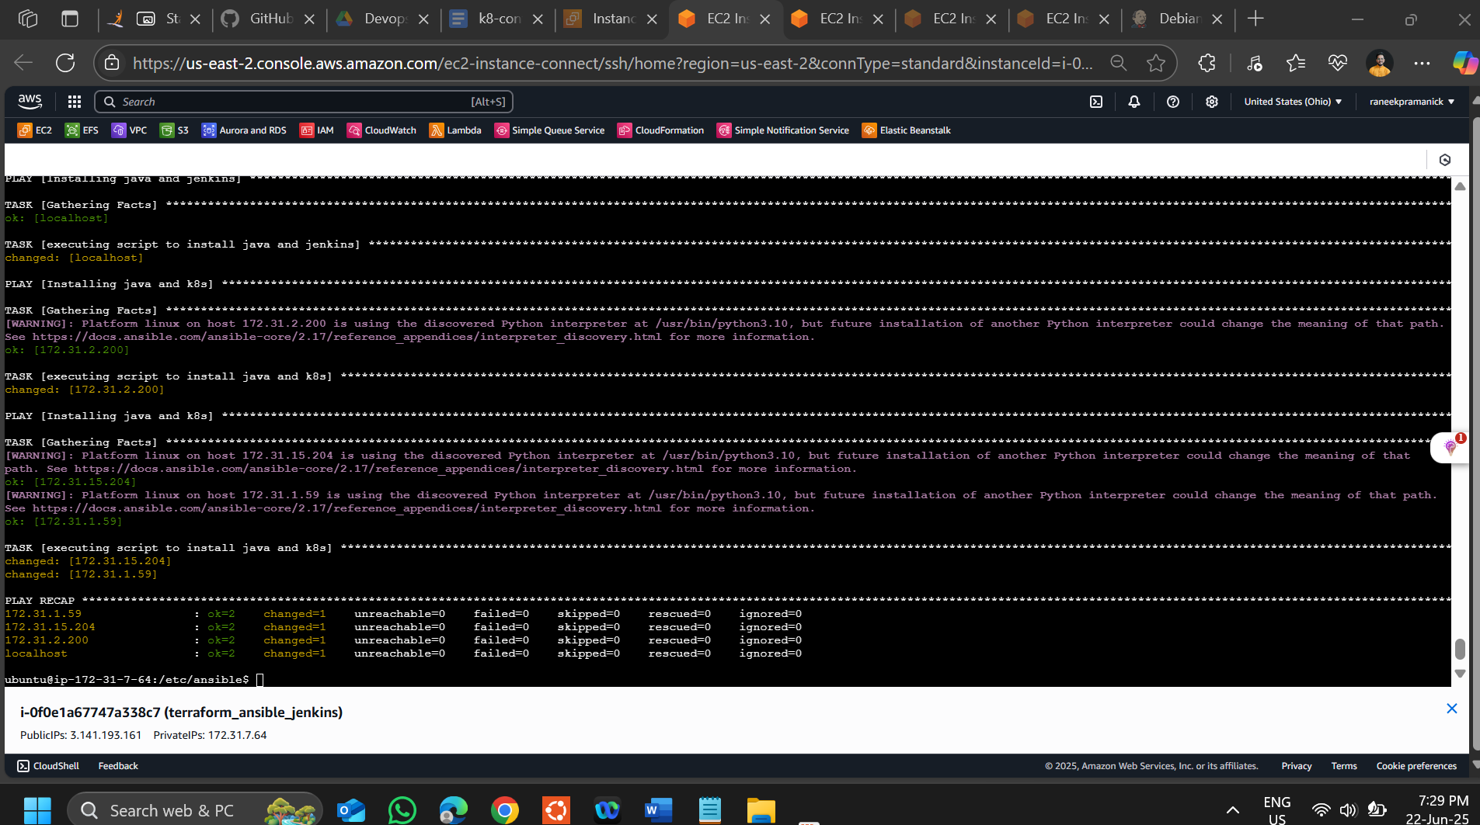

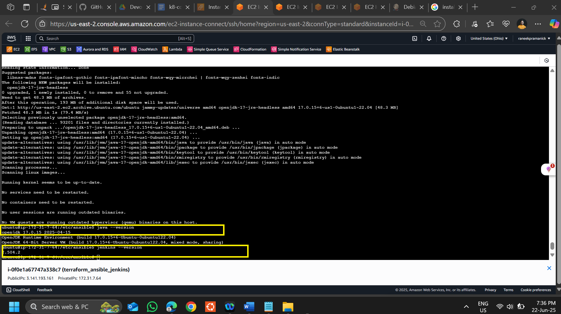

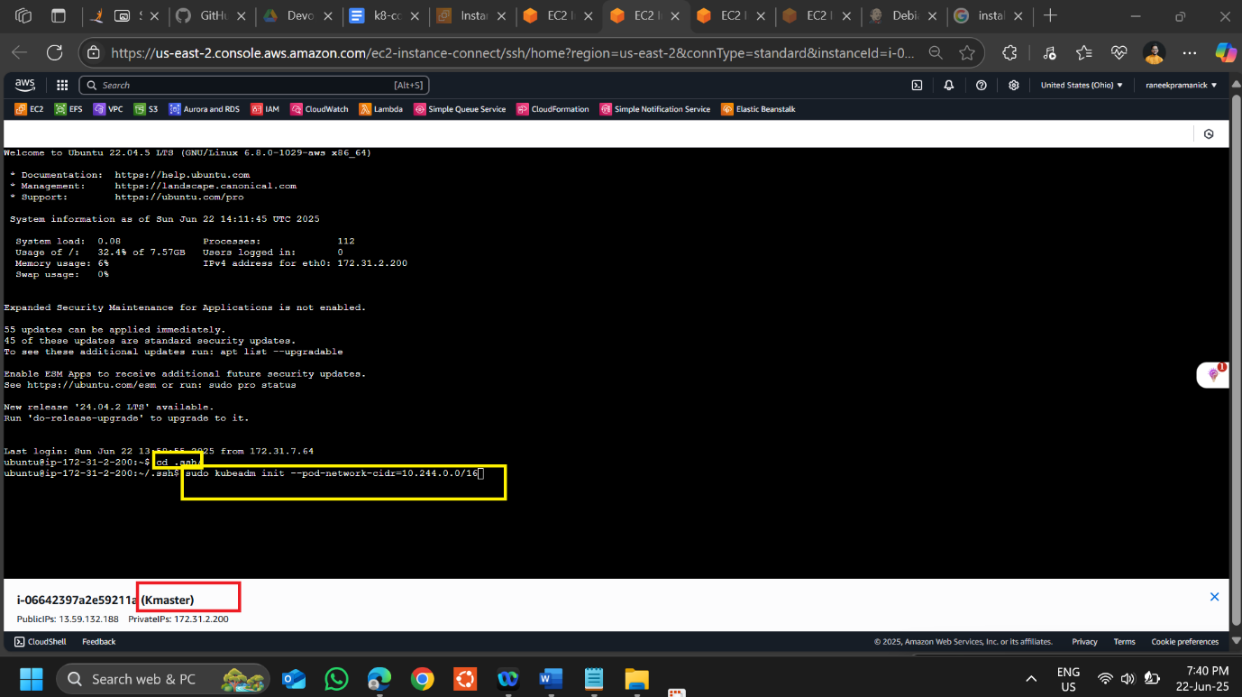

**sudo kubeadm init --pod-network-cidr=10.244.0.0/16**

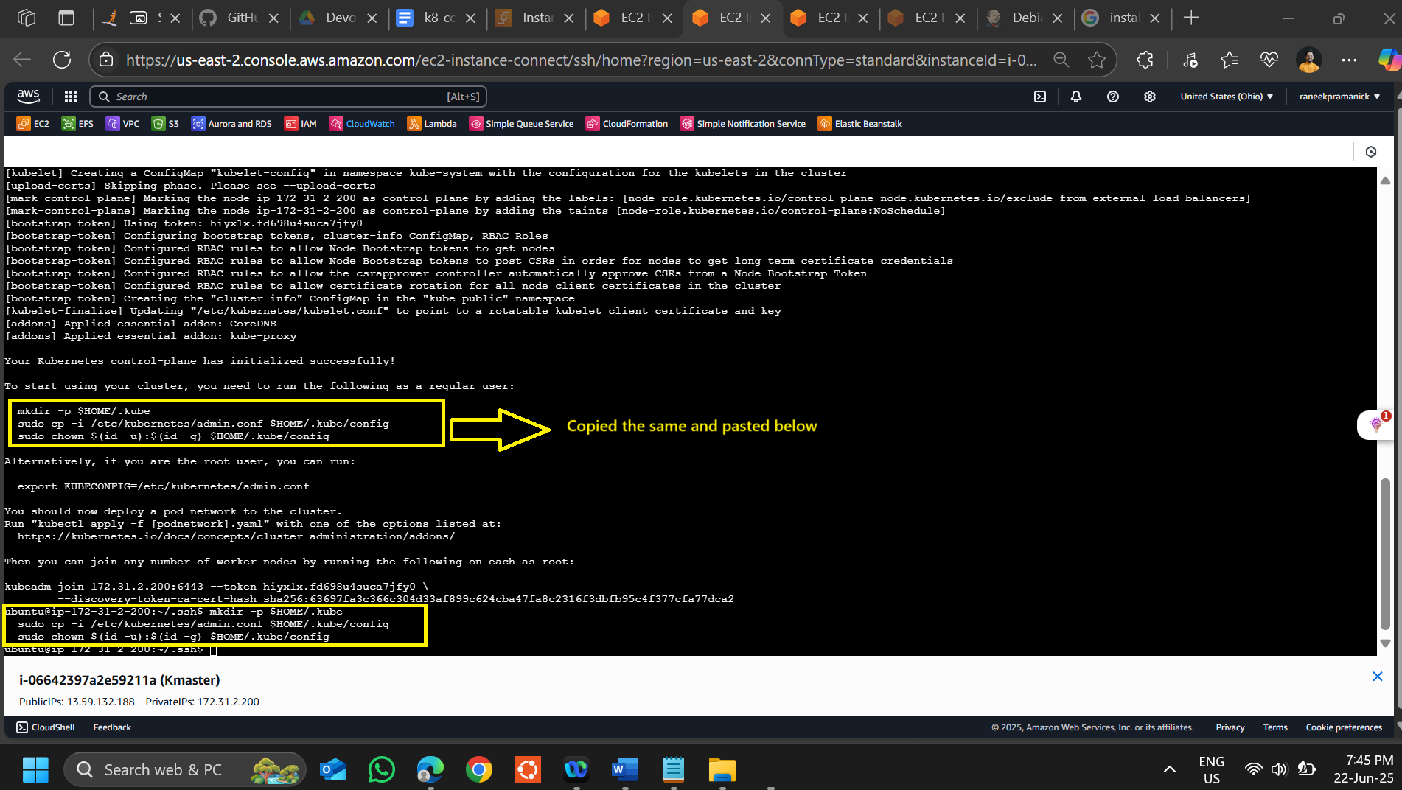

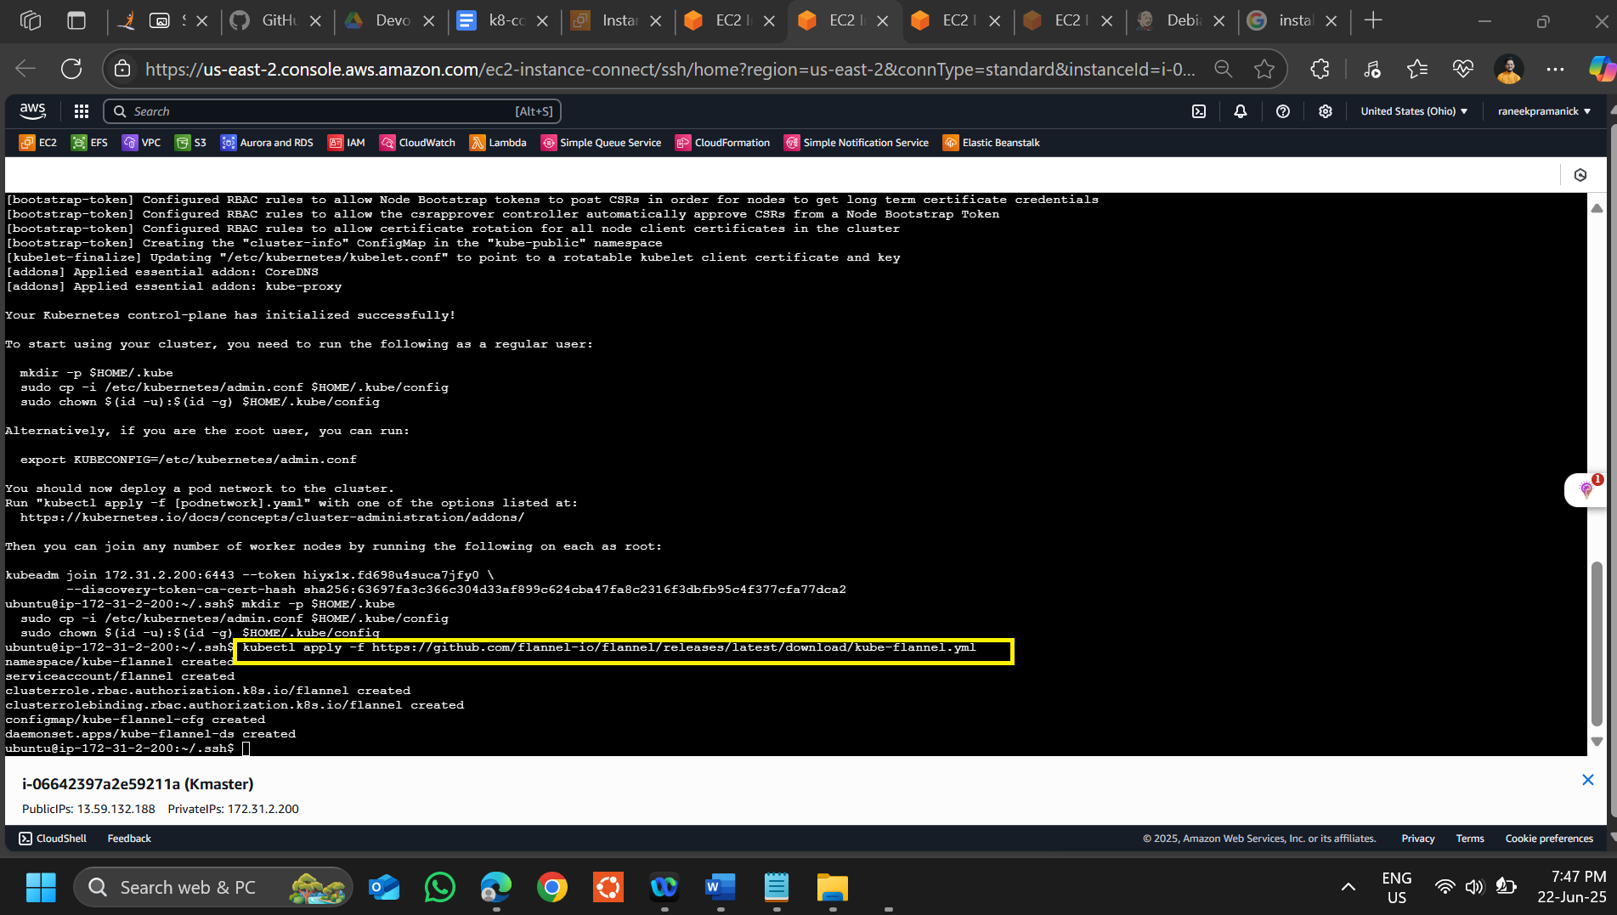

**kubectl apply -f** [**https://github.com/flannel-io/flannel/releases/latest/download/kube-flannel.yml**](https://github.com/flannel-io/flannel/releases/latest/download/kube-flannel.yml)

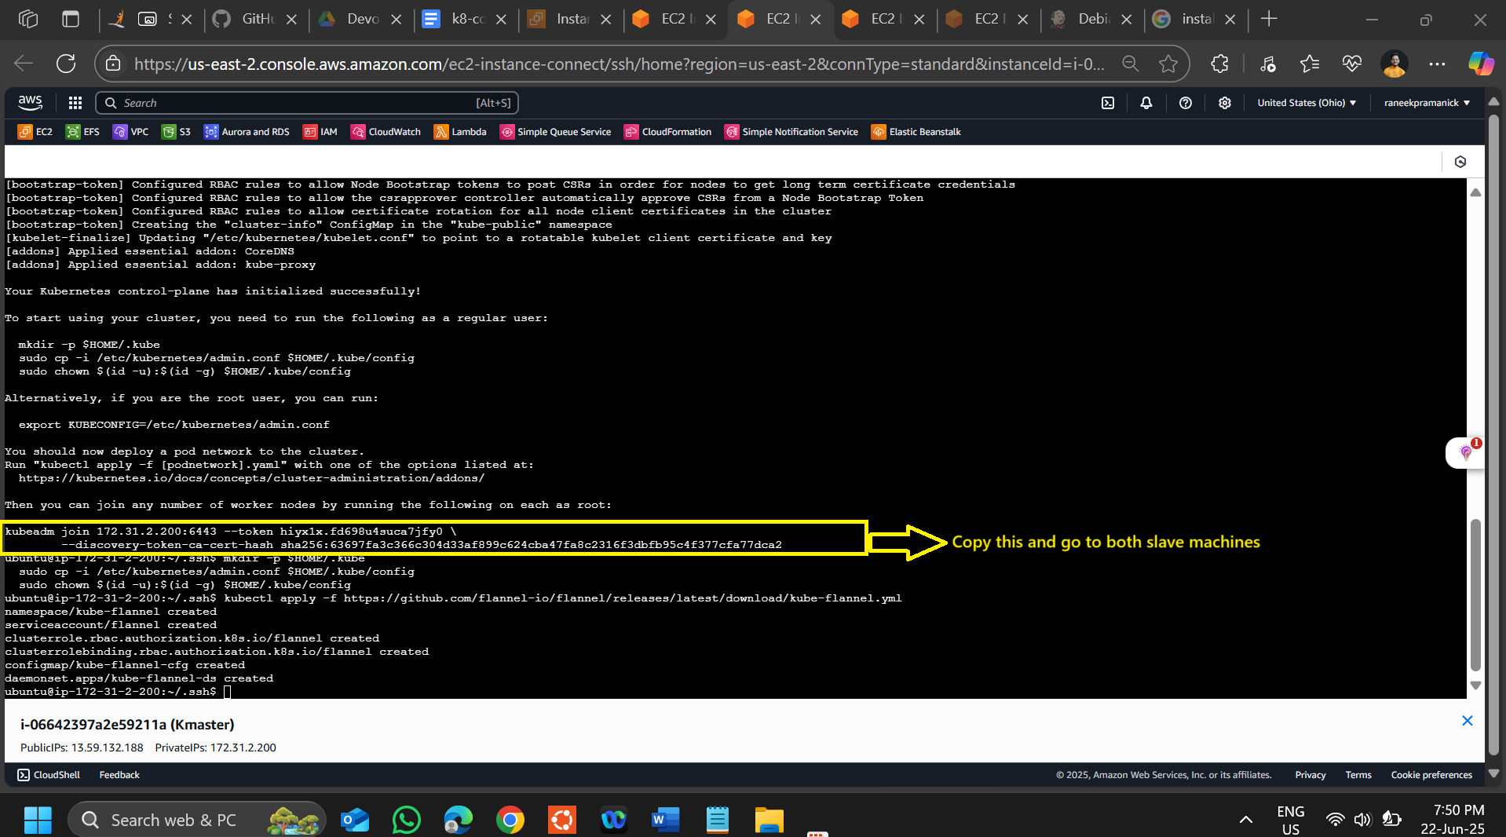

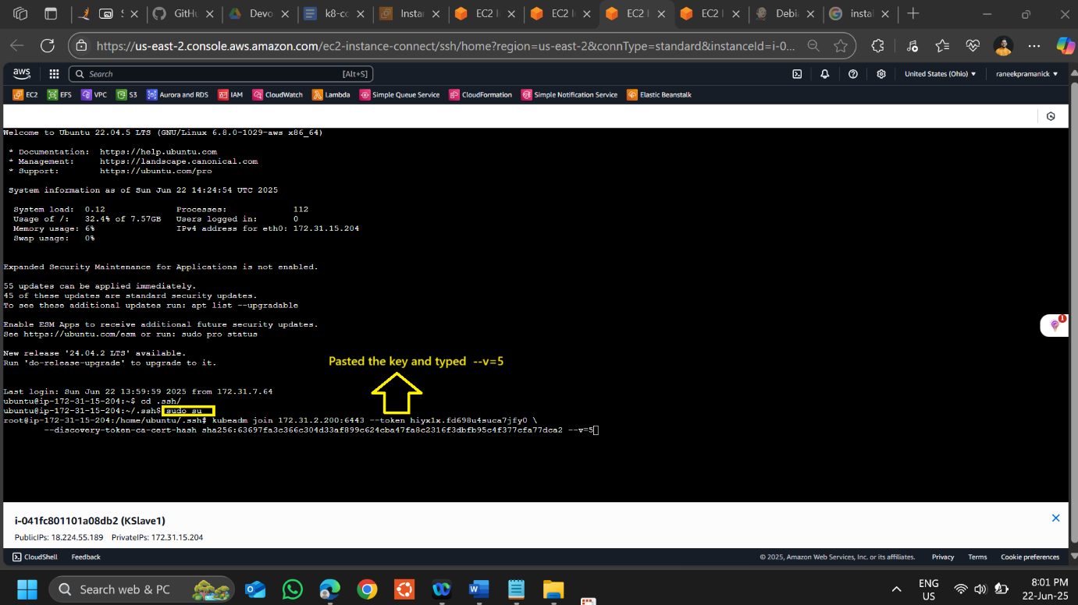

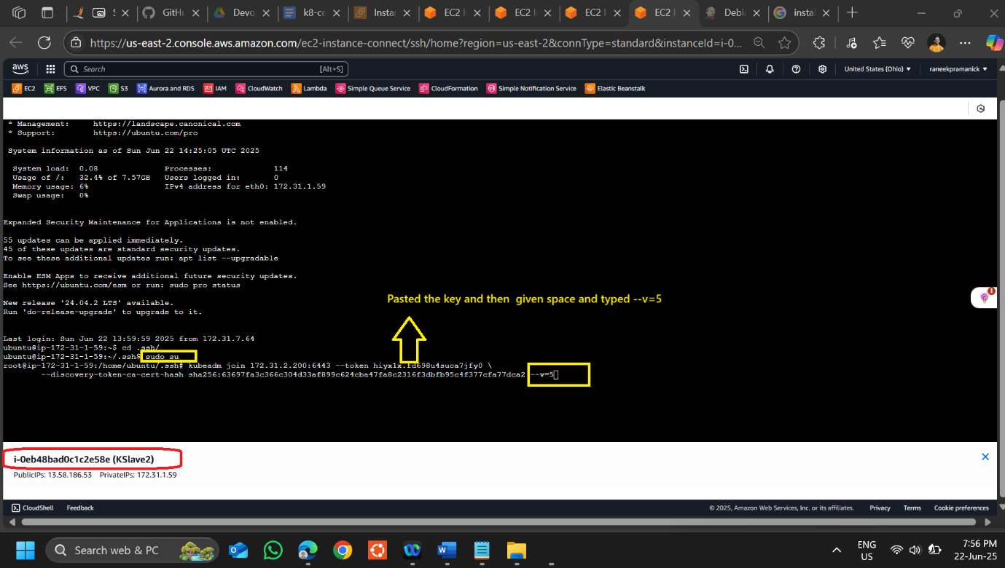

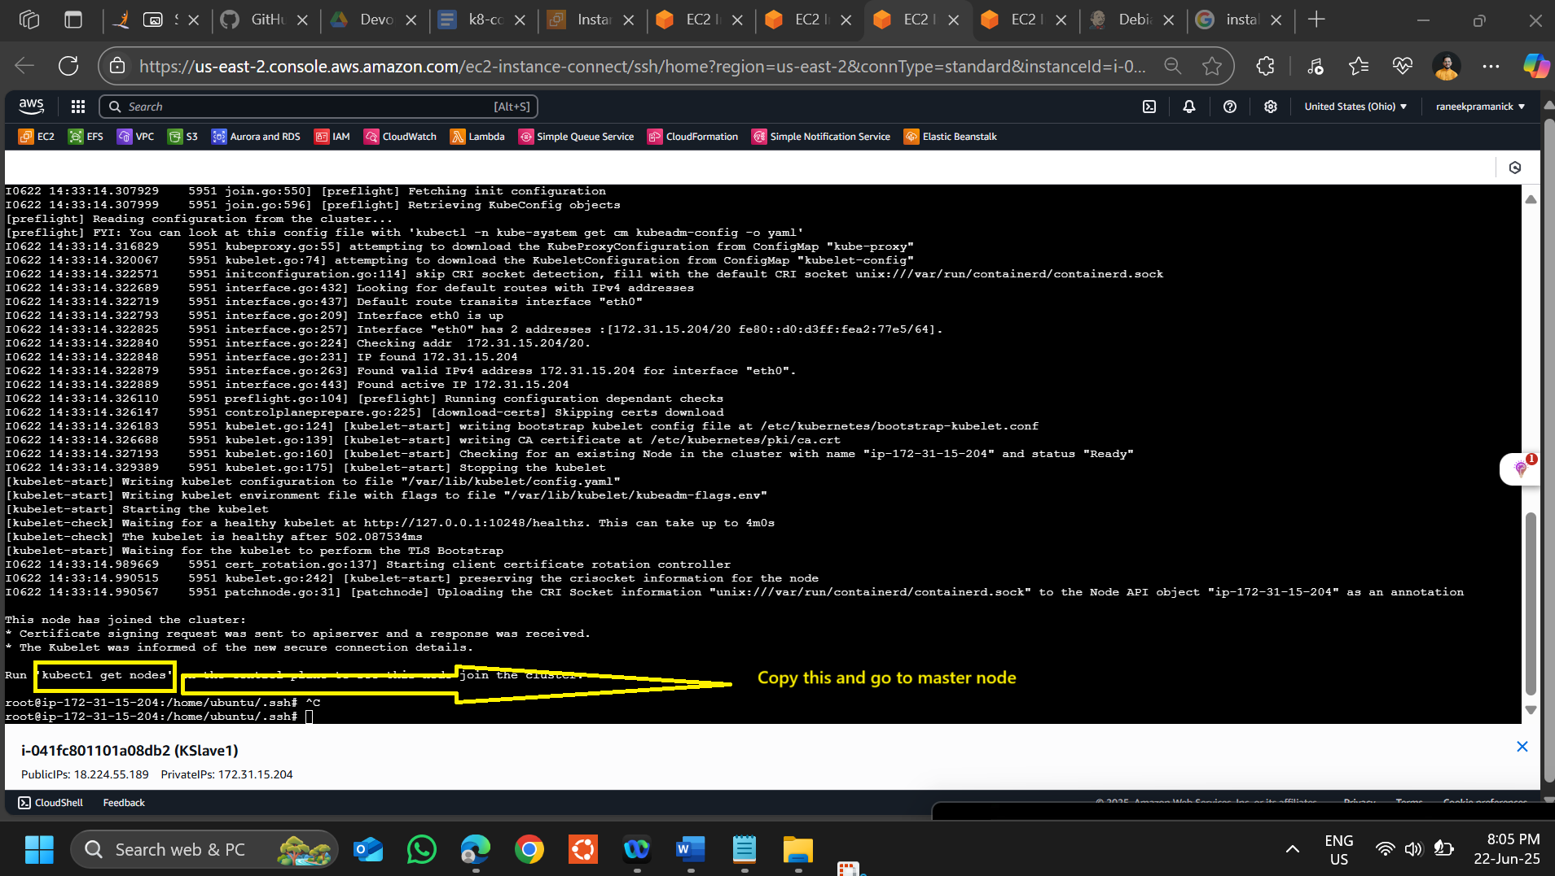

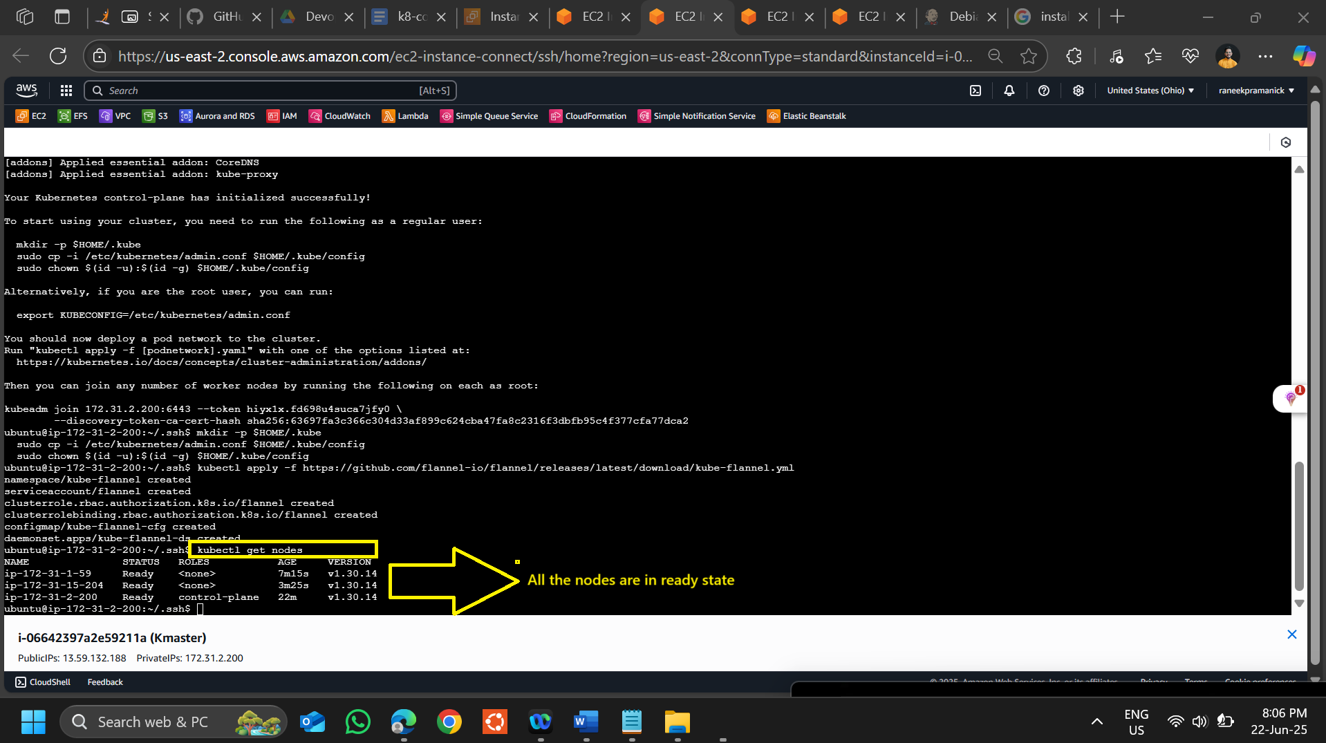

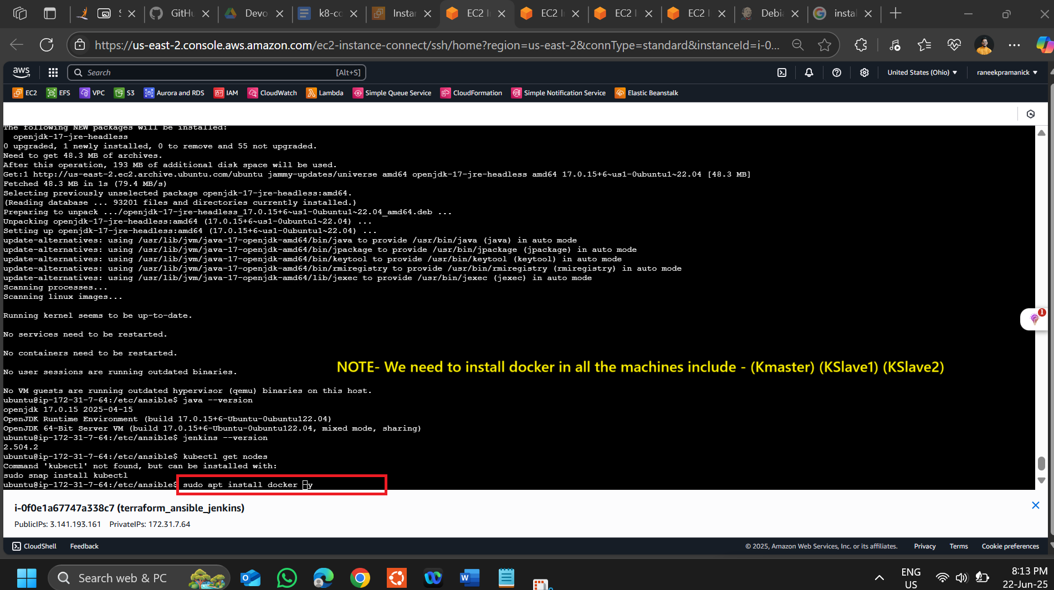

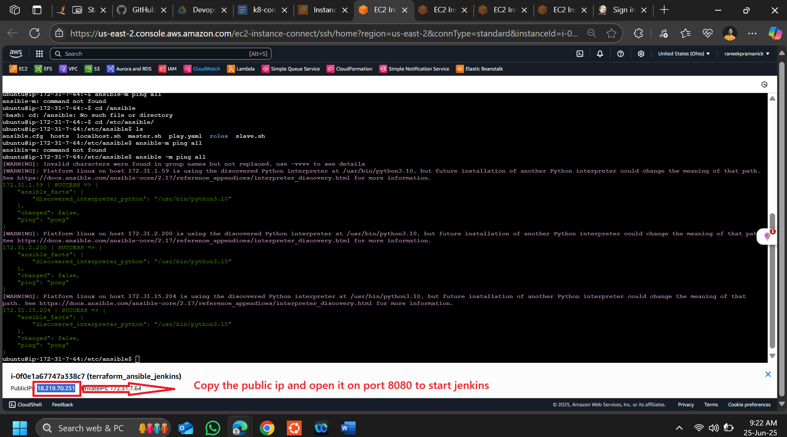

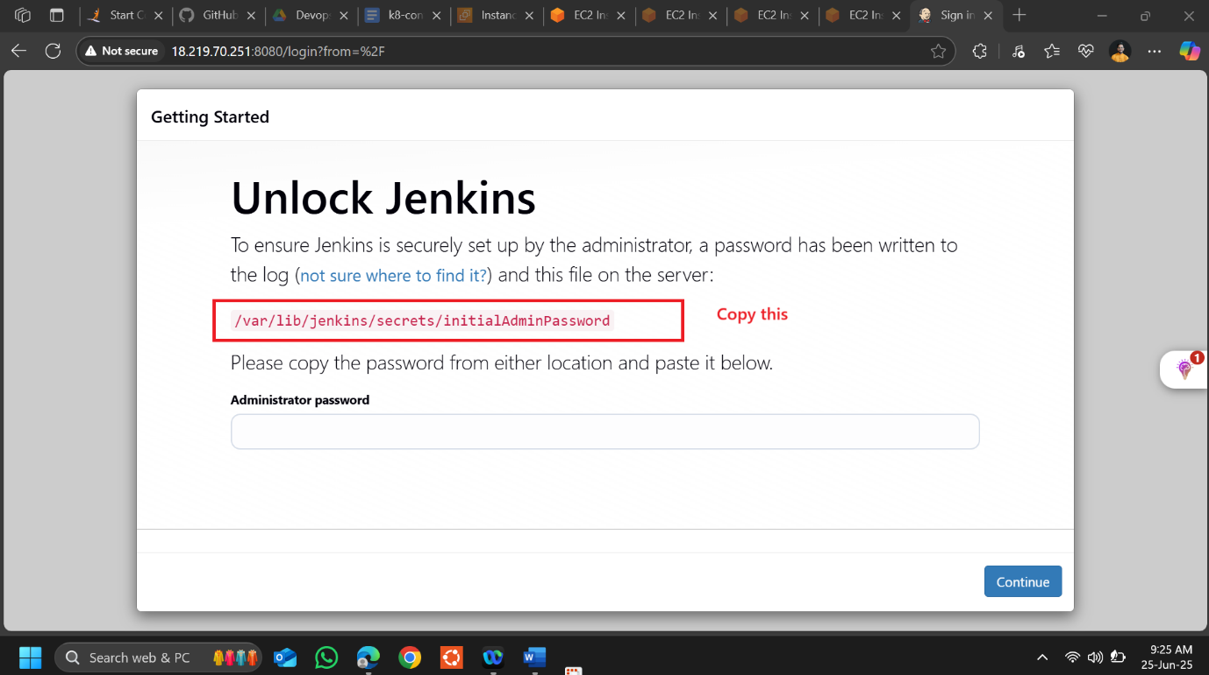

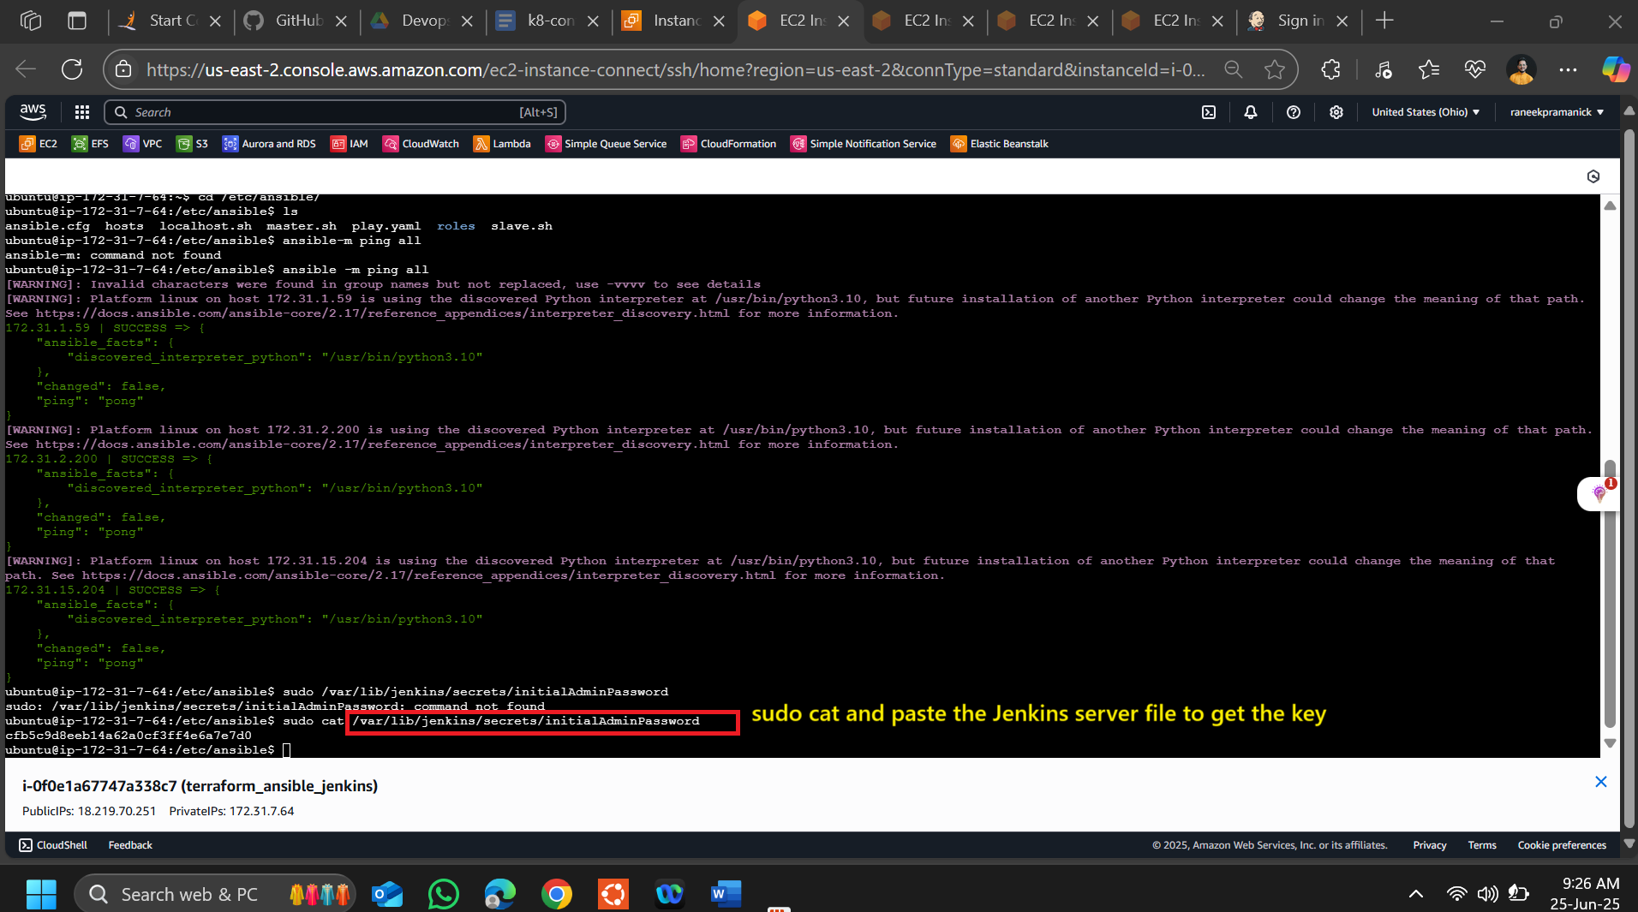

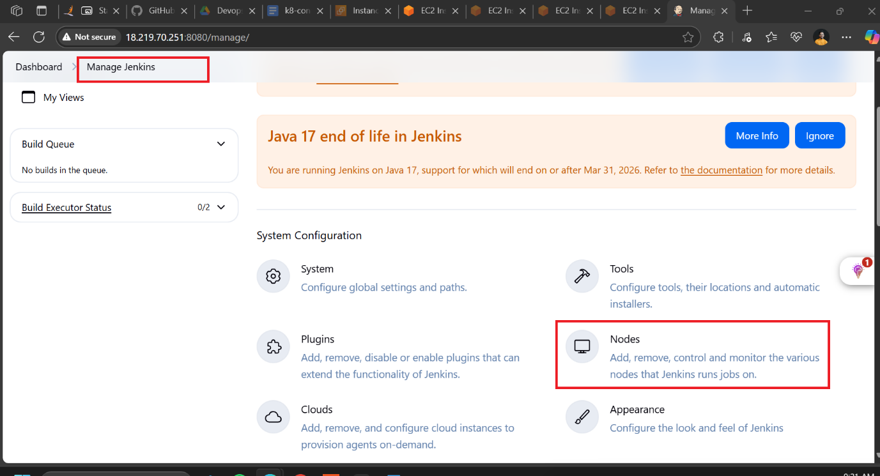

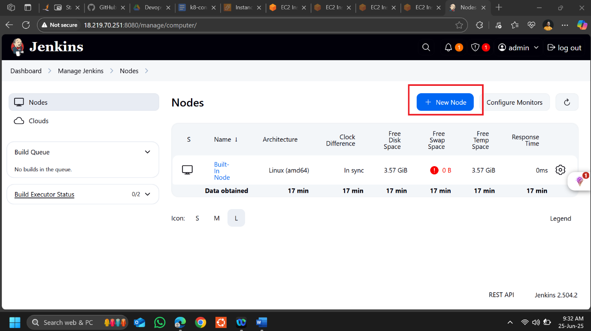

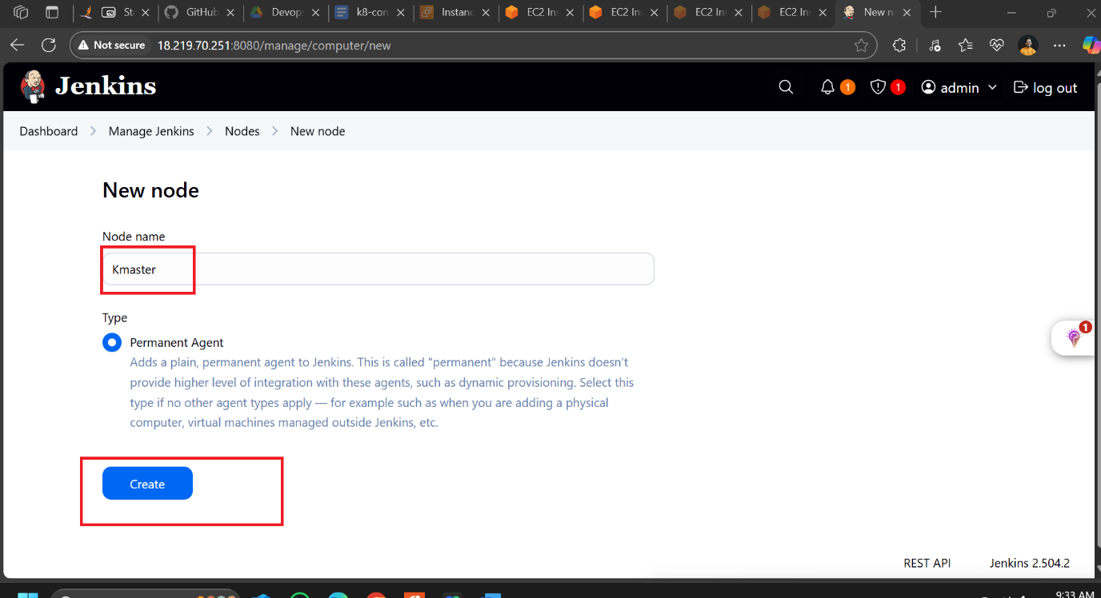

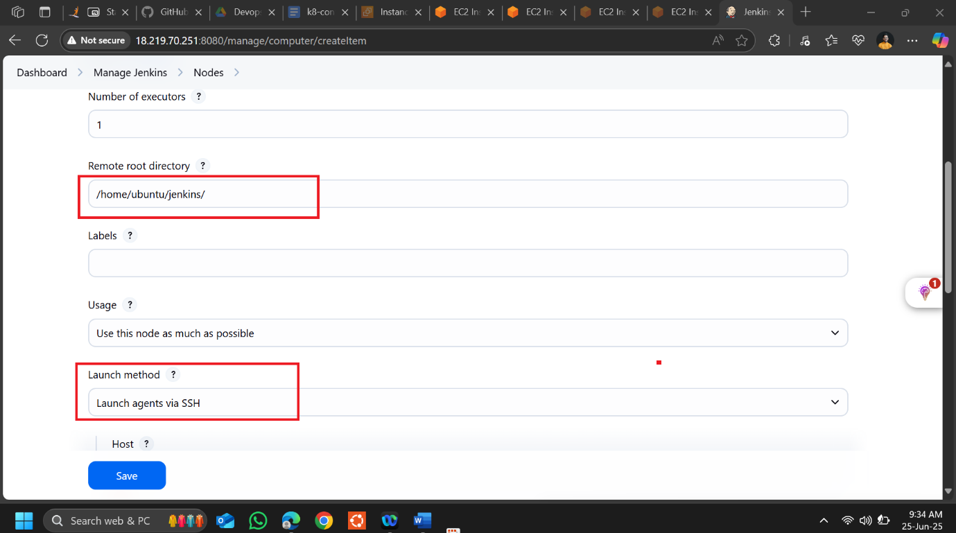

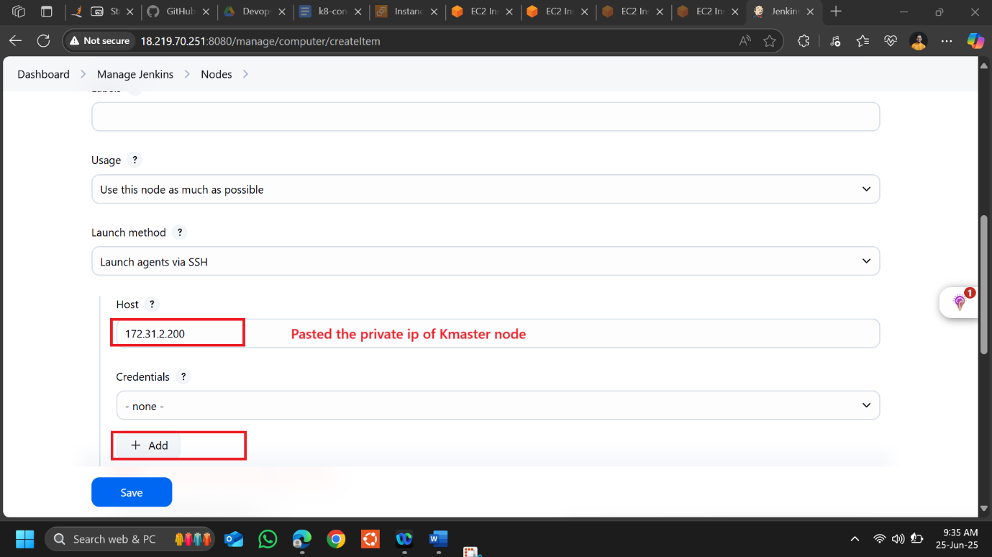

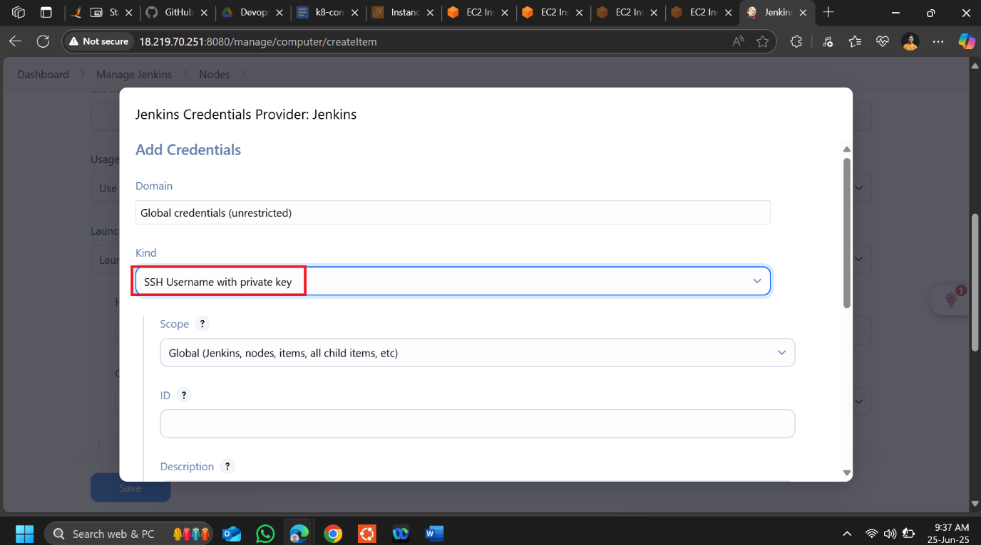

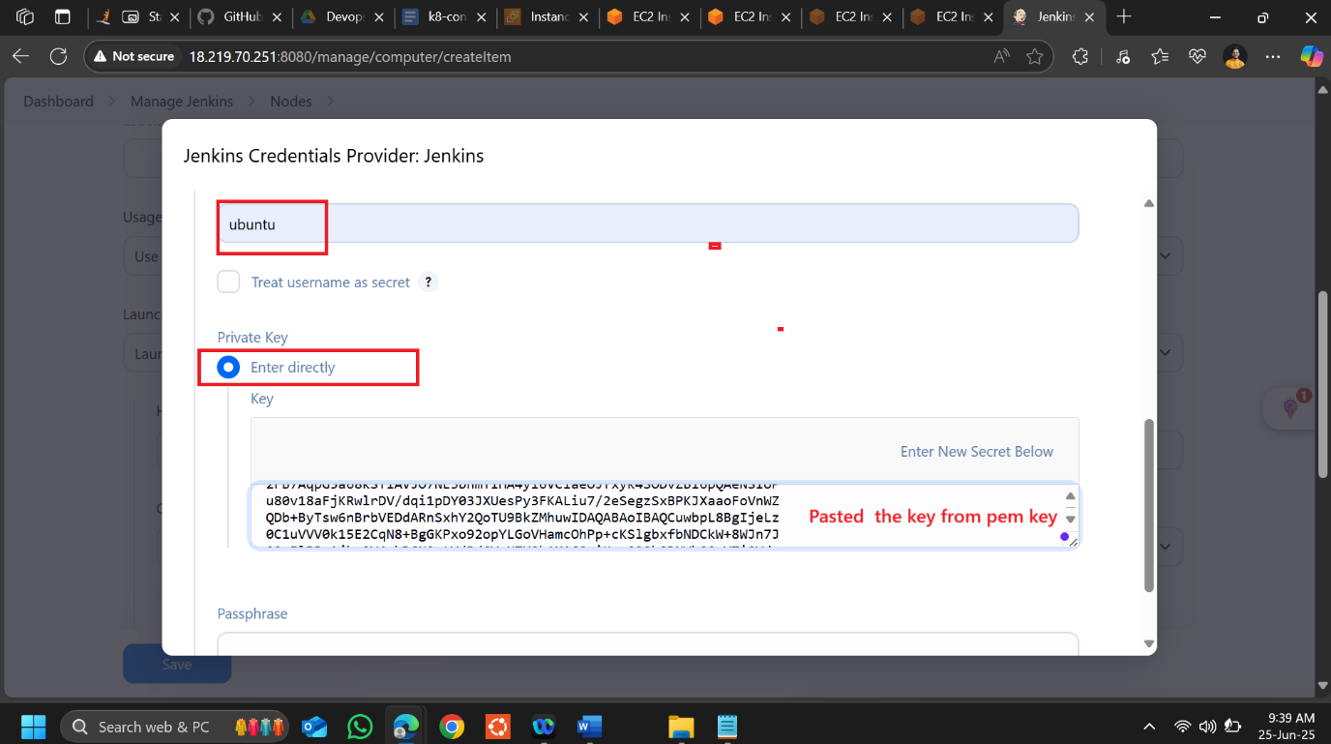

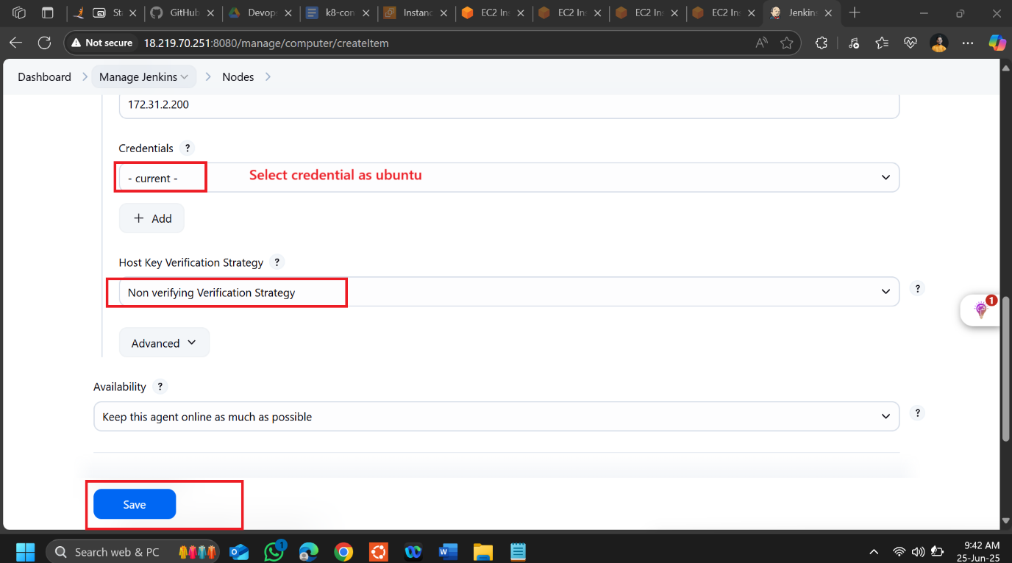

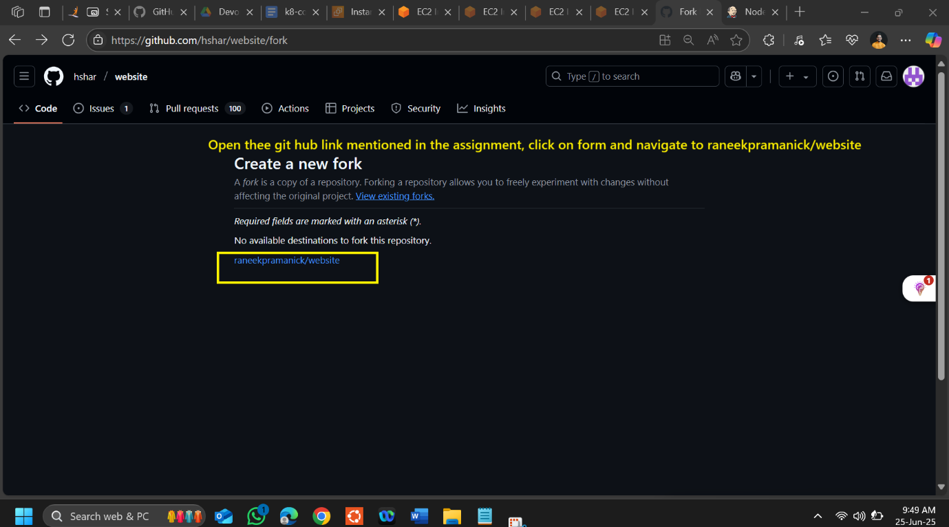

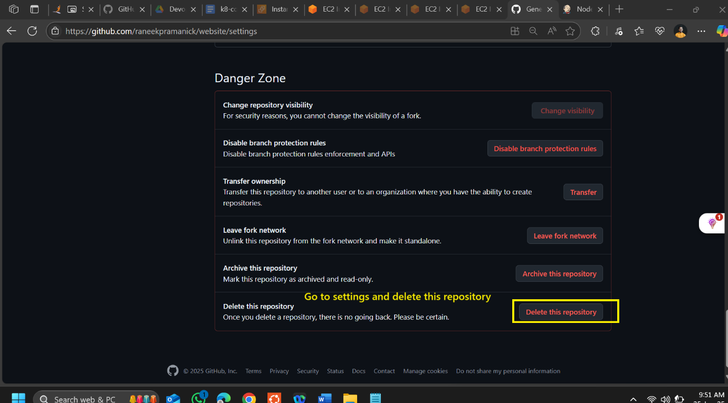

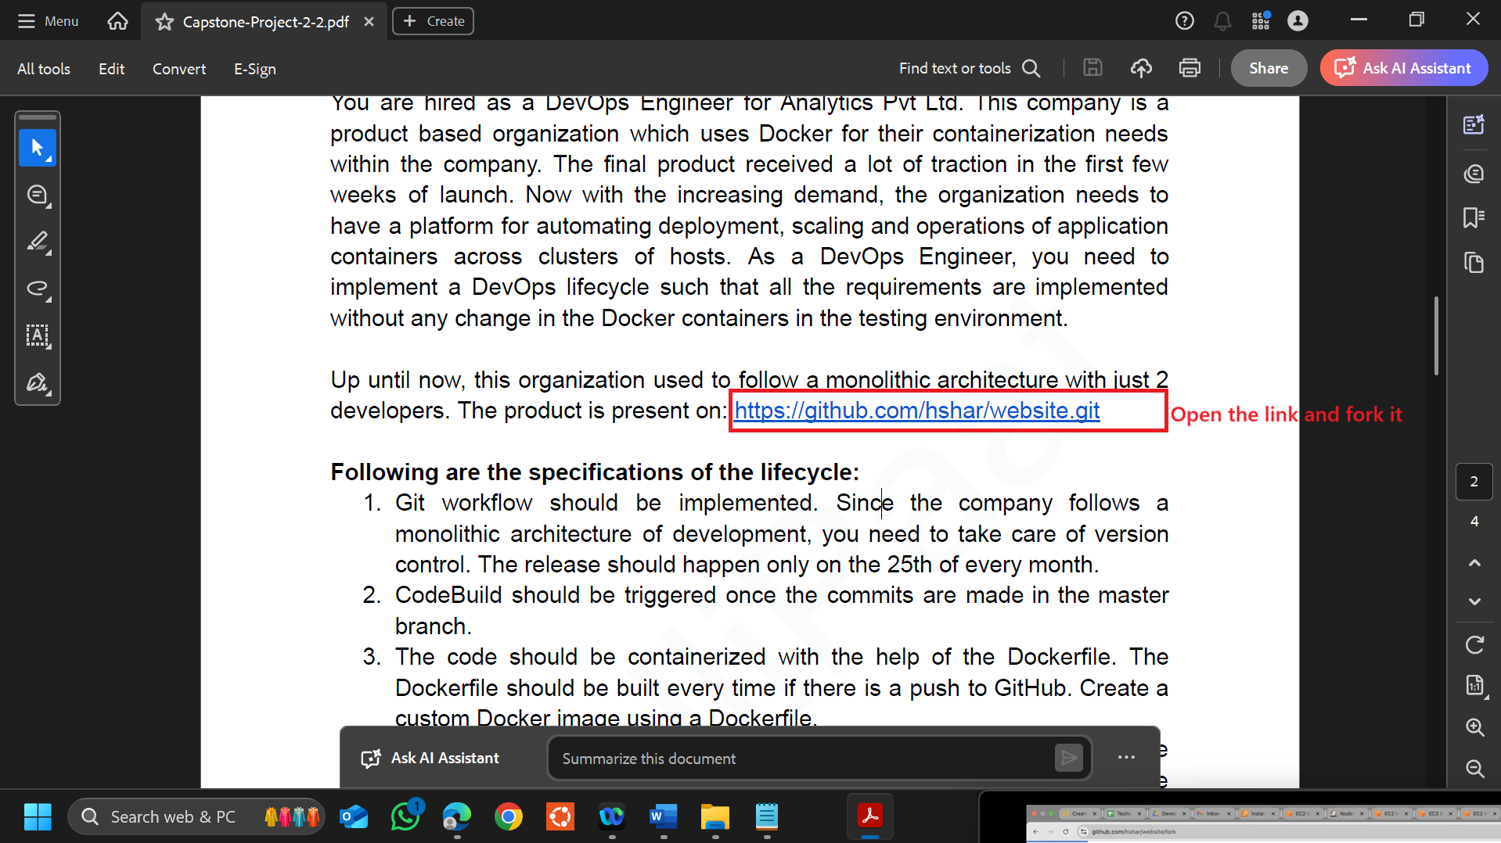

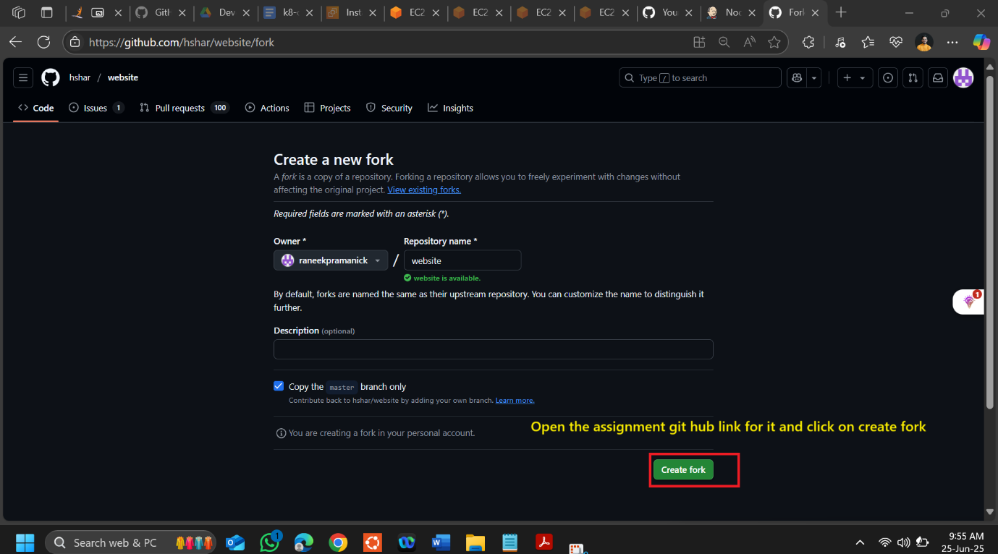

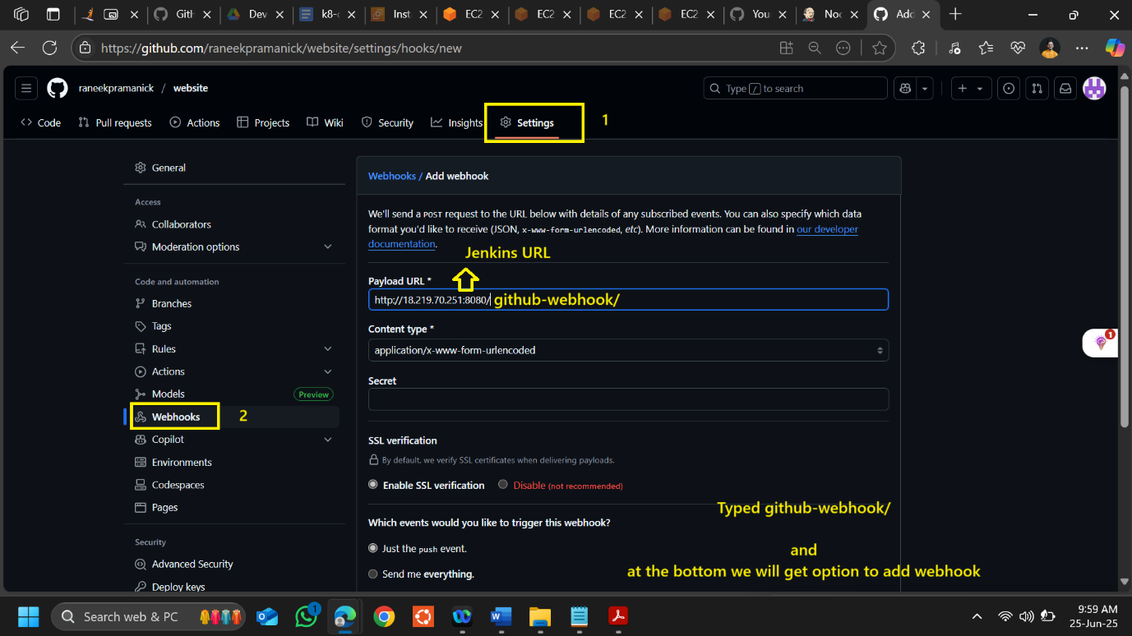

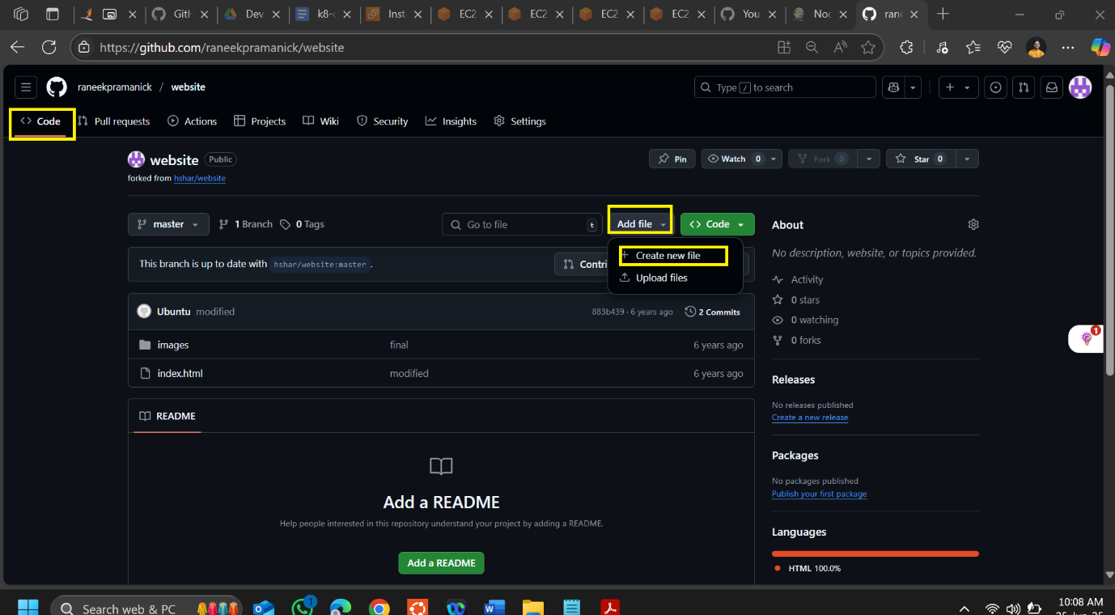

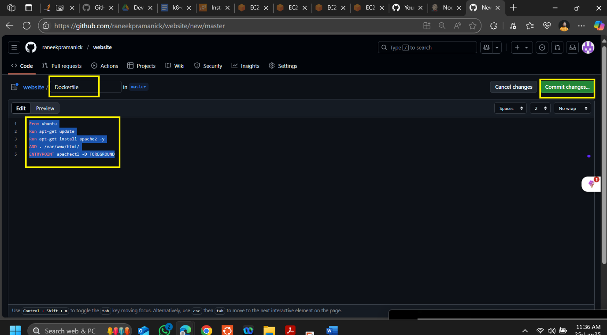

**From ubuntu**

**Run apt-get update**

**Run apt-get install apache2 -y**

**ADD . /var/www/html/**

**ENTRYPOINT apachectl -D FOREGROUND**

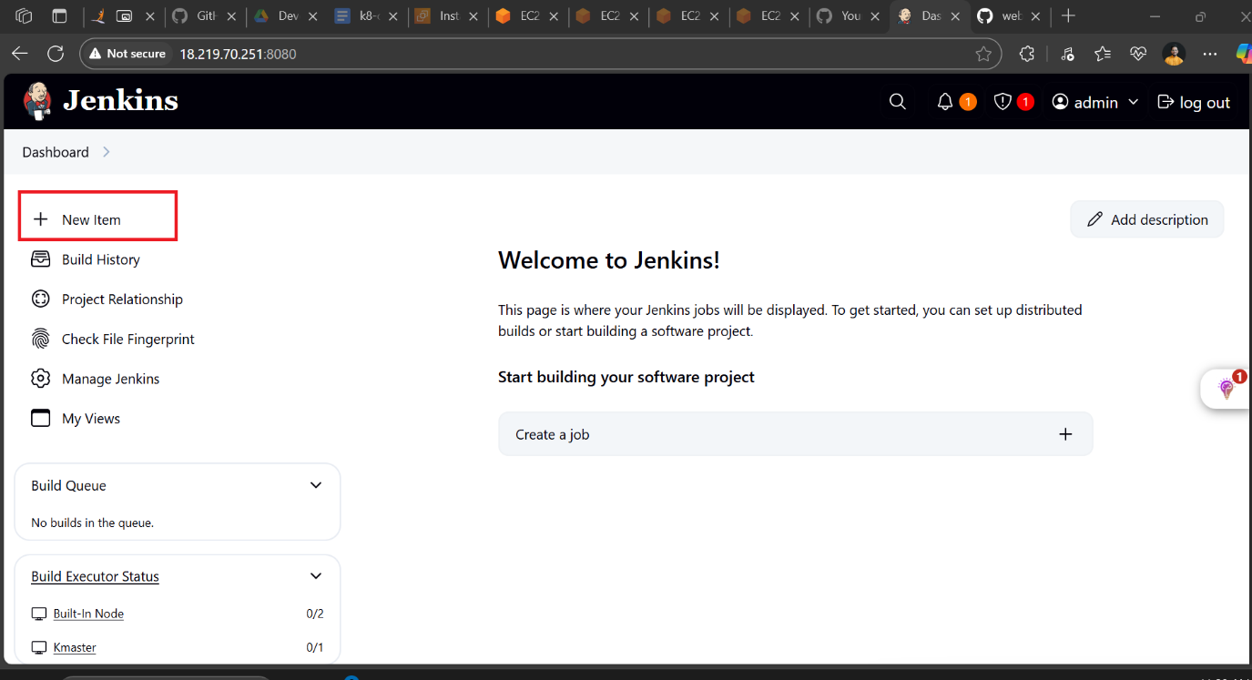

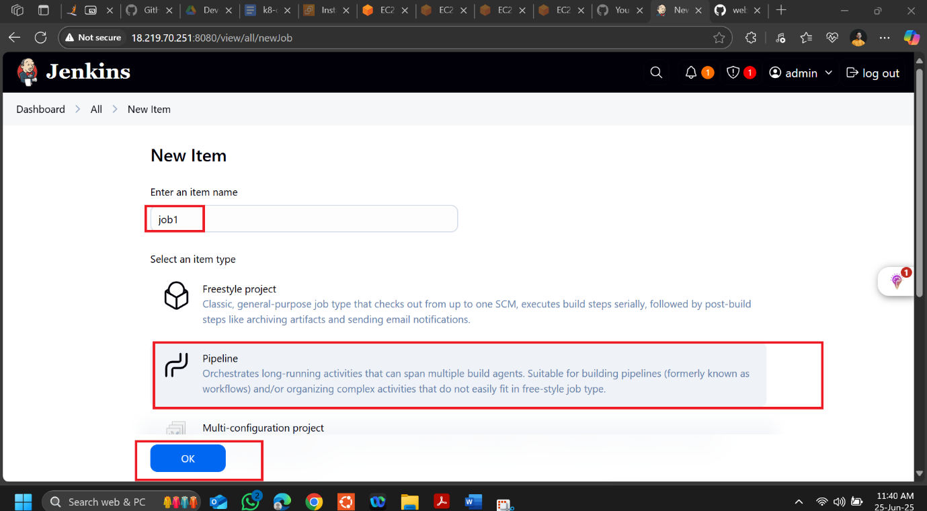

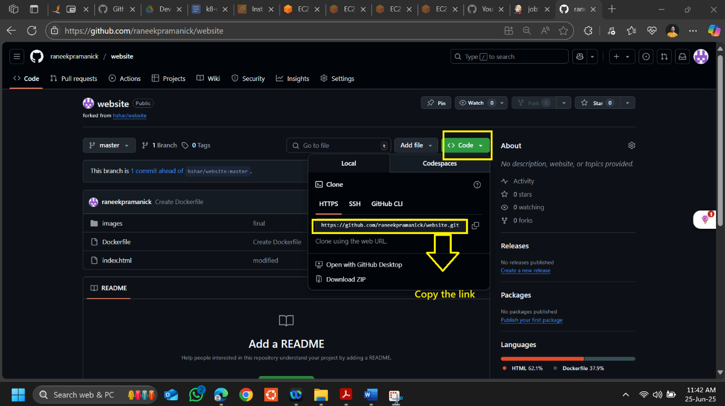

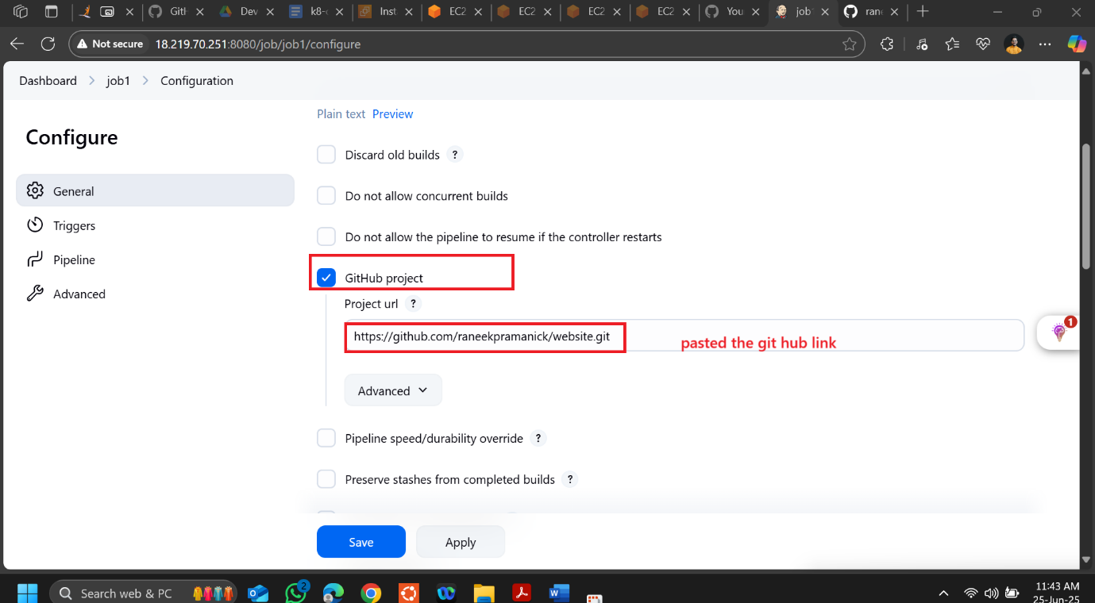

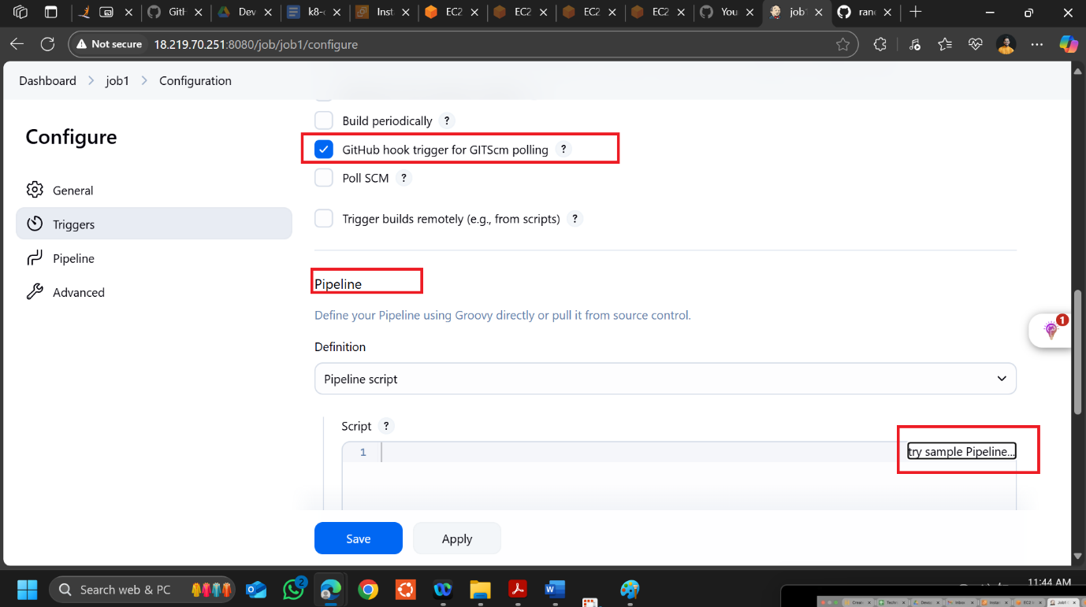

**OPEN the jenkin url in the new tab**

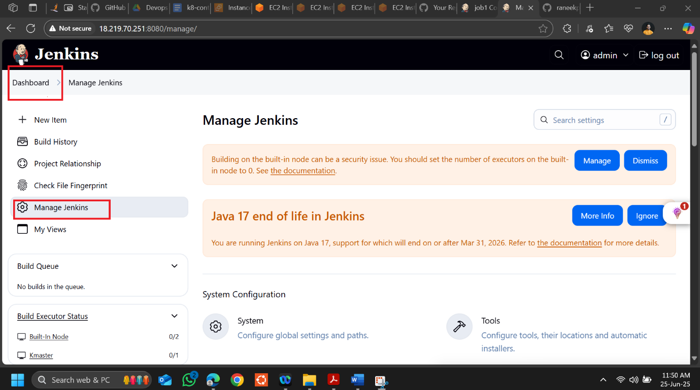

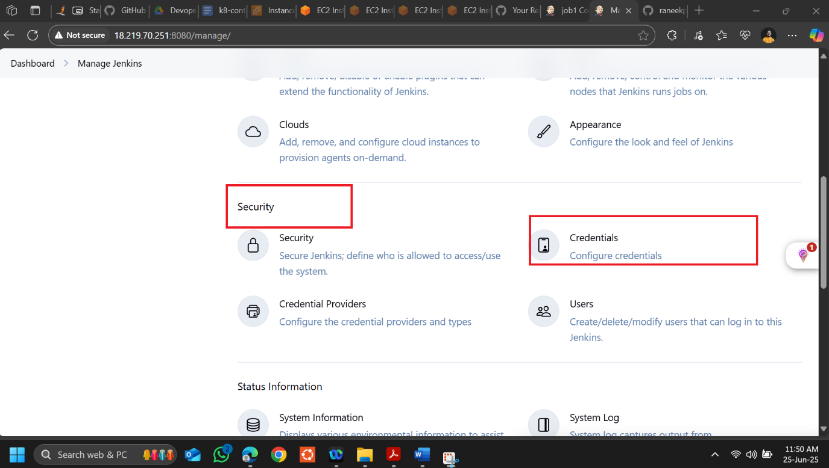

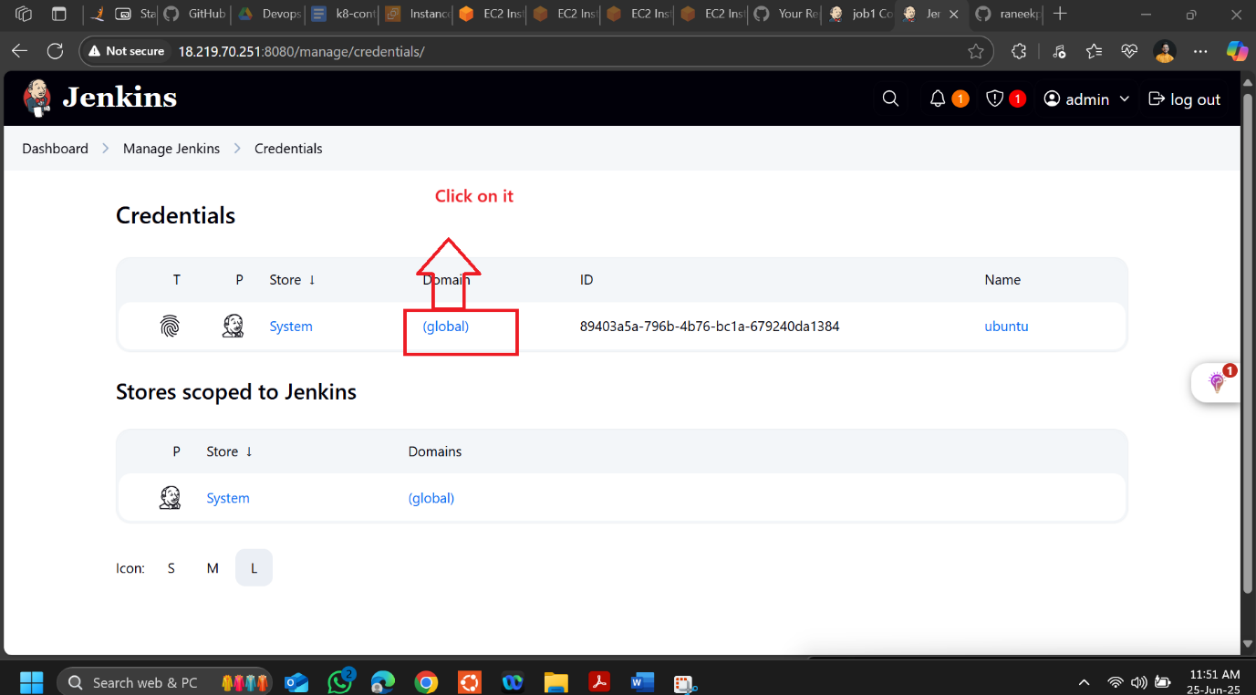

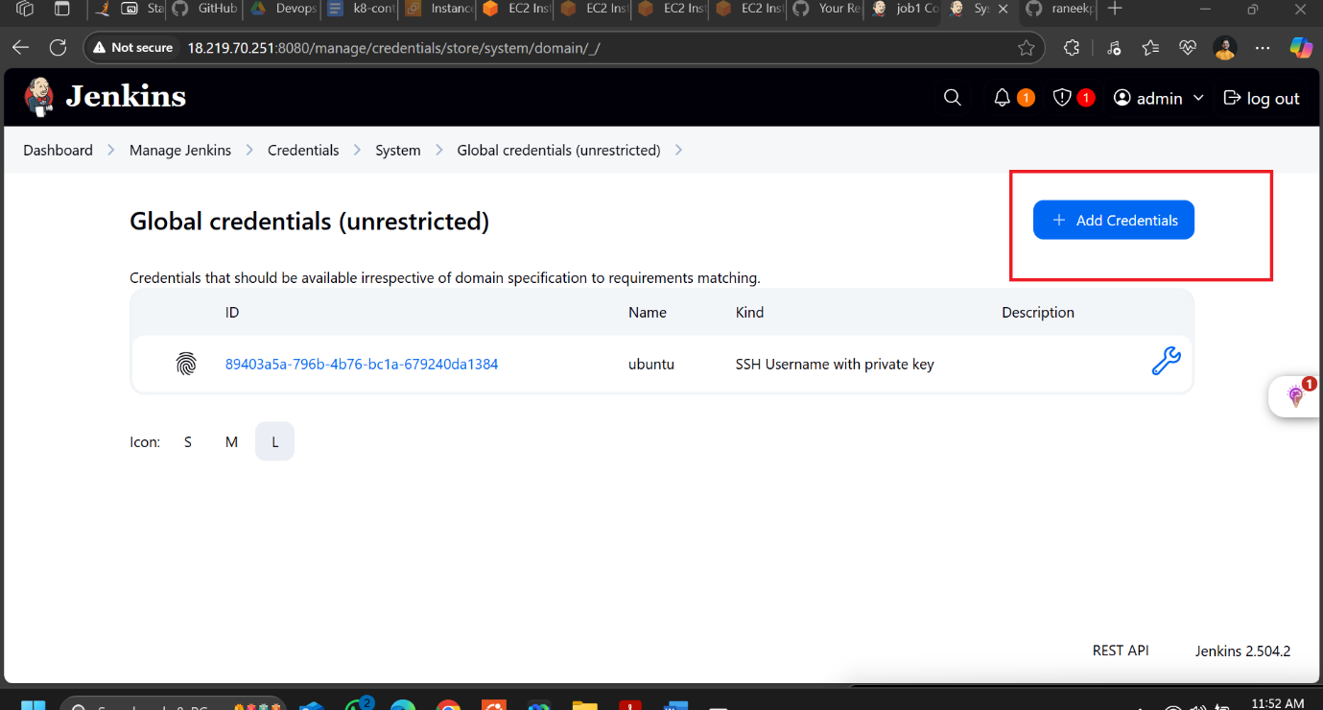

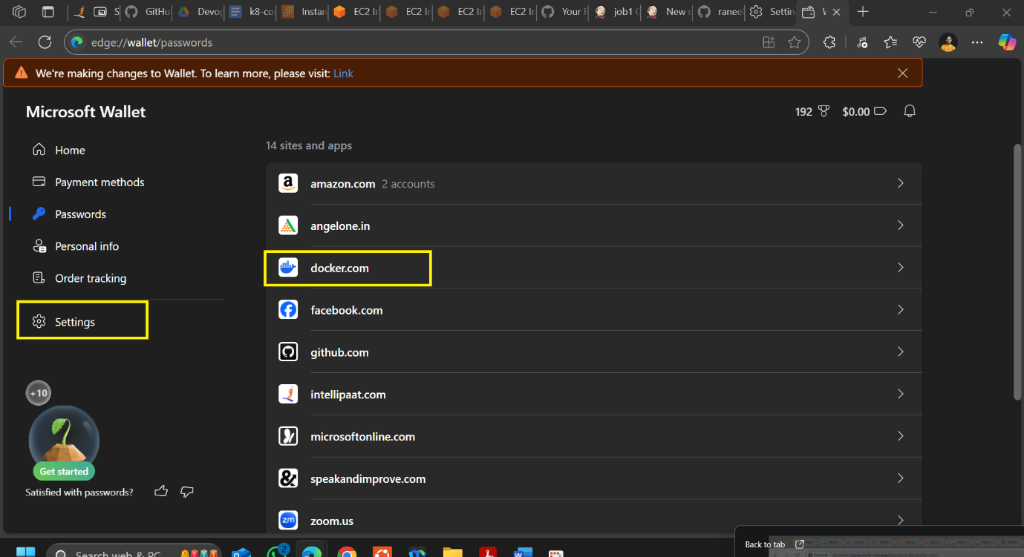

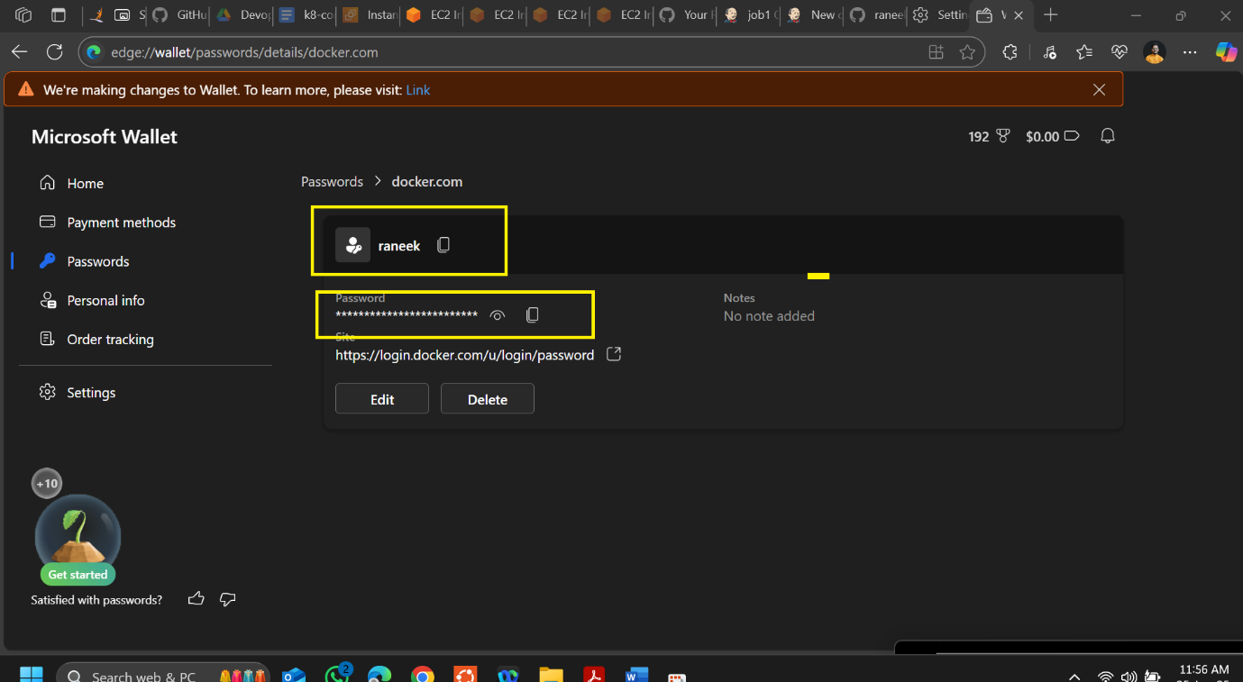

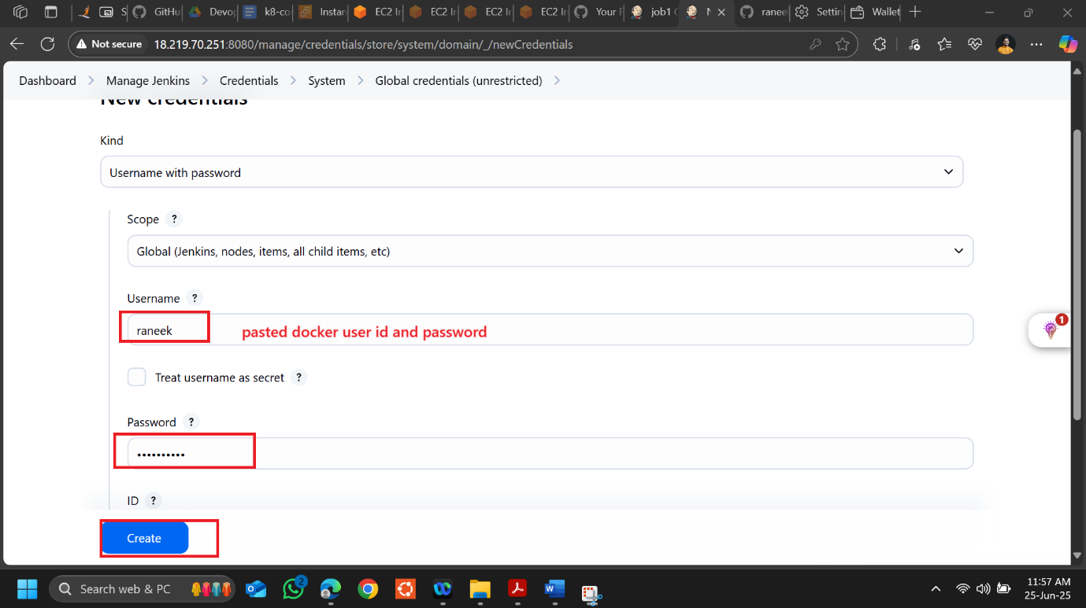

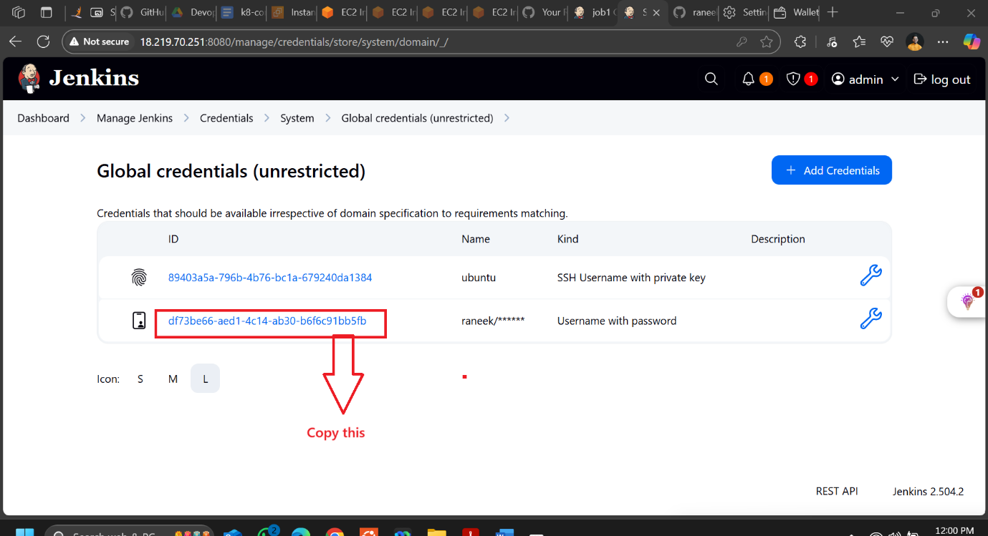

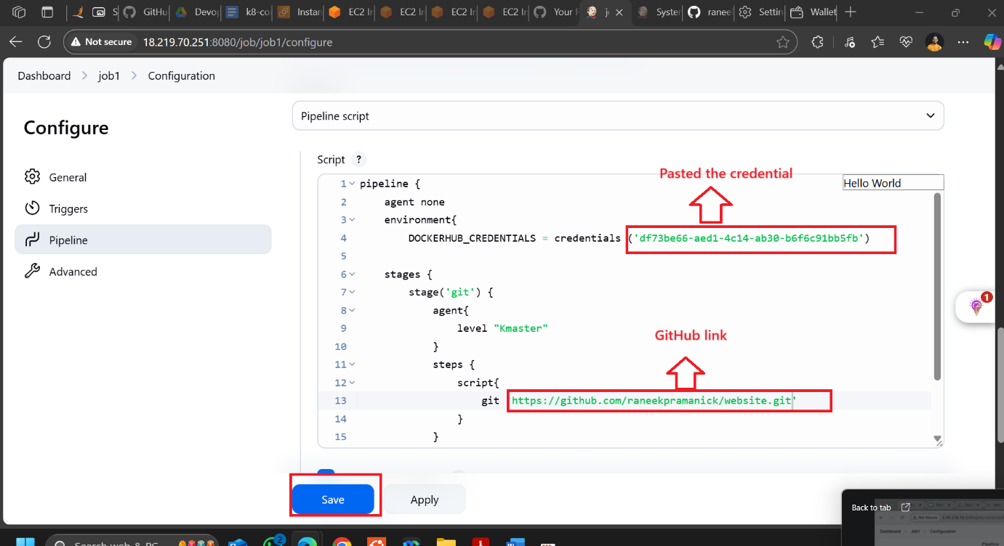

**pipeline {**

**agent none**

**environment {**

**DOCKERHUB_CREDENTIALS = credentials('df73be66-aed1-4c14-ab30-b6f6c91bb5fb')**

**}**

**stages {**

**stage('git') {**

**agent { label 'Kmaster' }**

**steps {**

**git 'https://github.com/raneekpramanick/website.git'**

**}**

**}**

**}**

**}**

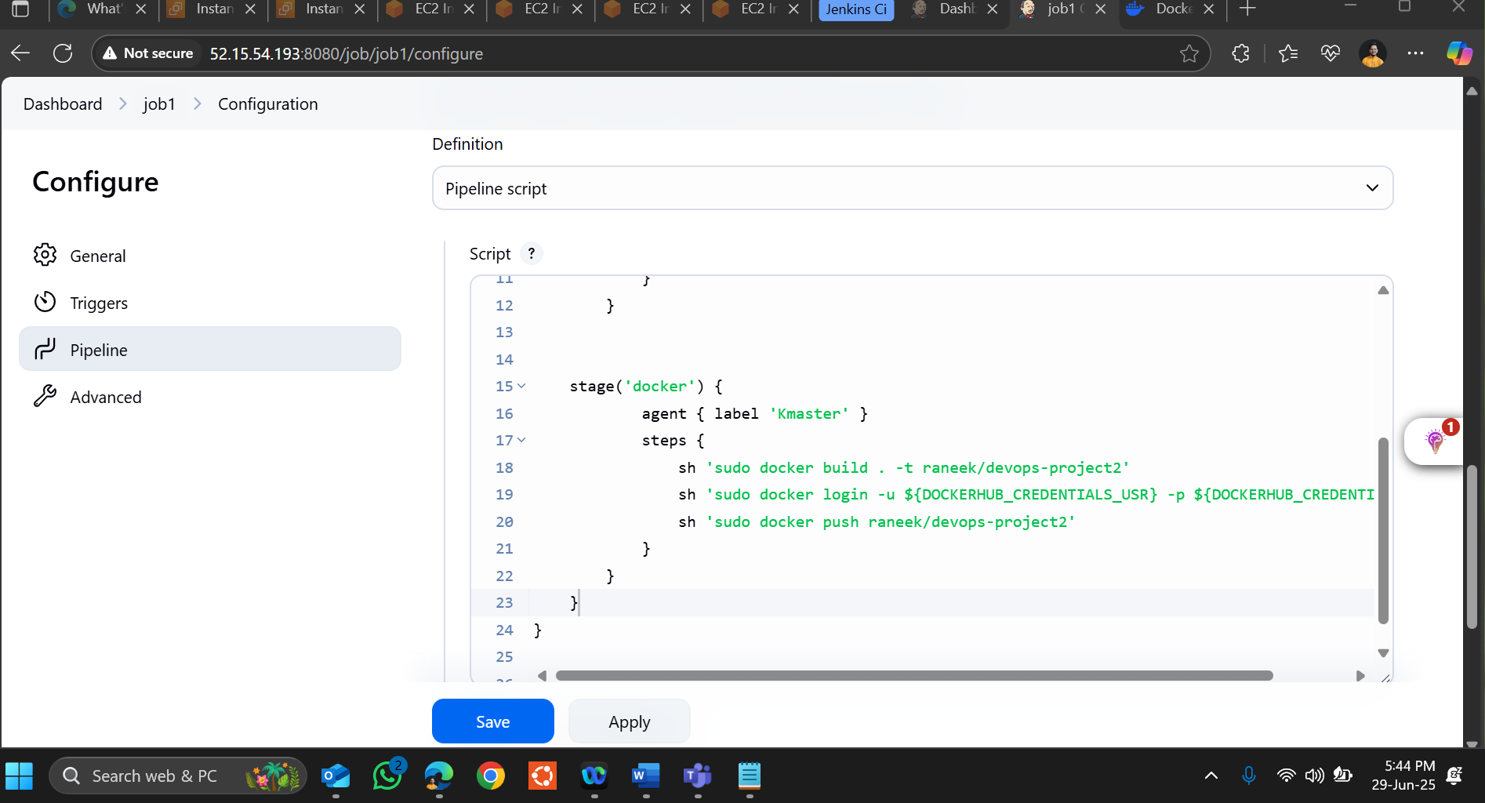

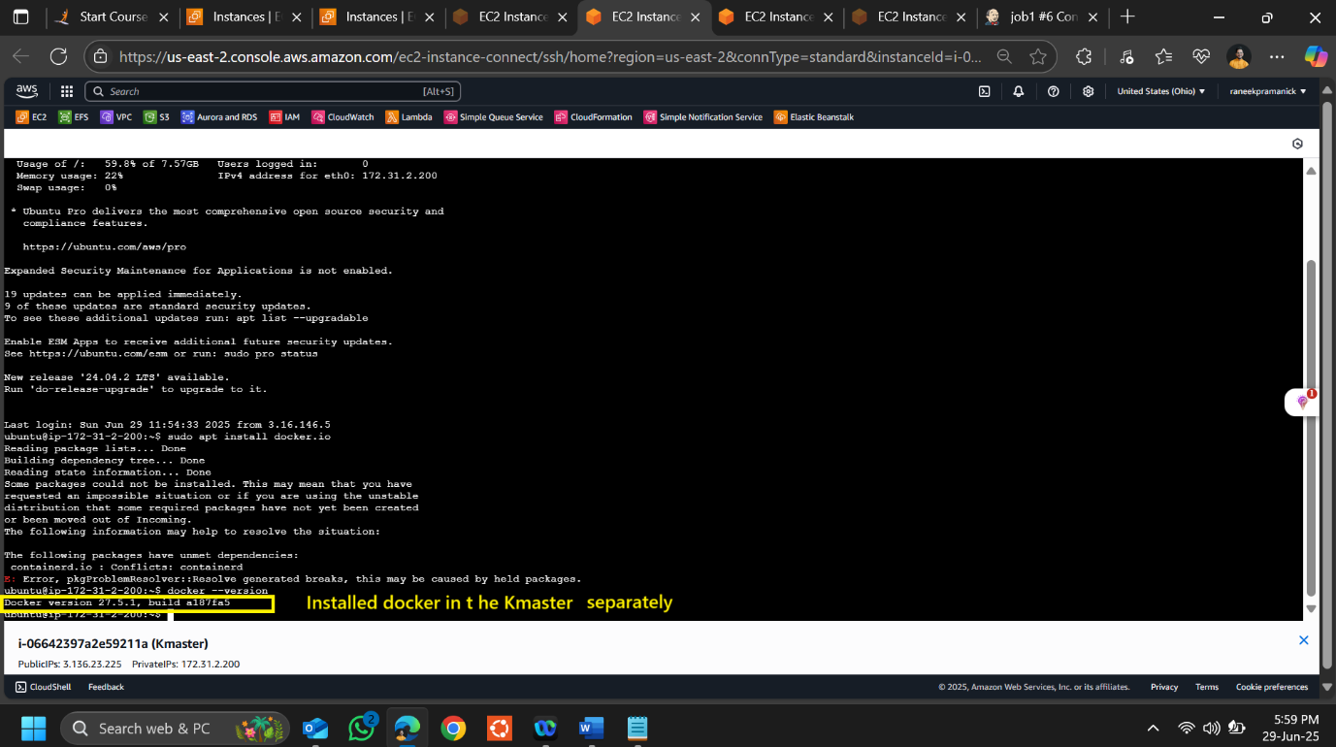

**pipeline {**

**agent none**

**environment {**

**DOCKERHUB_CREDENTIALS = credentials('df73be66-aed1-4c14-ab30-b6f6c91bb5fb')**

**}**

**stages {**

**stage('git') {**

**agent { label 'Kmaster' }**

**steps {**

**git 'https://github.com/raneekpramanick/website.git'**

**}**

**}**

**stage('docker') {**

**agent { label 'Kmaster' }**

**steps {**

**sh 'sudo docker build . -t raneek/devops-project2'**

**sh 'sudo docker login -u ${DOCKERHUB_CREDENTIALS_USR} -p ${DOCKERHUB_CREDENTIALS_PSW}'**

**sh 'sudo docker push raneek/devops-project2'**

**}**

**}**

**}**

**}**

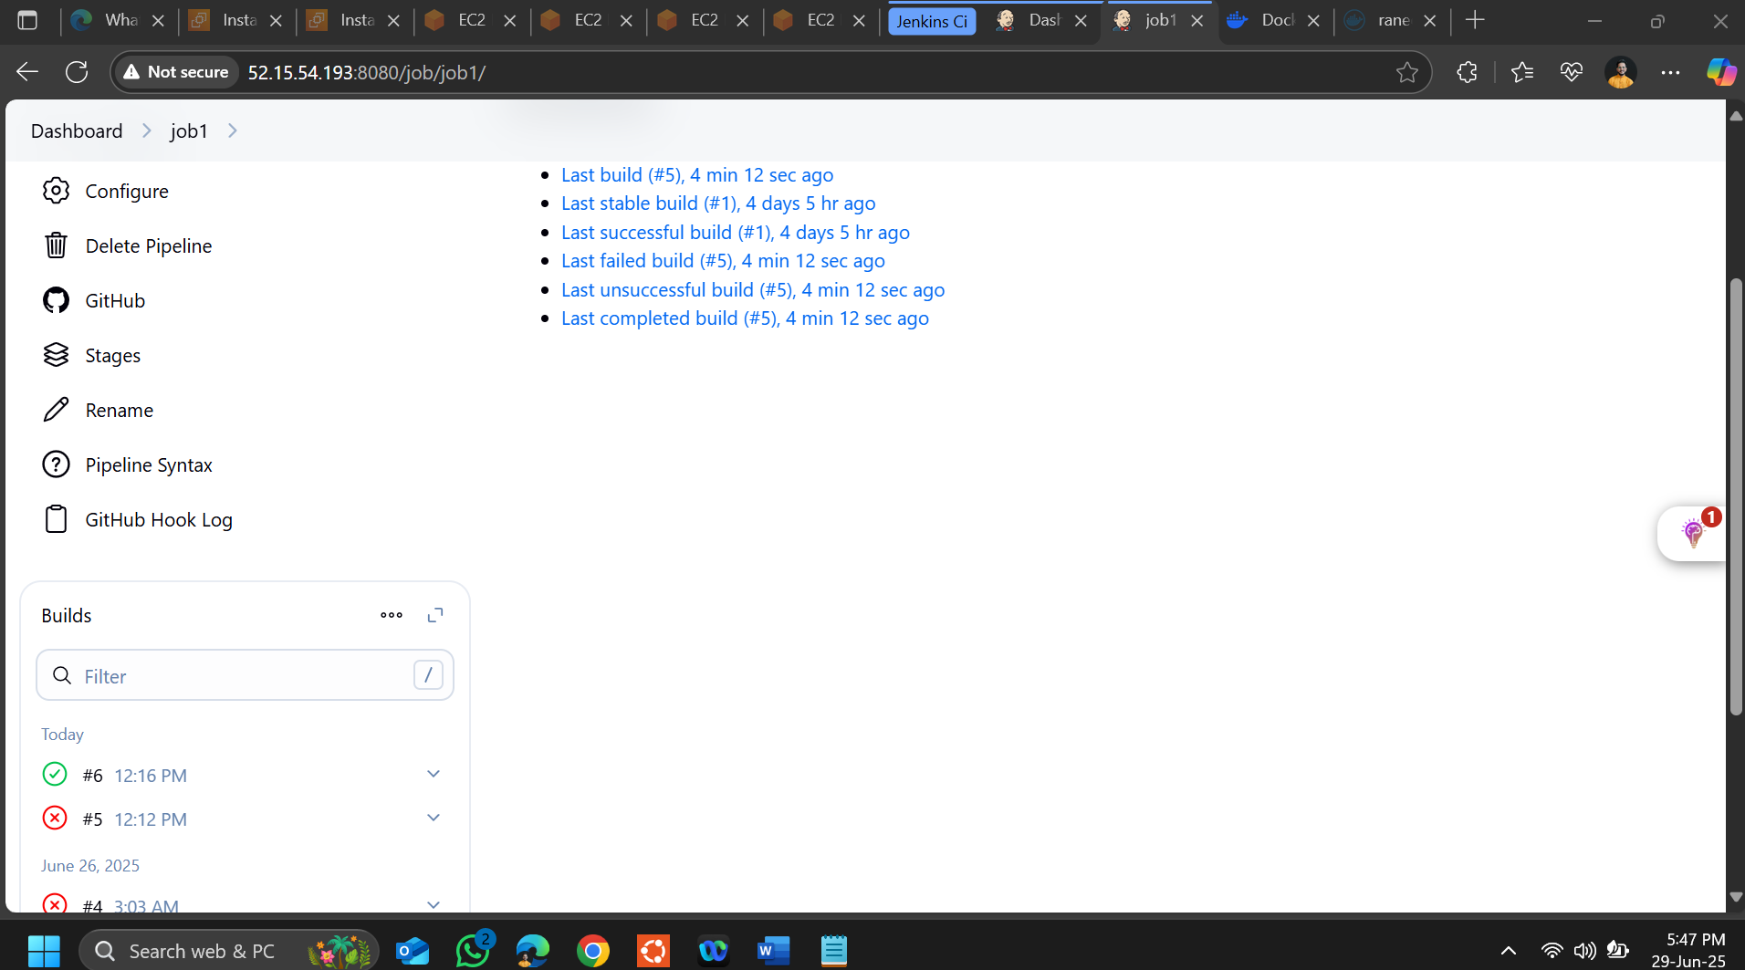

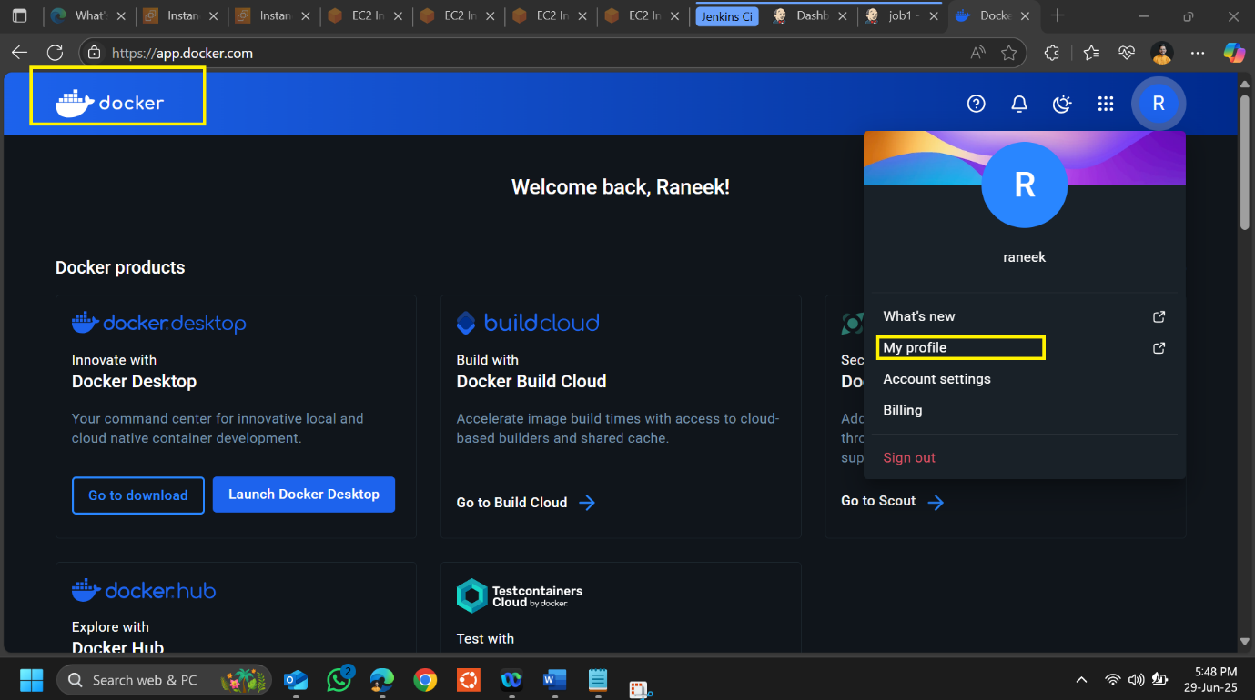

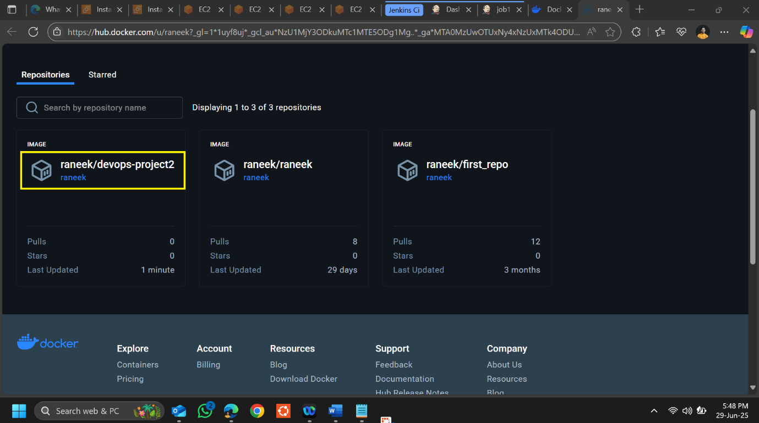

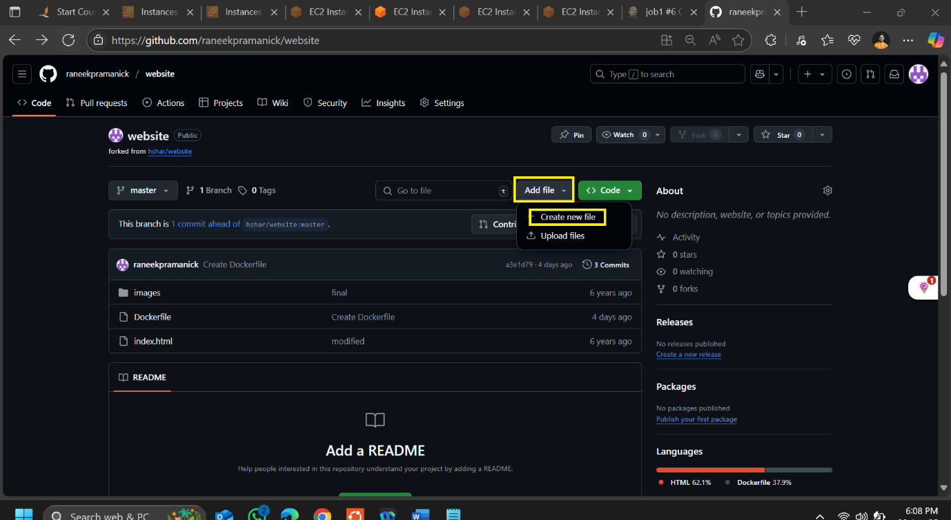

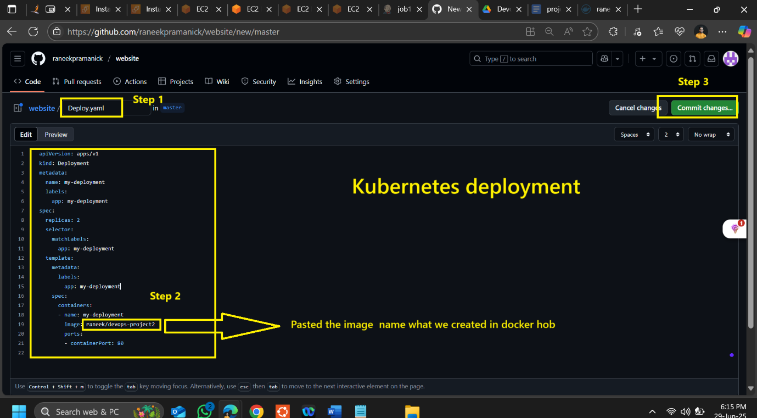

**apiVersion: apps/v1**

**kind: Deployment**

**metadata:**

**name: my-deployment**

**labels:**

**app: my-deployment**

**spec:**

**replicas: 2**

**selector:**

**matchLabels:**

**app: my-deployment**

**template:**

**metadata:**

**labels:**

**app: my-deployment**

**spec:**

**containers:**

**- name: my-deployment**

**image: raneek/devops-project2**

**ports:**

**- containerPort: 80**

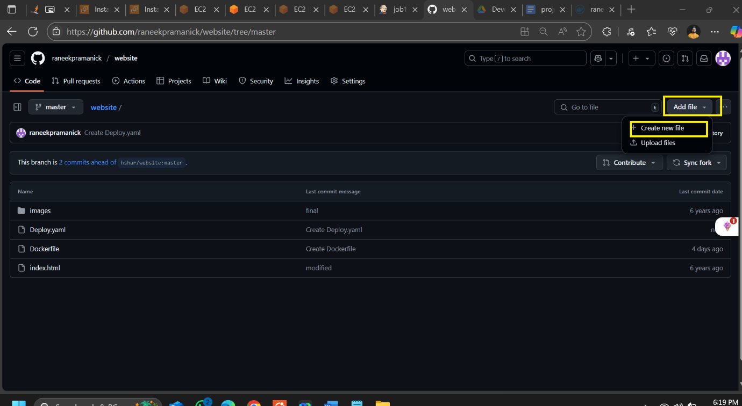

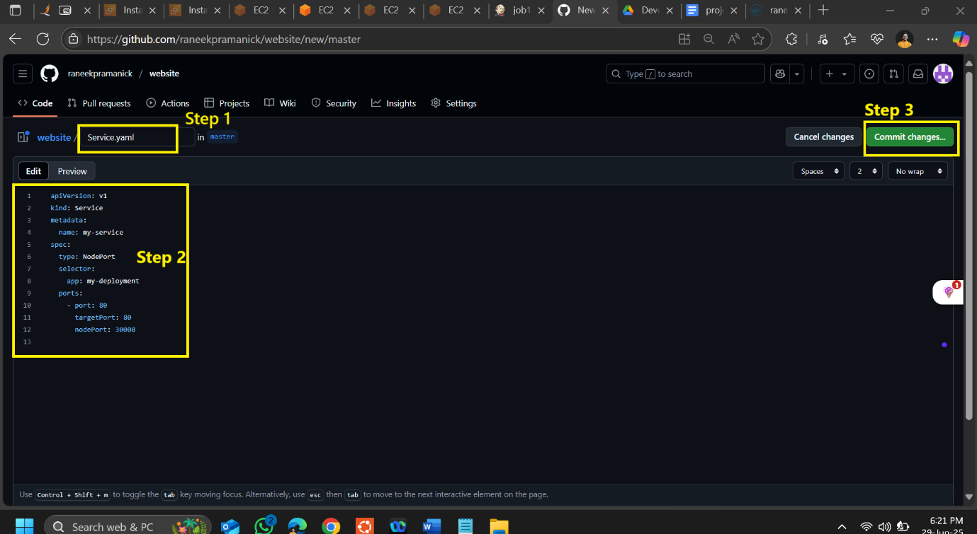

**apiVersion: v1**

**kind: Service**

**metadata:**

**name: my-service**

**spec:**

**type: NodePort**

**selector:**

**app: my-deployment**

**ports:**

**- port: 80**

**targetPort: 80**

**nodePort: 30008**

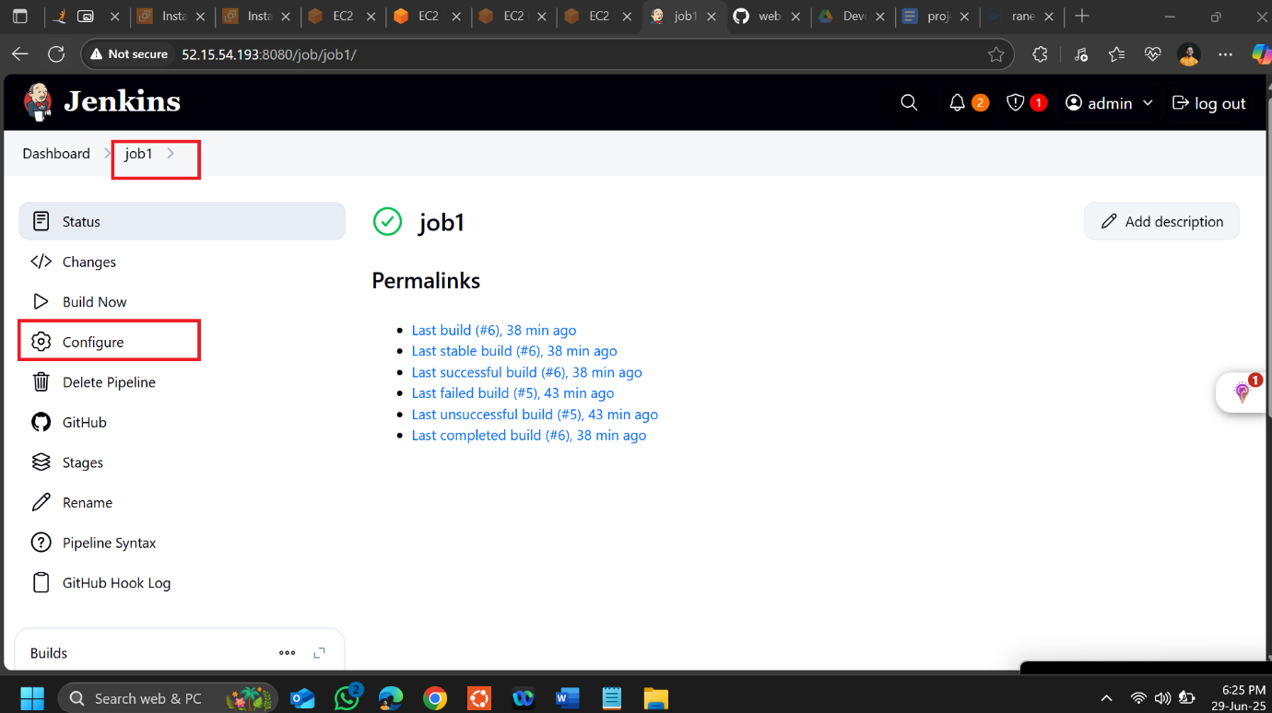

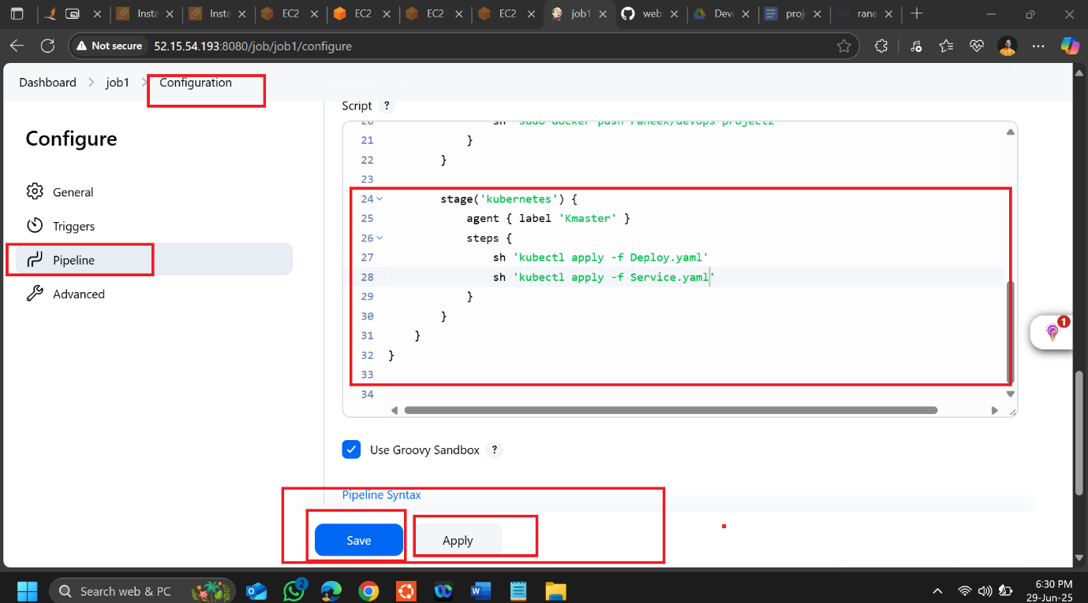

**pipeline {**

**agent none**

**environment {**

**DOCKERHUB_CREDENTIALS = credentials('df73be66-aed1-4c14-ab30-b6f6c91bb5fb')**

**}**

**stages {**

**stage('git') {**

**agent { label 'Kmaster' }**

**steps {**

**git 'https://github.com/raneekpramanick/website.git'**

**}**

**}**

**stage('docker') {**

**agent { label 'Kmaster' }**

**steps {**

**sh 'sudo docker build . -t raneek/devops-project2'**

**sh 'sudo docker login -u ${DOCKERHUB_CREDENTIALS_USR} -p ${DOCKERHUB_CREDENTIALS_PSW}'**

**sh 'sudo docker push raneek/devops-project2'**

**}**

**}**

**stage('kubernetes') {**

**agent { label 'Kmaster' }**

**steps {**

**sh 'kubectl apply -f Deploy.yaml'**

**sh 'kubectl apply -f Service.yaml'**

**}**

**}**

**}**

**}**

